**Software Development Project-II**

**On**

**“BrokersBunch”**

In fulfilment of Bachelor of Computer Applications (BCA)

**Developed By**

**(Group No: 23)**

Roll no:17-BCA-075: KHADIJA NADIADI

Roll no:17-BCA-103: NAYSHREE PACHORI

Roll no:17-BCA-138: NISHANT JAIN

**(Semester-6 Bachelor of Computer Application)**

**2019-2020**

Department of Computer Science

**St. Xavier’s College (Autonomous)**

**St. Xavier’s College Campus, Navrangpura, Ahmedabad-380 009**

**www.sxca.edu.in**

**Acknowledgement**

We wish to express our gratitude to all the people involved in contributing this project of our website “BrokersBunch”. We take this opportunity to thank all who have helped us during the project work.

We would like to thank our college, St. Xavier’s College (Autonomous) for providing us the opportunity to work on project and gain experience from the same. We present our heartful thanks to the Vice Principal, **Dr. (Fr.) Johnson Mundupuzhakal** for sharing his generous time and knowledge with us which helped us to complete this project on time and present it to the examiners.

Genuine thanks to **Ms. Nithya Nadar**, our internal guide for her critical reviews of the project which help us to make this more presentable. Her gentle support and direction guided us in all aspects of the project. It has been pleasure to work with **“Hauper Technologies Pvt. Ltd.”**, and we appreciate the cooperation of the staff. Our special thanks to the external guide **Mr. Abhishek Shah** for his kind review of the project.

We would also like to thank all the faculty members of St. Xavier’s College (Autonomous) for their tangible, but always unspoken support for this project.

Last but not the least we would like to express our sincere thanks to our parents for their precious support and their motivation for completing this project.

**INDEX**

**INDEX**

**Sr. No. TOPIC PAGE NO.**

1. SCREEN LAYOUTS……………………………………………………….1
2. REPORTS LAYOUTS………………………………………………….….42
3. CONCLUSION..……………………………………………………………72
4. BIBLIOGRAPHY…………………………………………………………..73

**Screen Layouts**

**HOMEPAGE**

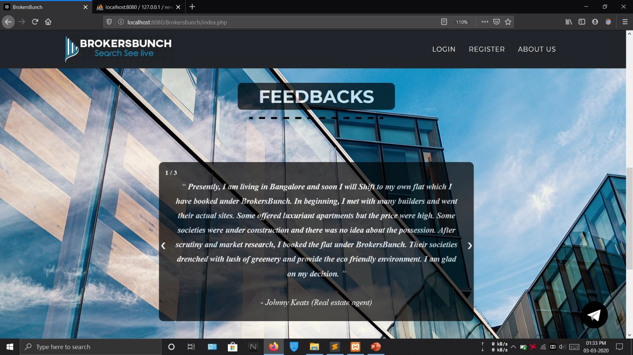

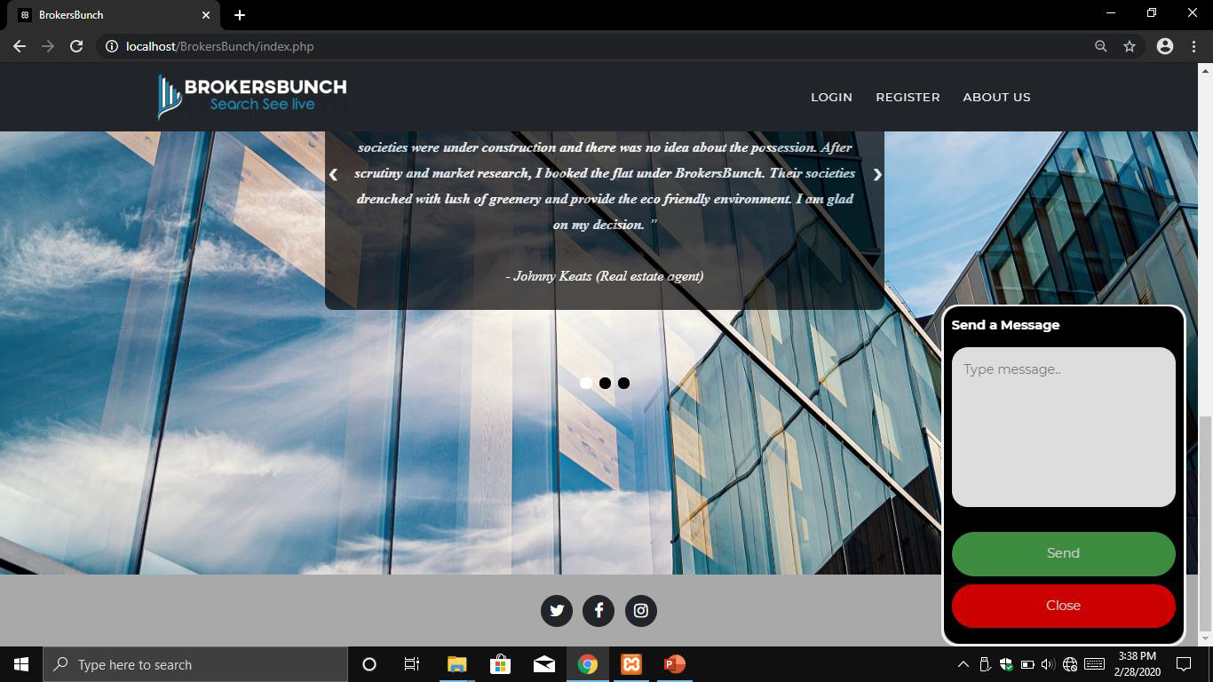**CHAT**

Type Message: Message textbox takes input from the user in any form. User can type any kind of message.It take values in form of varchar and help to store it in same format.

Send Button: On clicking this button message will be sent to the receiver. Client can send any of his query through this form to the broker.

Close Button: On clicking this button this form will be closed.

 **ABOUT US**

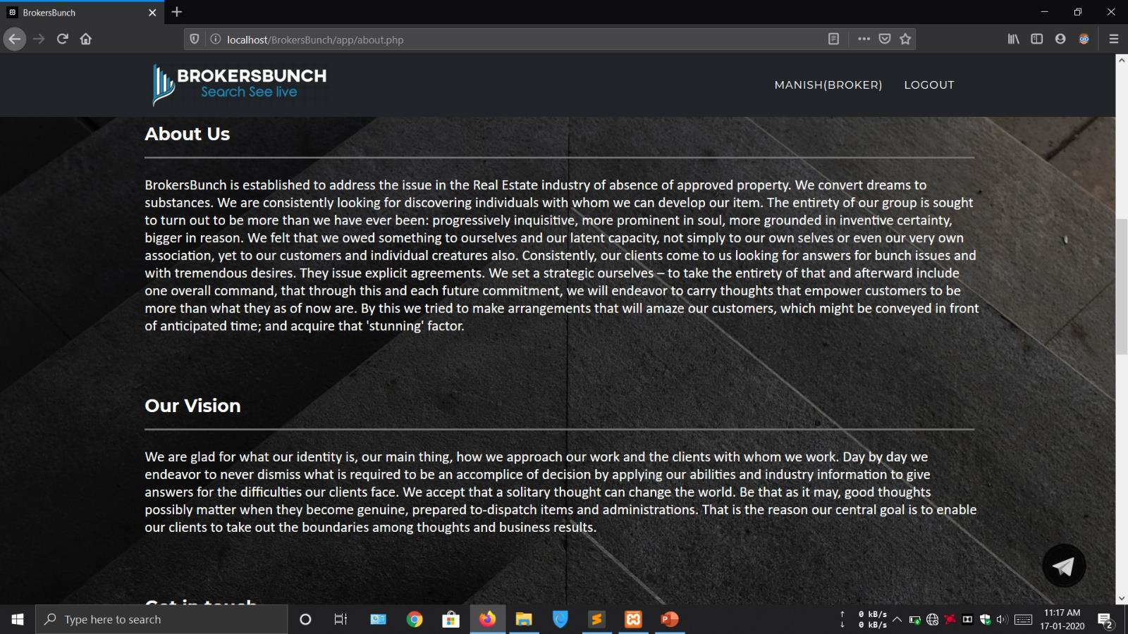

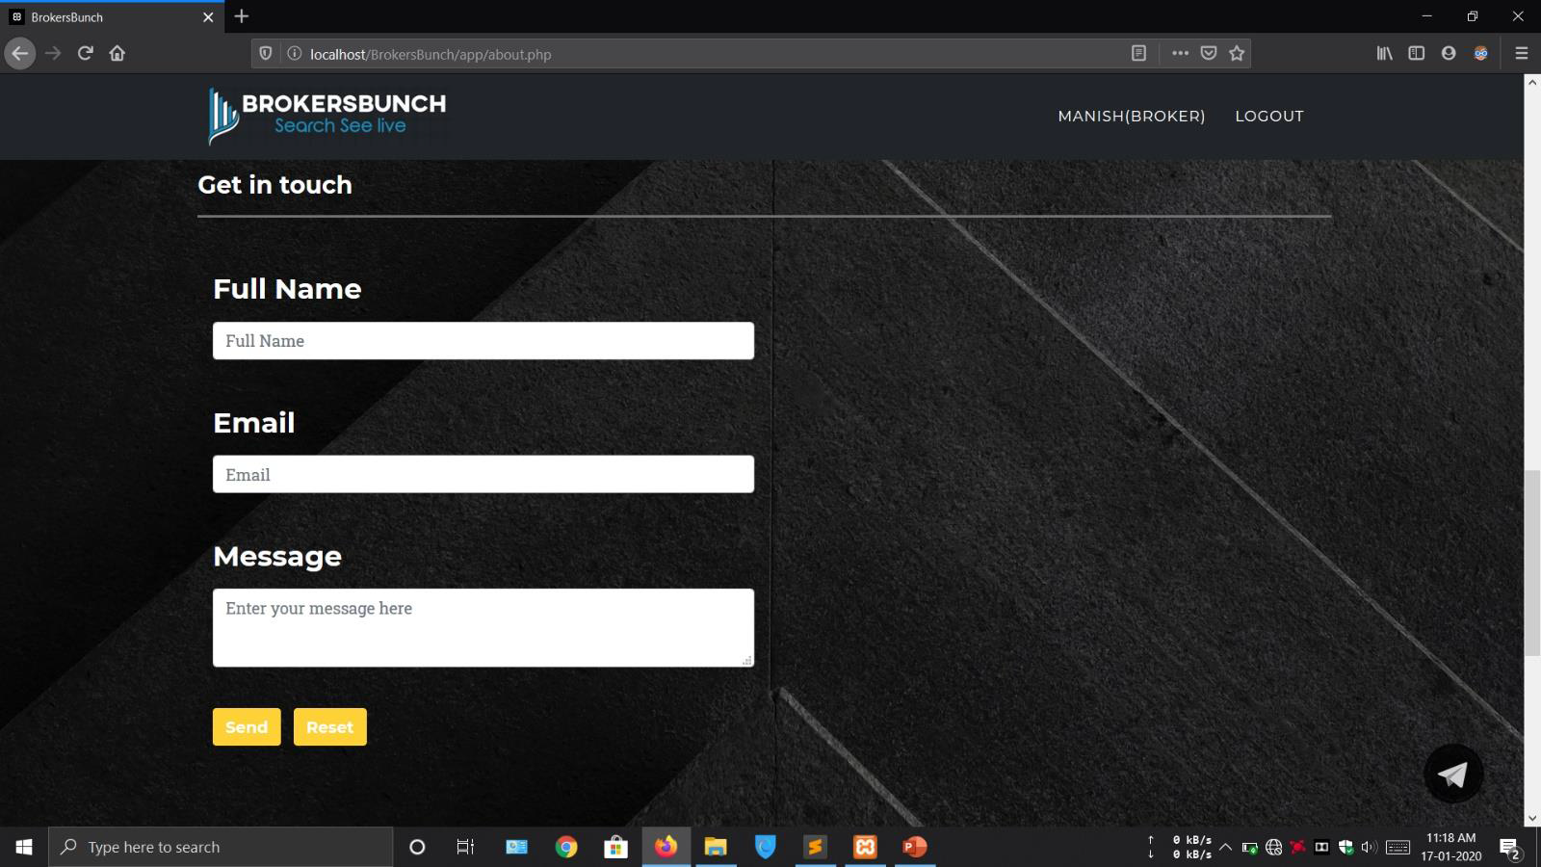

Full Name: Full name textbox takes input in form of plain text. User cannot enter any number in this field.

Email: Email textbox takes user's email as input. Email should contain "@" and "." in it at appropriate position.

Message: Message textbox takes the input from the user in form of text. It can have all/any characters in it. It contains message or query of the user which is for the system administrator.

Send Button: On clicking this button all the details will be stored so that system administrator can take required action.

Reset Button: on clicking this button all the fields of the form will be cleared and set to null.

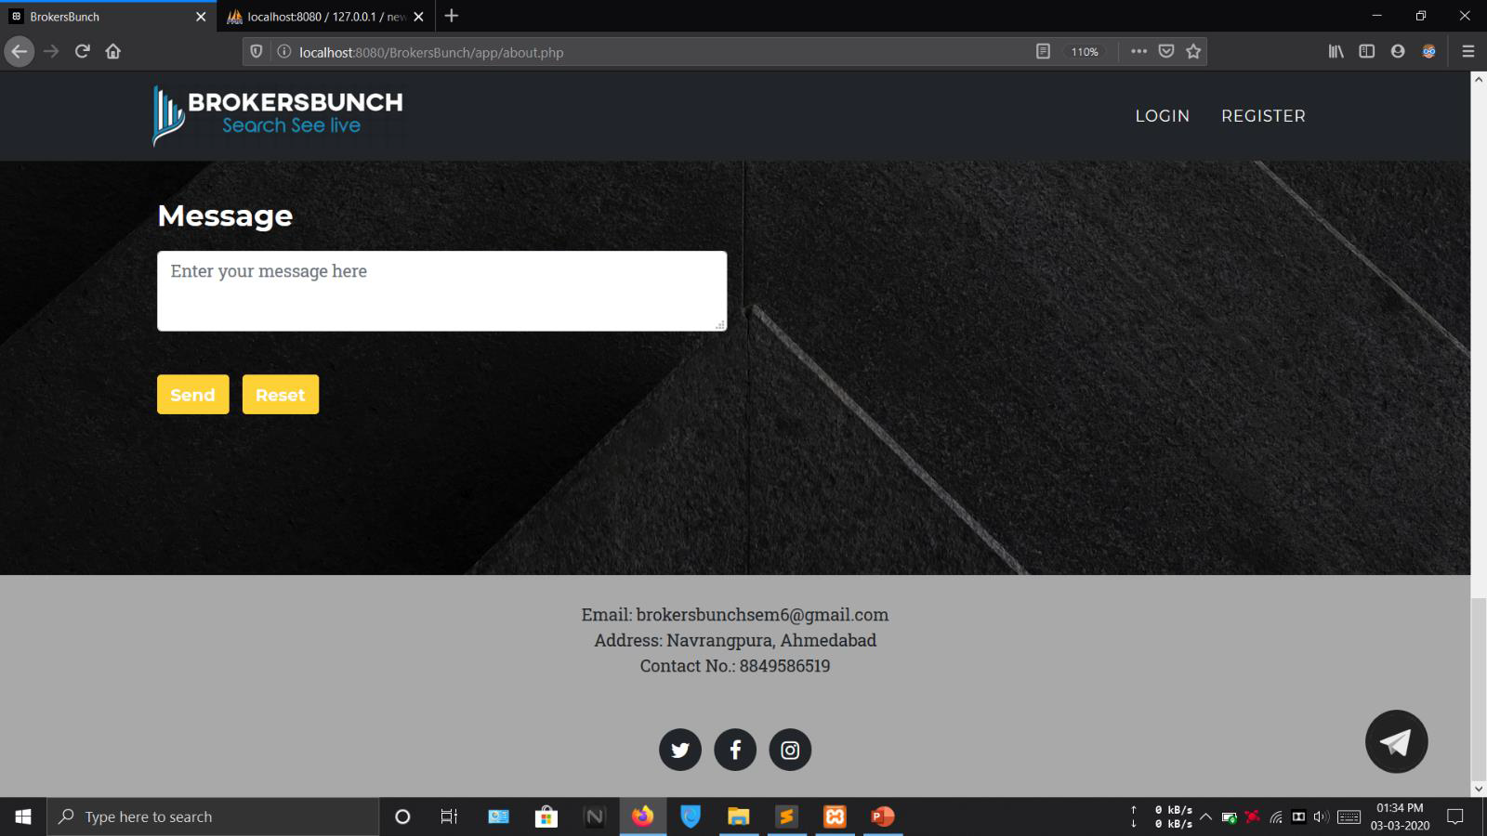

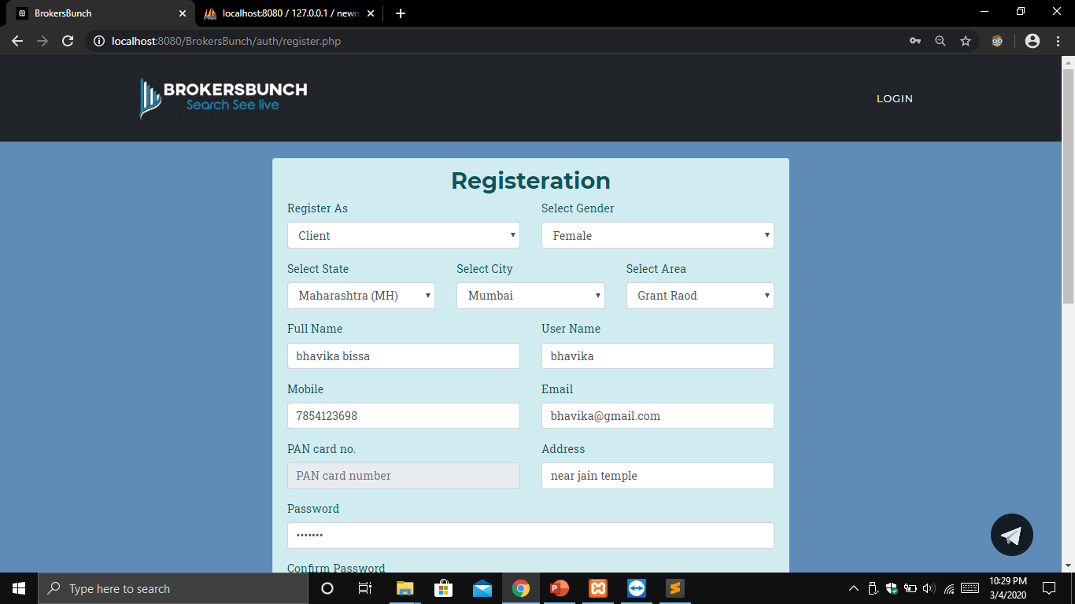**REGISTERATION**

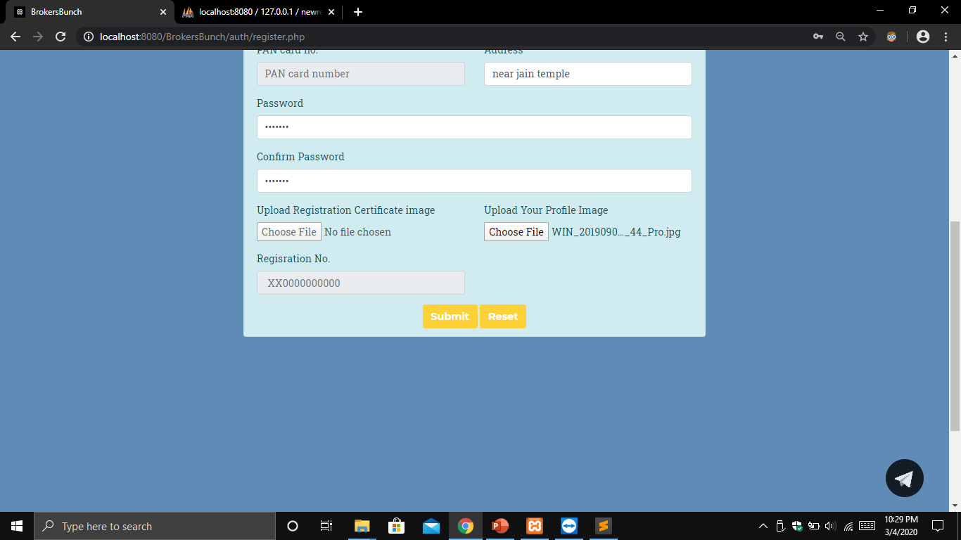No fields can be left empty in this form.

Register As: this combo box allows user to select their type whether they are client or broker.

Select Gender: This combobox allows the user to select their gender for male, female and others.

Select State: This combobox displays all the states. User can choose its state from the available option.

Select City: This combobox gets its selection list on the basis of the option choosen in select state combobox. It displays the corresponding city to state of select state combobox.

Select Area: This combobox gets its selection list on the basis of the option choosen in select city combobox. It displays the corresponding area to city of select city combobox.

Full Name: Full name textbox takes input in form of plain text. User cannot enter any number in this field.

User Name: User name textbox takes input in form of plain text. User cannot enter any number in this field. value should be different from the user name stored beforehand.

Mobile: Mobile textbox takes input in form of numbers. User cannot enter any other character except number. It should have 10 digits. It should not match of any mobile number stored beforehand.

Email: Email textbox takes user's email as input. Email should contain "@" and "." in it at appropriate position. It should not match any of the emails stored beforehand.

PAN Card No.: This field takes input in alphanumeric form. It should contain 5 letters followed by 4 numbers and a letter.

Address: This textbox take input in form of varchar. User need to enter its entire address. Except state, city and area.

Password: This field takes input in form of varchar. It should be combination of letters and number. It should be minimum 8 character long.

Confirm Password: This field checks whether the value of the Password field and this field matches or not. If not then it displays error message.

Upload Registeration Certificate Image: This field is able only if user type is broker. It takes image of the broker's RERA certificate which helps in verification of broker's identity.

Registeration No: This field is able only if user type is broker. It takes RERA number from the broker which should be 12 characters long and alpha numeric.

Upload your Profile Image: this field takes image of user. File should be in image formats i.e. jpeg and png.

Submit button: Onclicking this button all the details will be stored in in the database. All the server constriaint check will be carried out if any error then it will be shown.

Reset Button: On clicking this button all the fields will be cleared.

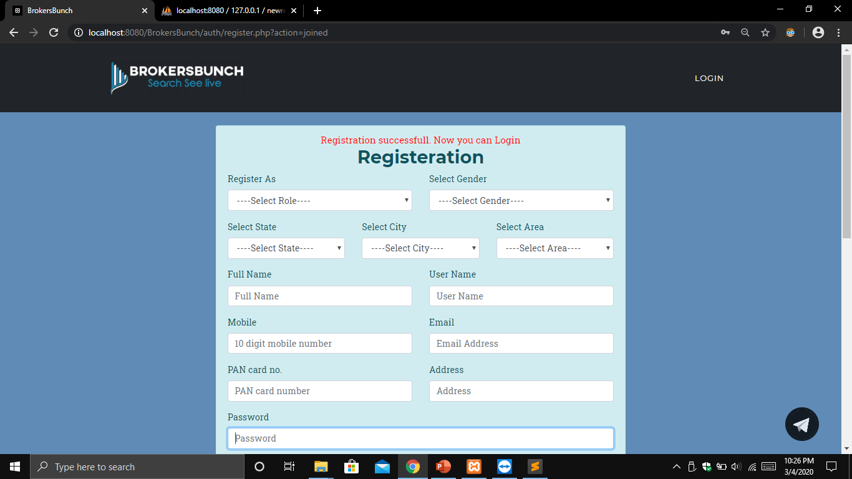

**ADMIN LAYOUTS**

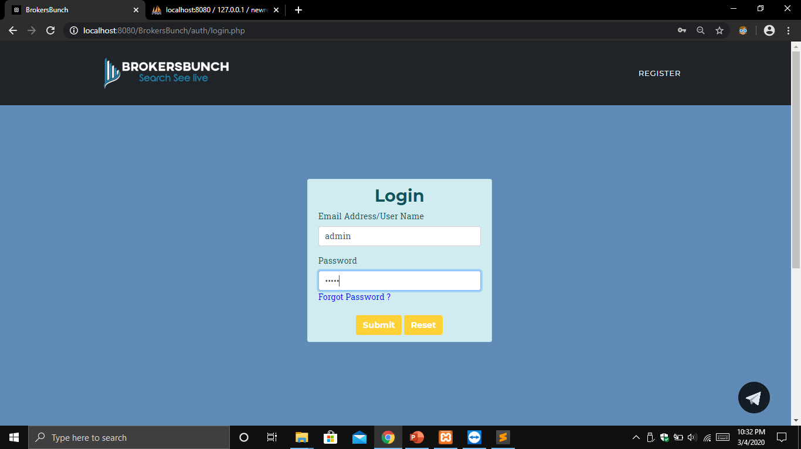**LOGIN**

User Name/Email: In this field admin needs to provide the username which he has been given beforehand.

Password: In this field admin needs to enter his password.

Submit Button: once clicked the submit button, user name and email will be authenticated with the saved ones.

Reset Button: The reset button here is used to clear the values in all the fields.

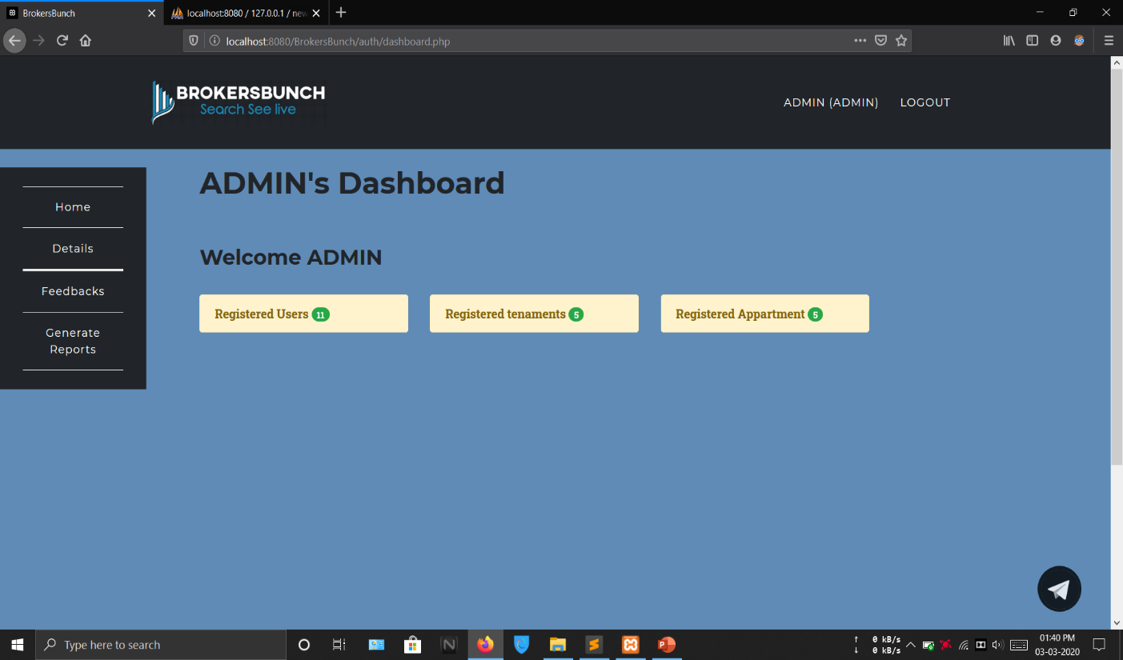 **ADMIN’S DASHBOARD**

**LIST OF USERS**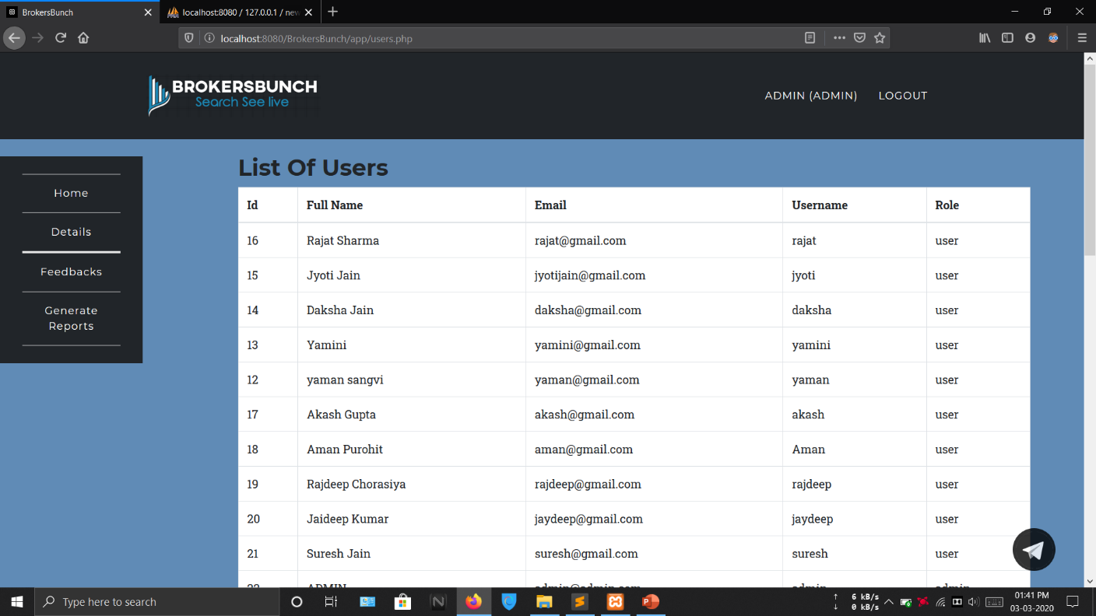

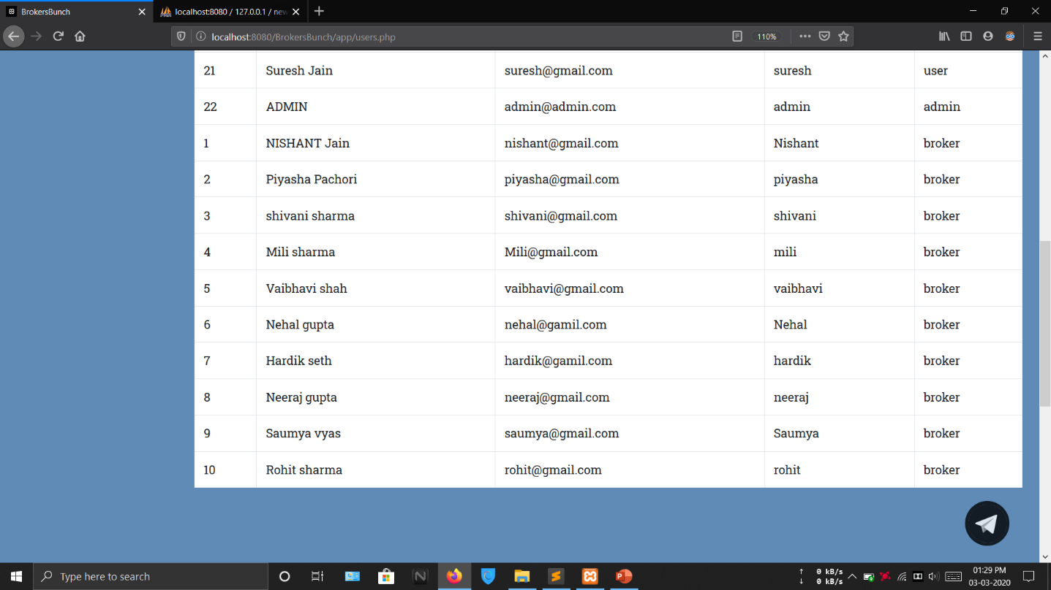

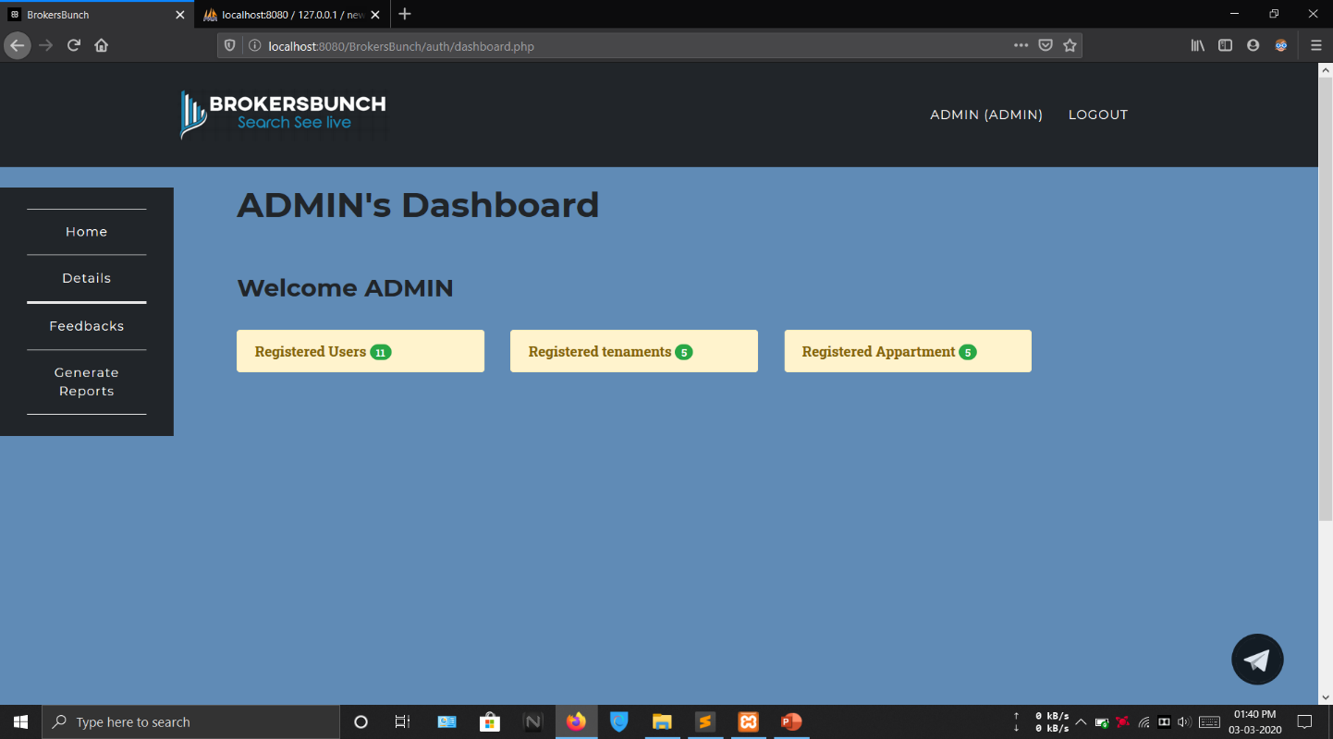**REGISTERED TENAMENTS**

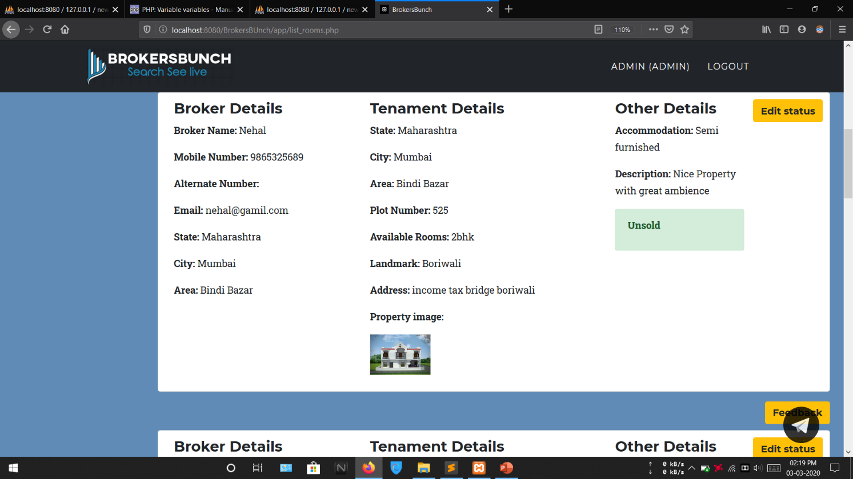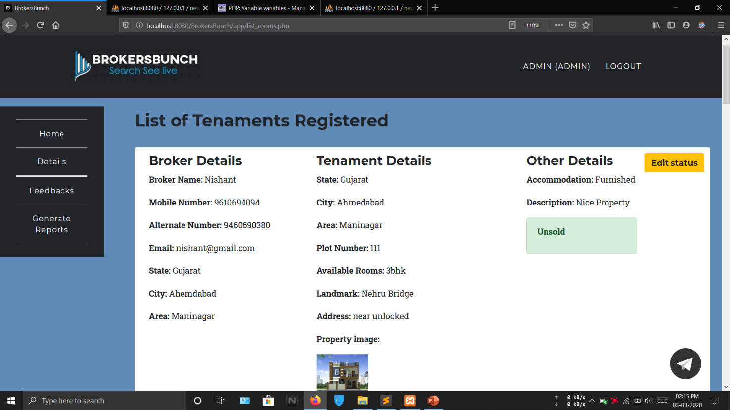

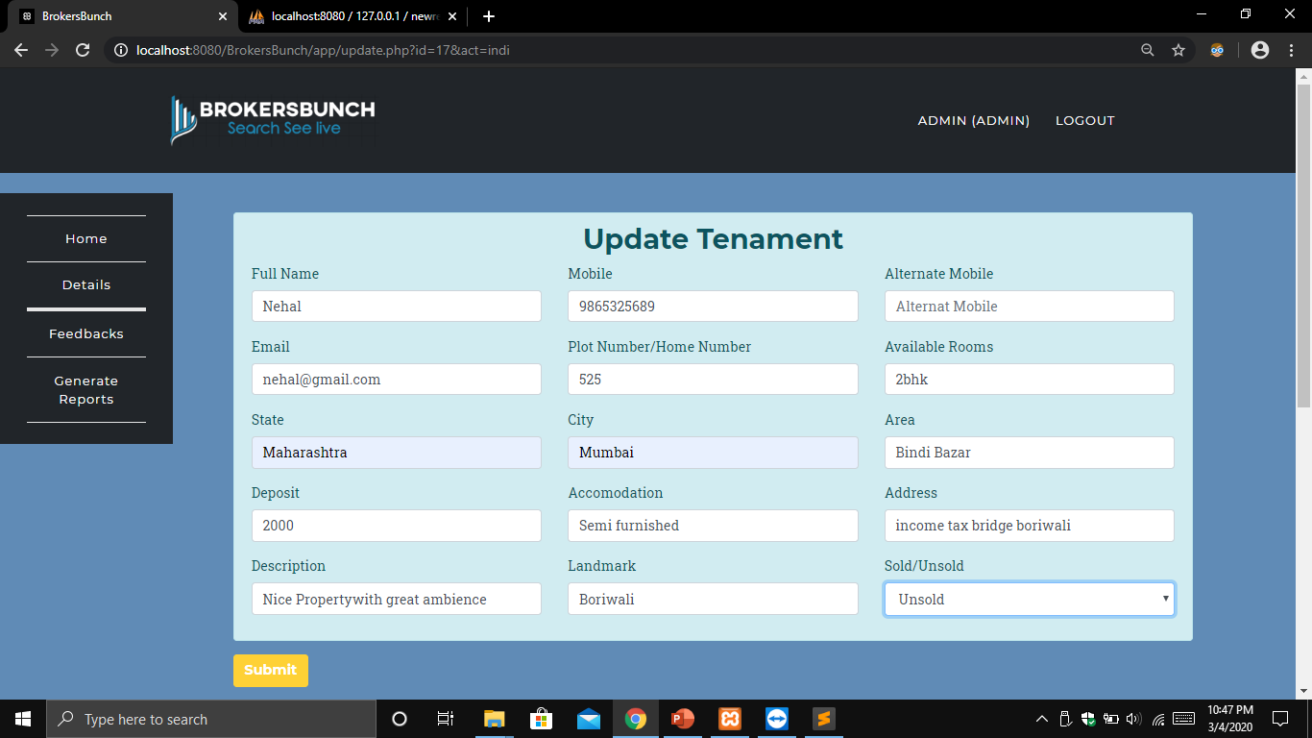 Sold/Unsold: In this field combobox is used where admin can change the status of the tenament whether sold or not and on basis of that list of properties to be shown will be updated.

Submit button: On clicking this button status of tenament will be stored to the database.

All the controls are by default disabled i.e Admin can only change the value of Sold/Unsold Combobox.

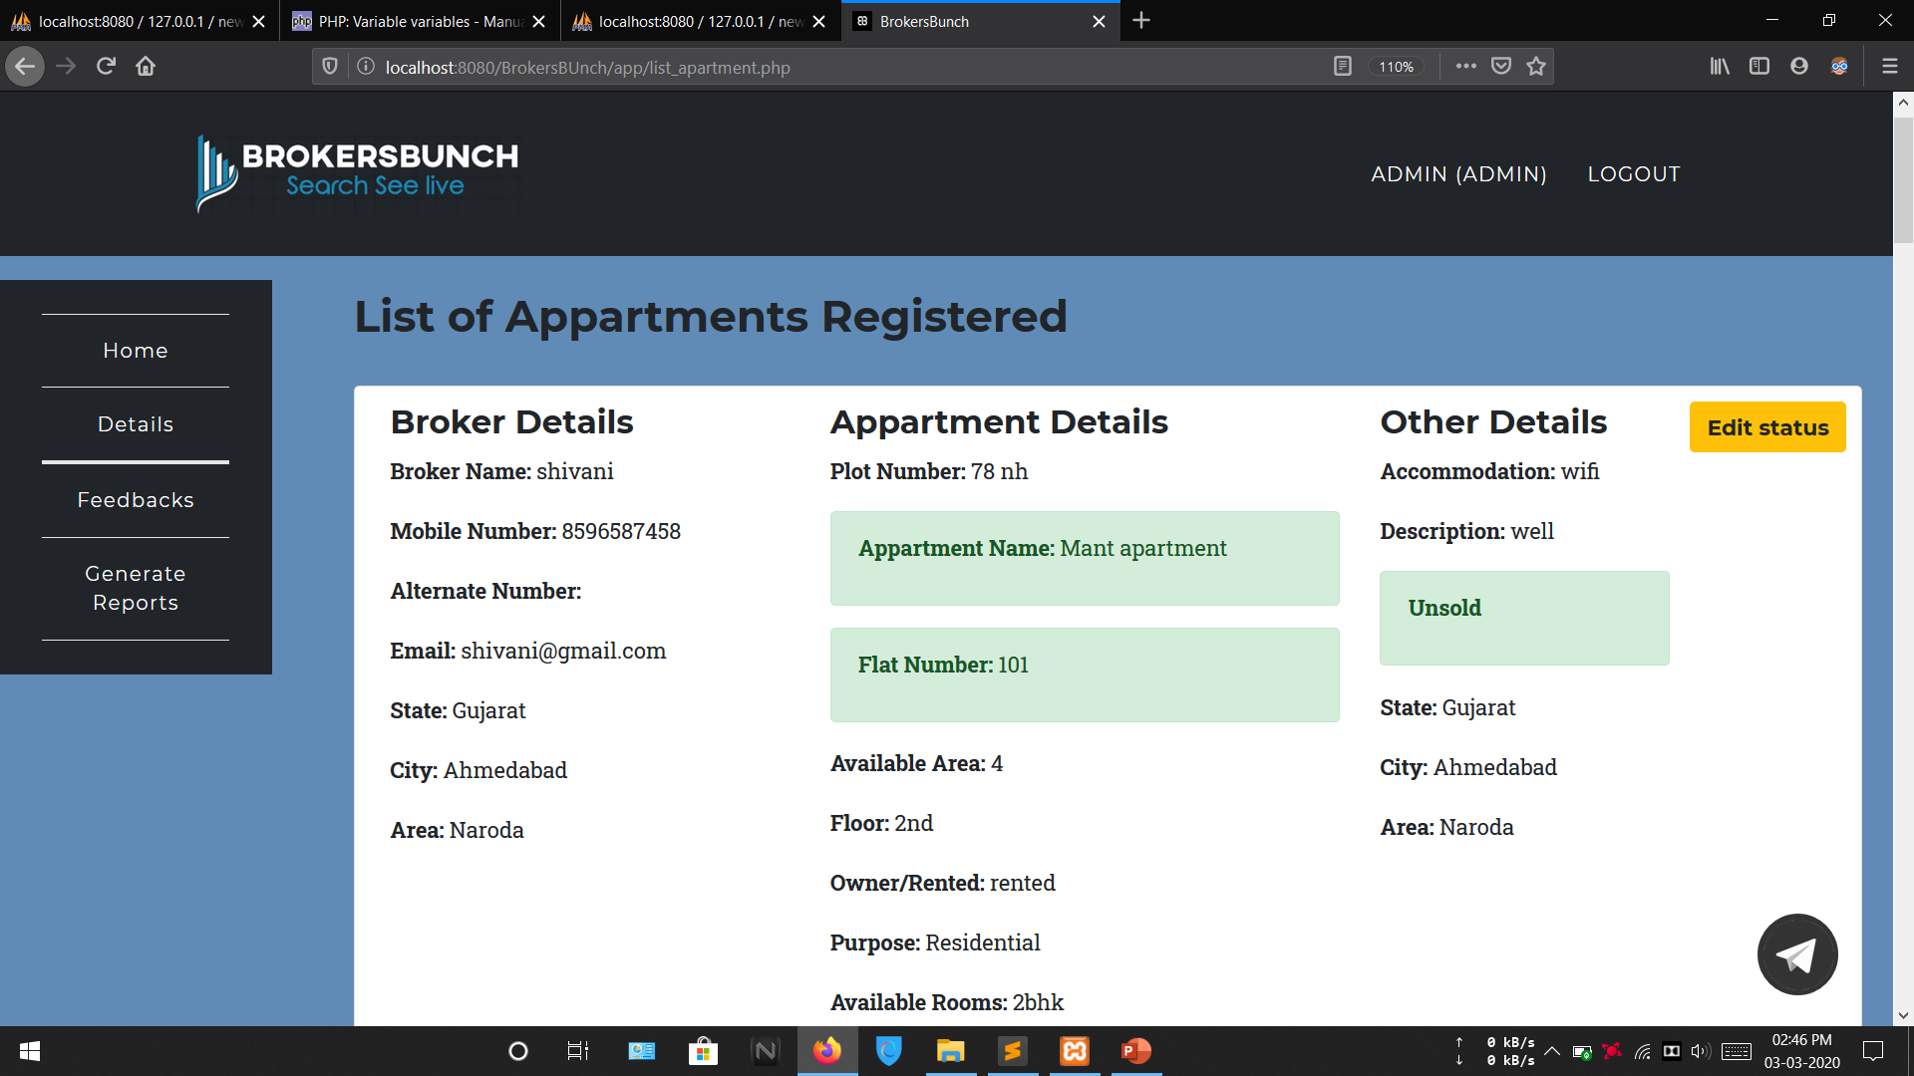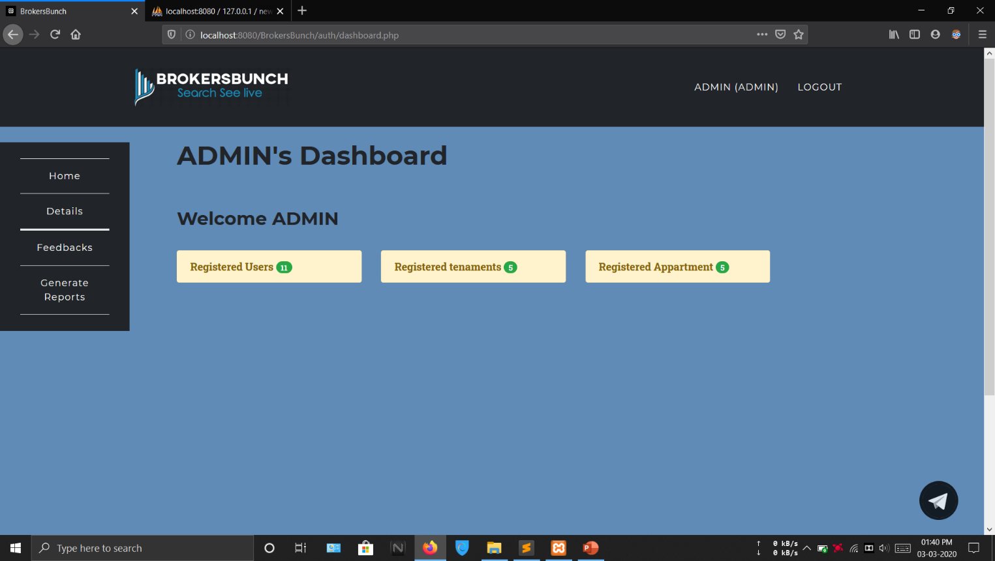**REGISTERED APPARTMENT**

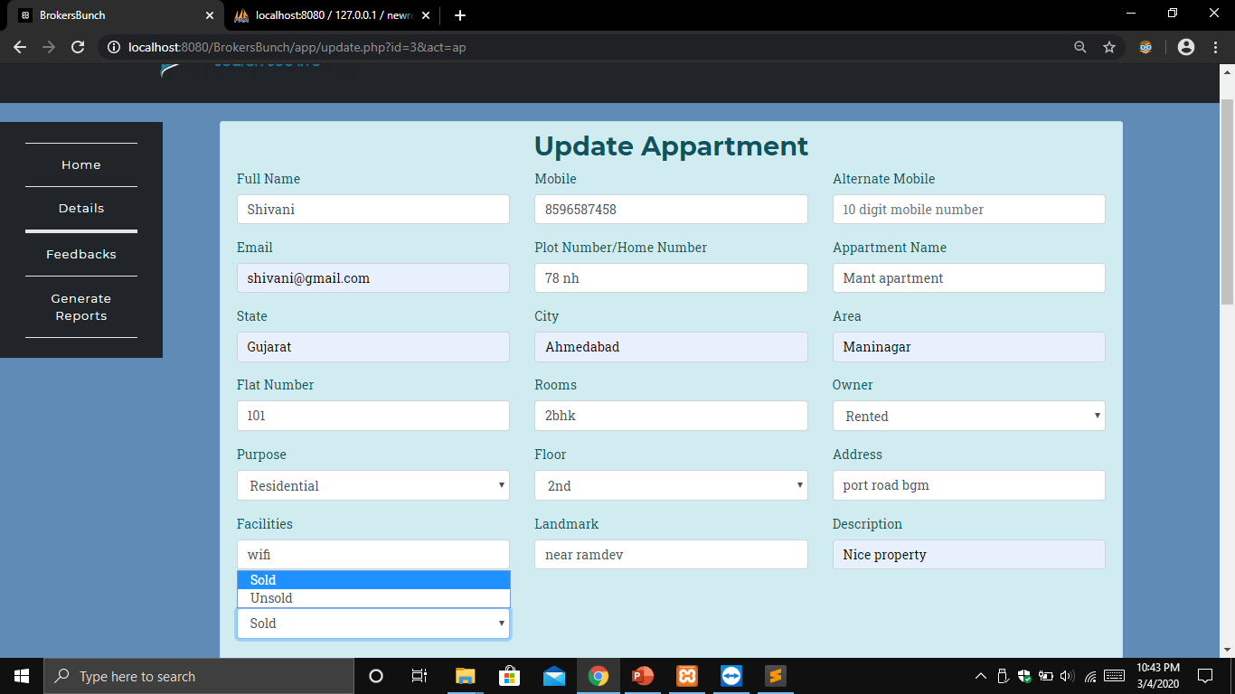Sold/Unsold: In this field combobox is used where admin can change the status of the appartment whether sold or not and on basis of that list of properties to be shown will be updated.

Submit button: On clicking this button status of apartment will be stored to the database.

All the controls are by default disabled i.e Admin can only change the value of Sold/Unsold Combobox.

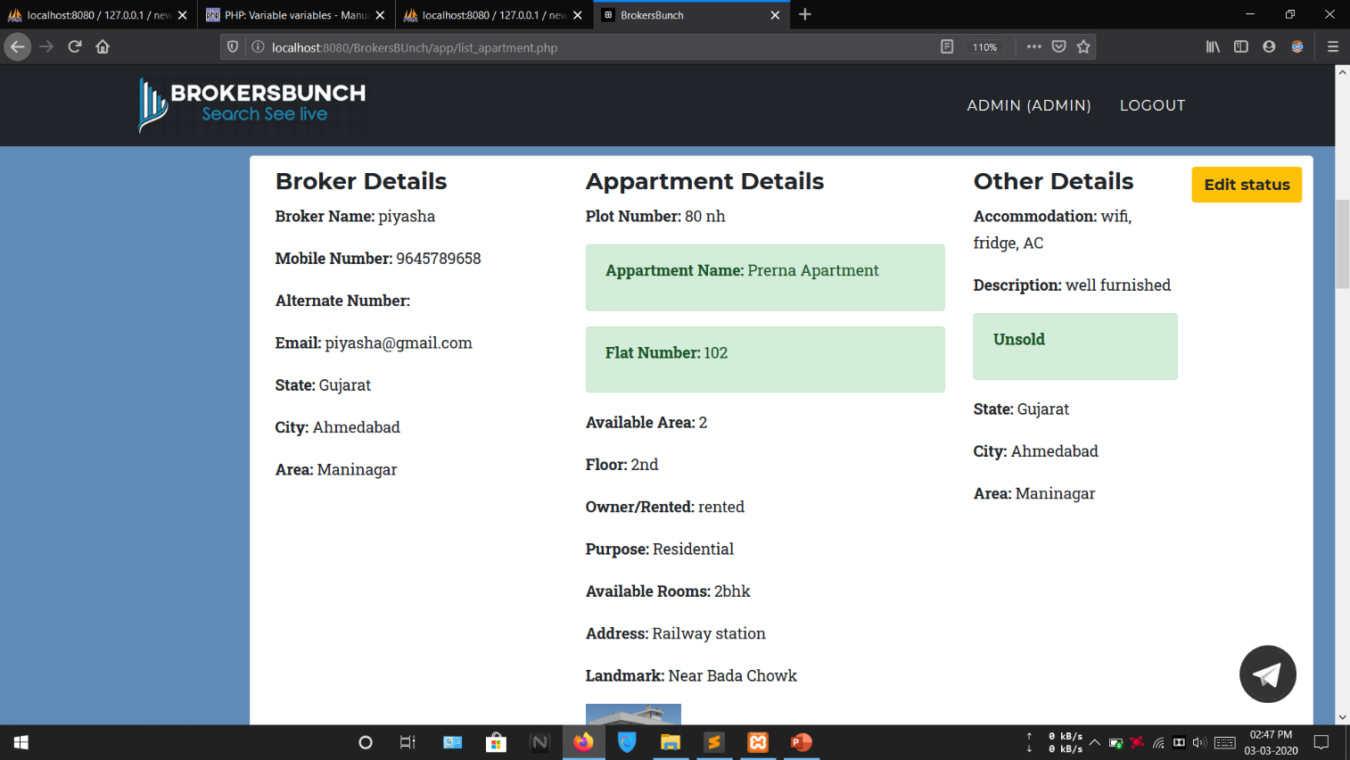

**VIEW ALL PROPERTIES**

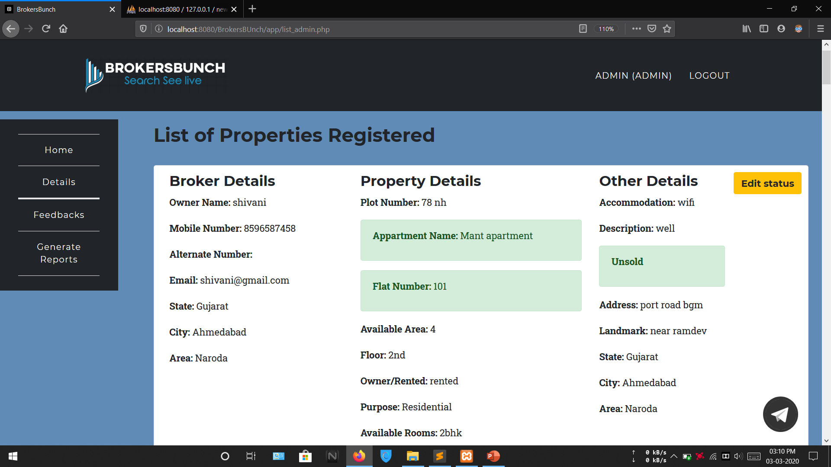

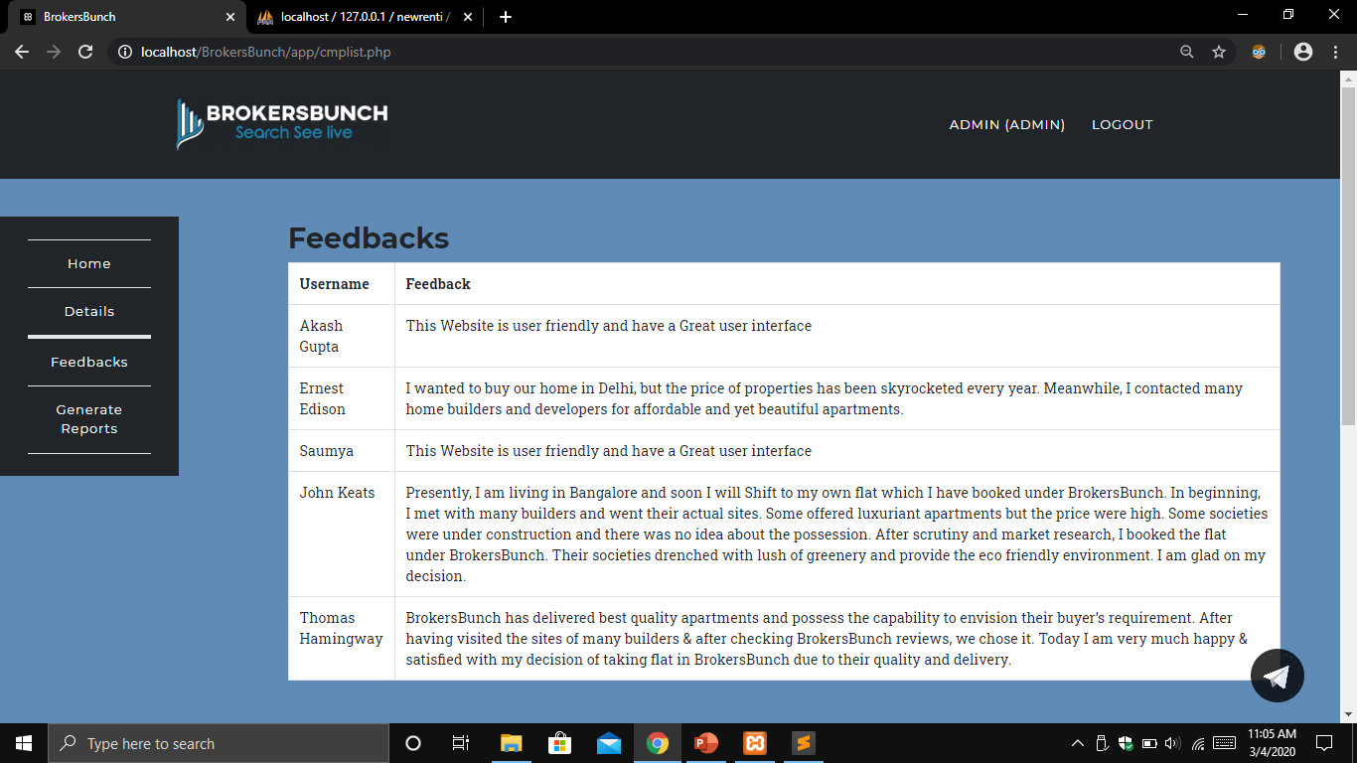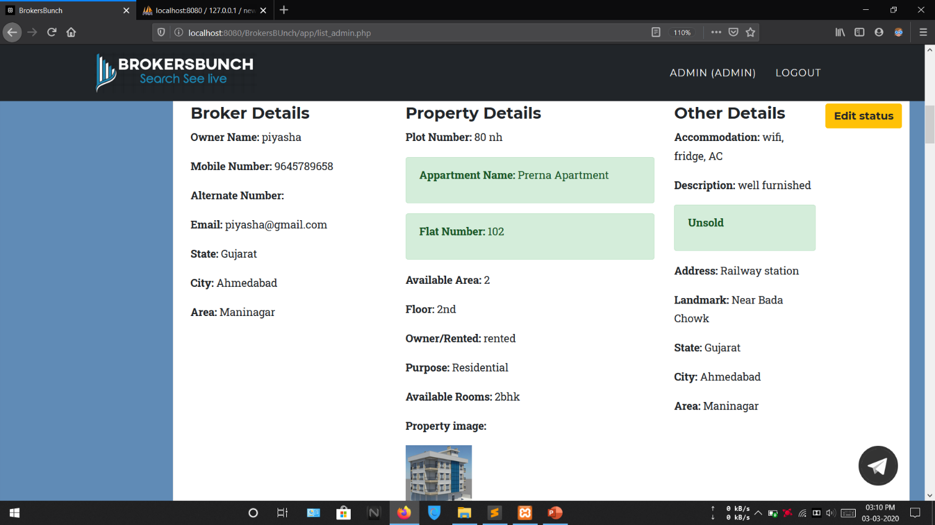

**FEEDBACKS**

**BROKER LAYOUTS**

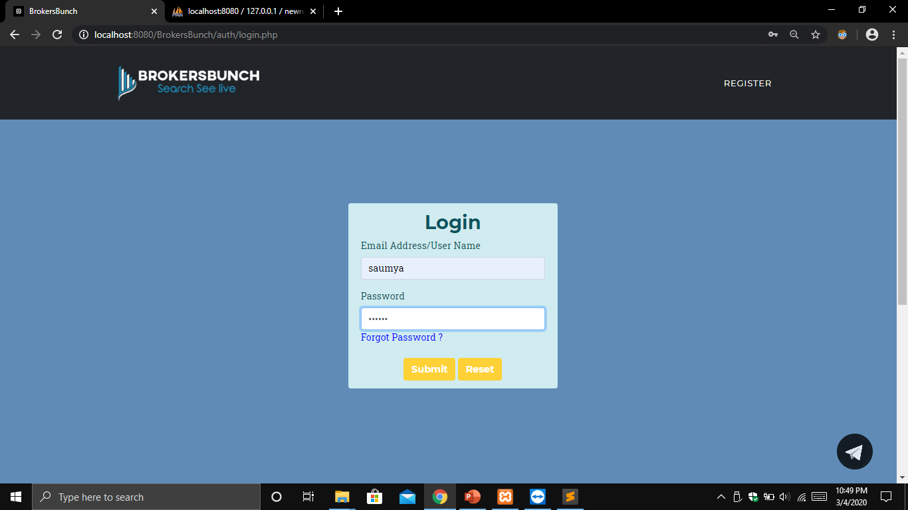**LOGIN**

User Name: Full Name: The user name textbox includes a validation in which user can insert only text and cannot insert a numerical value or any special characters.

Email: email textbox includes email validation in which an email address must contain a @ sign and a . and should be having you proper domain no alphanumeric characters and numeric values are allowed before @ symbol.

Password: password textbox includes a validation in which user can enter both text and number or any special characters.

once clicked the submit button, user name and email will be saved to the database.

The reset button here is used to clear the values in all the fields.

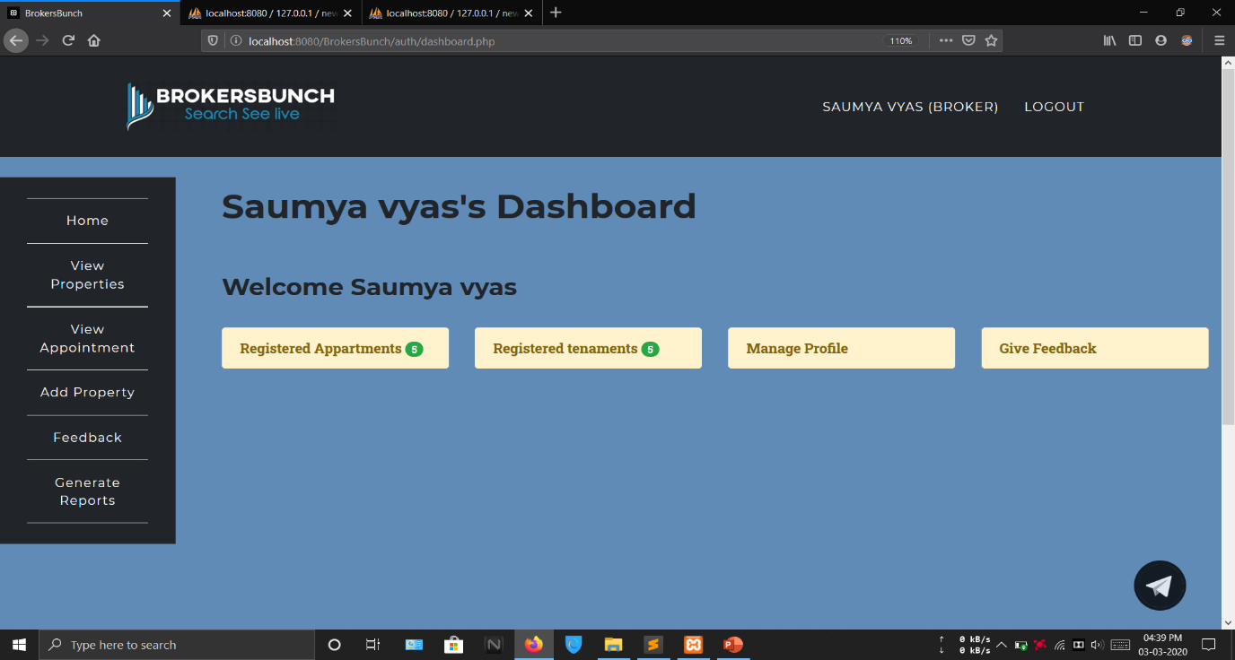**BROKER’S DASHBOARD**

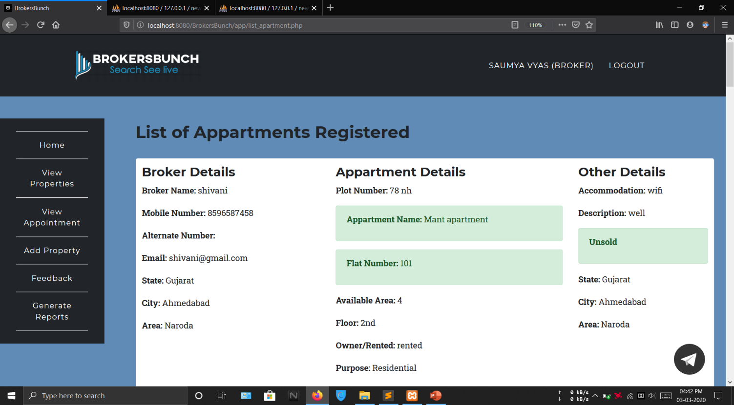**REGISTERED APPARTMENT**

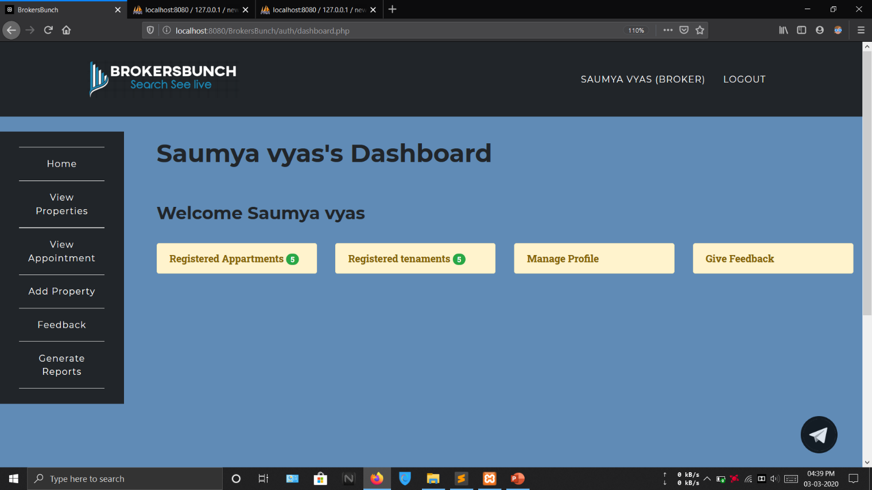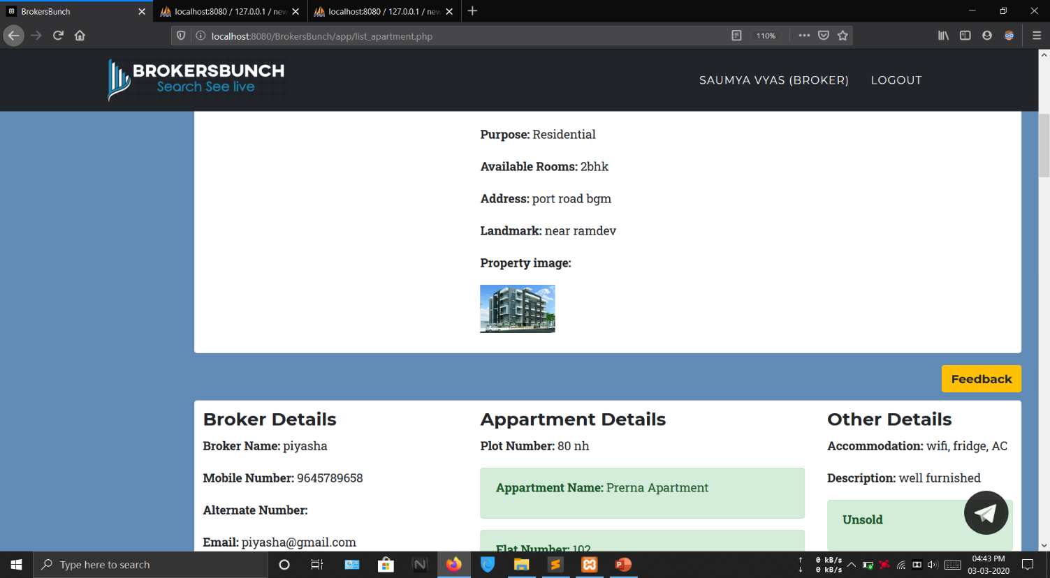

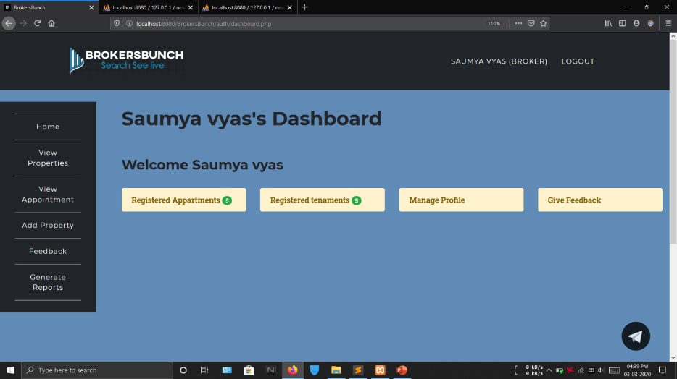**REGISTERED TENAMENT**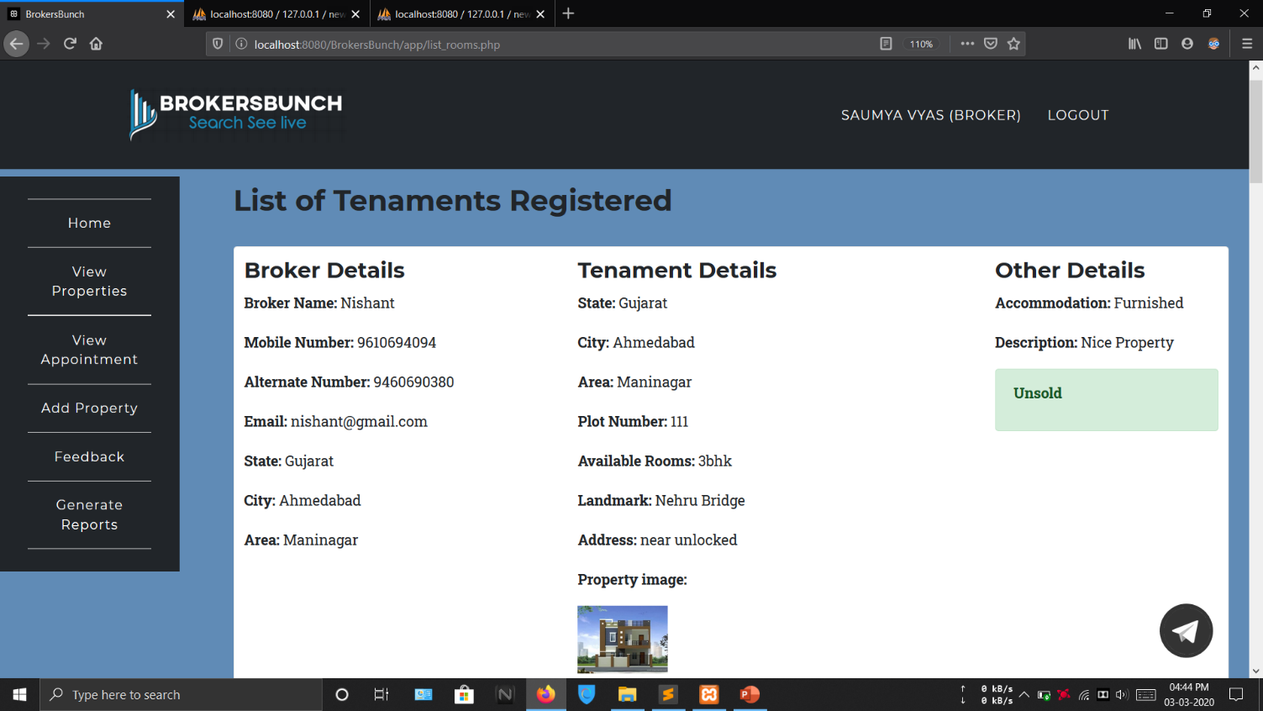

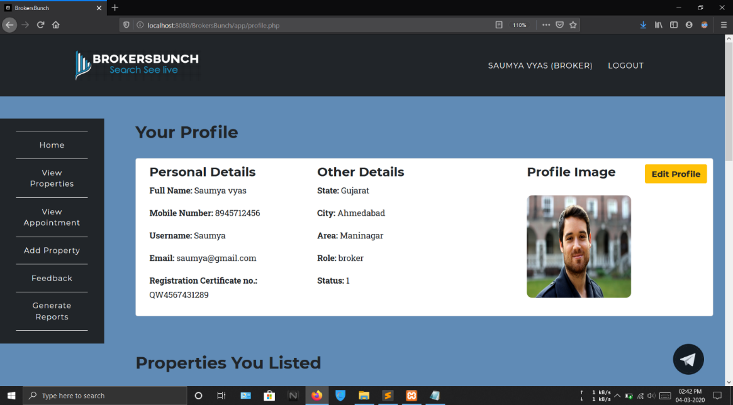**MANAGE PROFILE**

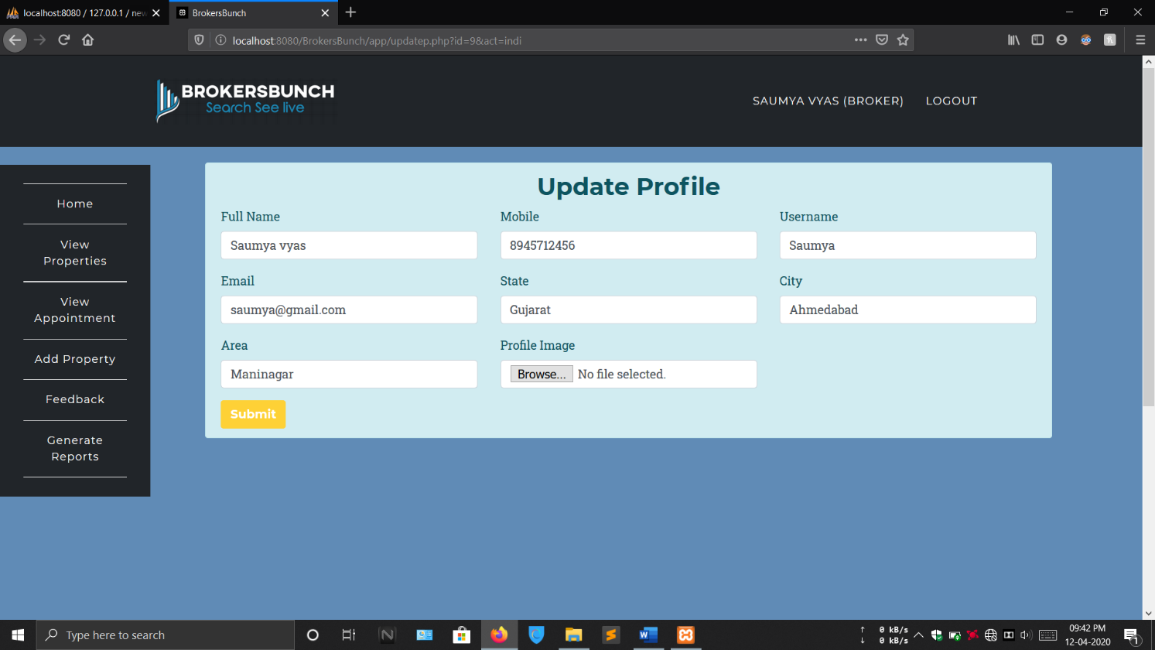

This form allows broker to change his personal details once the changes are made he or she can pressed submit button and get his changes saved. This form includes text boxes for inserting the text and mobile number

Full Name: The full name textbox includes a validation in which user can insert only text and cannot insert a numerical value or any special characters.

Mobile: the mobile number text field includes validation which allows user to enter only numeric values and that must be of 10 digits user cannot insert any alphabetical values special characters in mobile number text field.

User Name: The user name textbox includes a validation in which user can insert only text and cannot insert a numerical value or any special characters.

Email: the email text field includes a validation of accepting a proper email address including @ sign and a . and a proper domain user can insert numeric values in this but before the @ it does not accept any special characters.

State, City, Area: the state city and area textboxes also include validation of accepting only text values and not accepting numeric values or any special characters.

File Upload Control: the file upload control is here use to upload a profile picture if not selected profile picture and click submit it gives validation error.

all the controls are here validated as required as if none of the text box is filled with the correct data and hits submit the form will give a validation error in all those controls and the changes will not be saved.

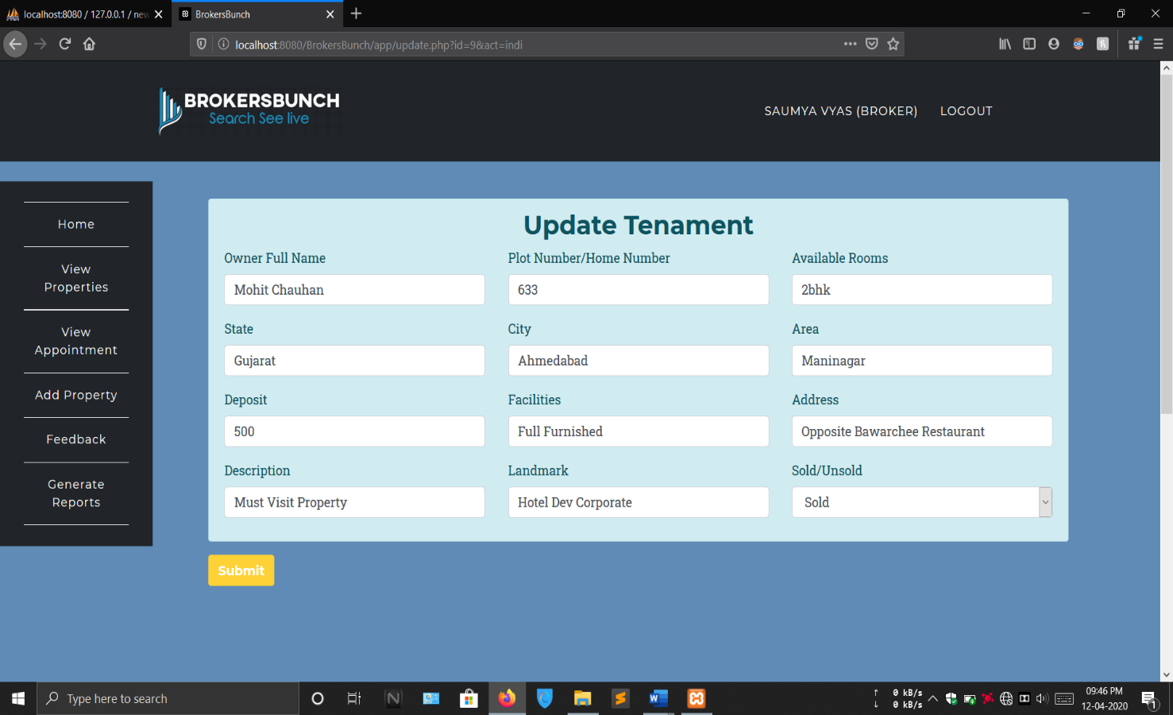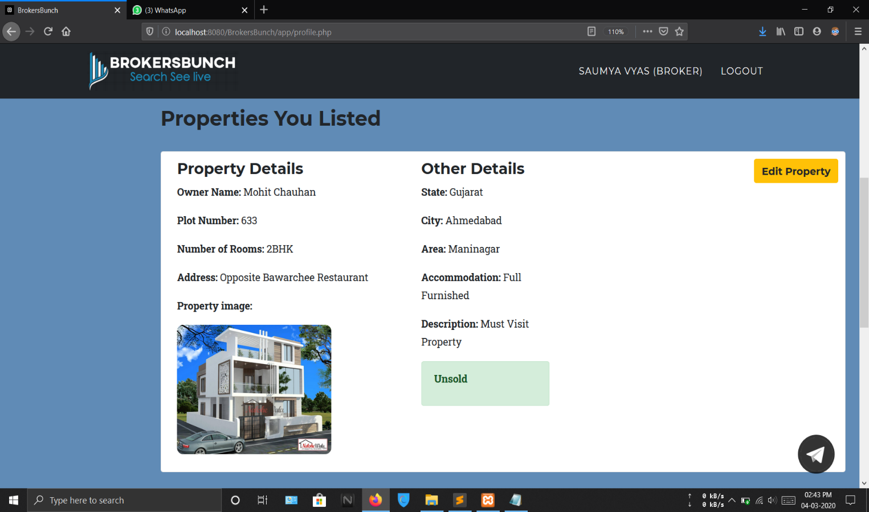

This form allows a broker to edit his or her property uploaded on the website whether it is a tenement or apartment after changing the details he can press submit to save his details.

Full Name: The full name text field includes a text validation where it cannot be inserted.

Plot Number: plot number text field includes number validation in which text cannot be inserted

Available rooms: Available rooms text field in alphanumeric text field in which user can enter digit as well as alphabets both.

State, City, Area: state city in area are having a text validation where is a cannot insert number or any special characters.

Deposit: The deposit text field includes a number validation in visual basic in insert only numeric values no alphabets and alphanumeric or special characters are allowed.

Facilities: facilities address description landmark for the text field with text validation in them so that user cannot insert any special characters or number in those text fields.

Sold/Unsold: The sold and unsold here is a combobox control in which user can select only one value either sold or unsold.

If all the controls are left blank then after clicking the submit button the form will give error message on every control as each control is having a required validation in them so all the controls are compulsorily be filled with some value. After submitting the form with a particular correct information the changes will be updated in the database and will be refreshed on the my profile page.

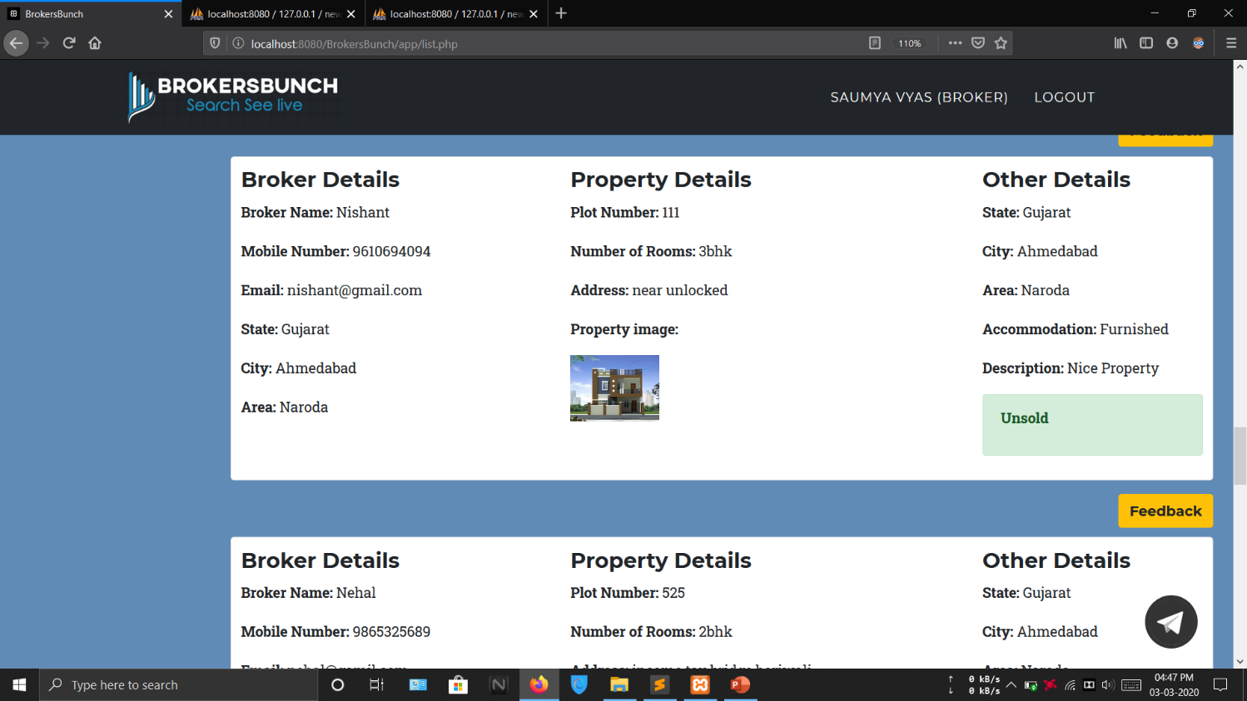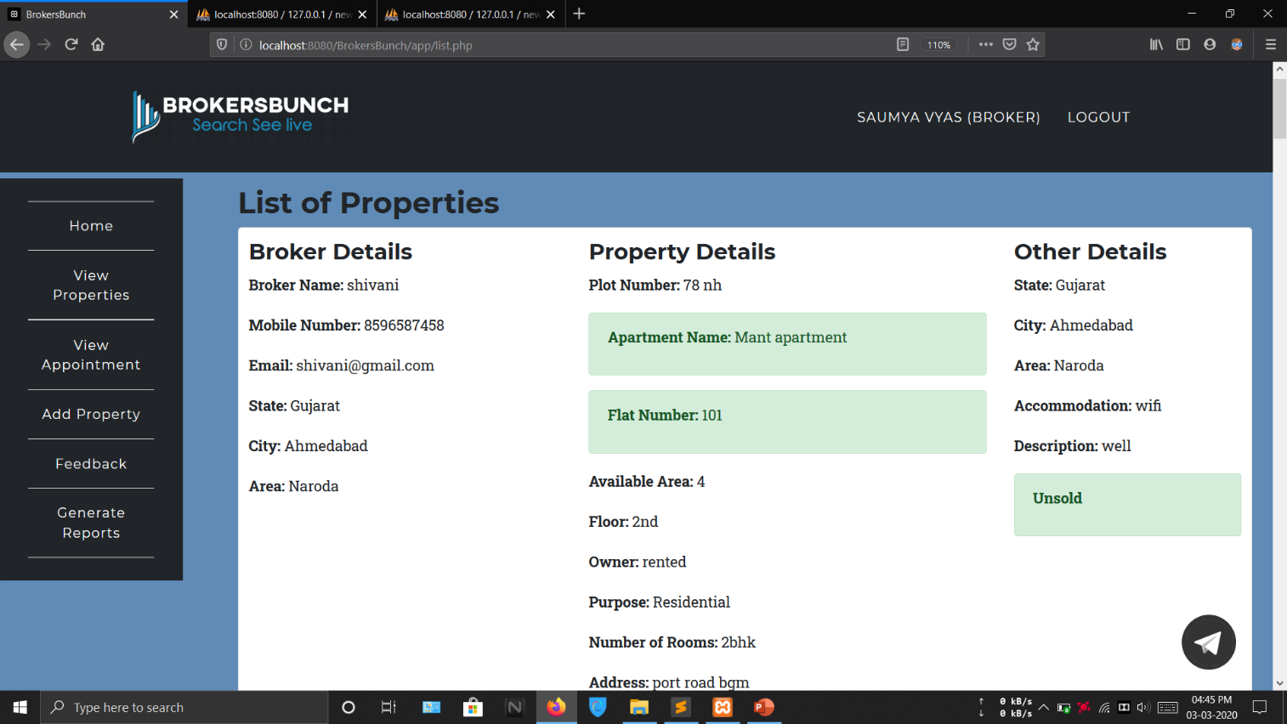  **VIEW ALL PROPERTIES**

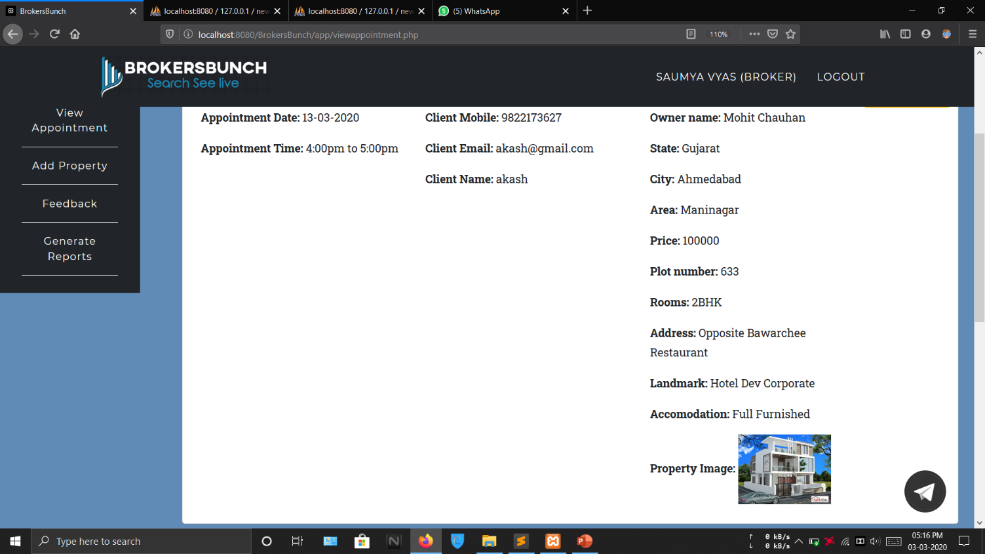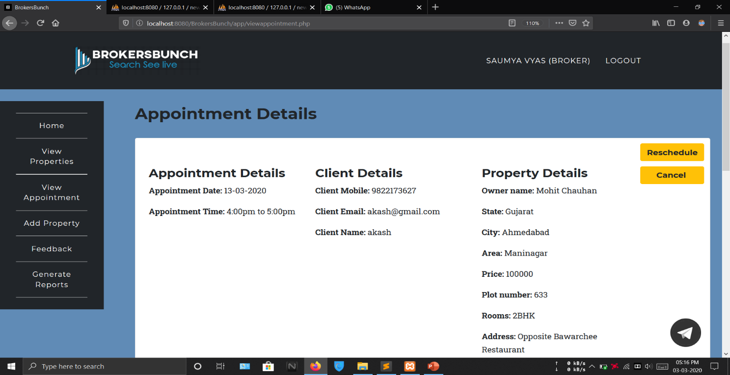**VIEW APPOINTMENT**

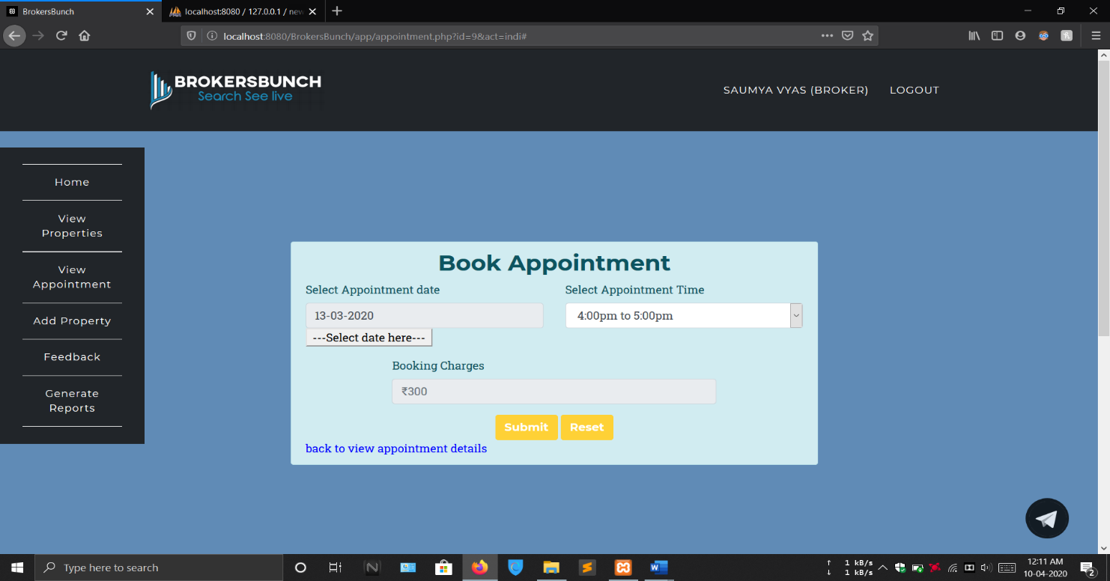****

this form allows Broker to reschedule appointment fixed by the client he/she can change the date and time of the appointment

Appointment Date: slide appointment date includes a textbox in which only did it can be inserted from the below given button as the textbox is disabled so user cannot enter a direct value.

Appointment Time: select appointment and includes a problem list which includes different time slots off 1 hour you can only select one time slot from the list.

Booking Charges: The broker will not be giving any booking charges marriage scheduled appointment only the client has to pay the booking charges to book an appointment.

once clicked the submit button, new date and times will be saved to the database and the same will be informed to the client and broker.

As in this form every control includes required validation so none of them can be left blank before clicking submit.

The reset button here is used to clear the values in all the fields.

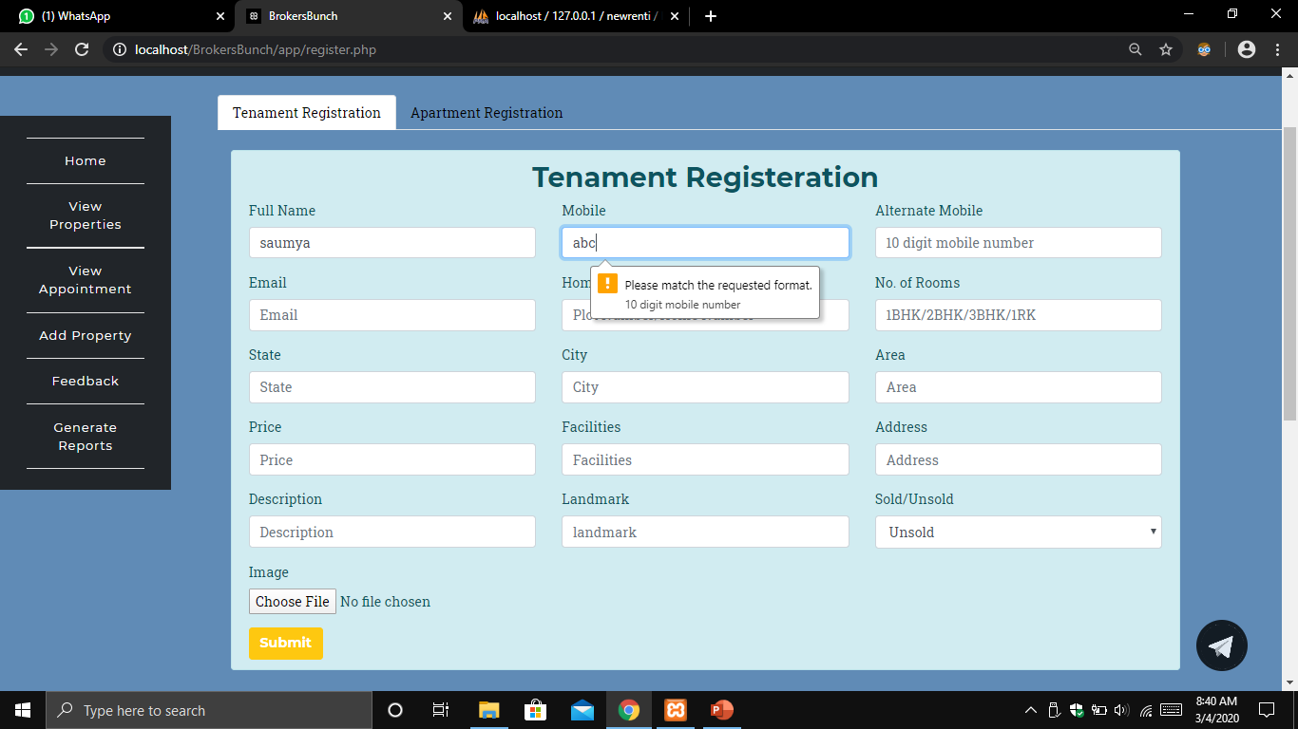This form allows broker to list Tenament on the website.

This com basically includes text box drop down list and fileupload control.

Full Name: The full name text box includes your text validation in which user can only enter text values and will not be able to enter any numeric values or any special characters into that.

Mobile Number: mobile number text field includes number validation which accepts only numeric values of 10 digits not more than this user also cannot insert any alphabetical values alphanumeric values and any special character also space is not allowed.

Alternate Mobile Number: The alternate mobile number is an optional text field which can be left blank.

Email: email textbox inclusion email validation in which an email address must contain a @ sign and a . and should be having you proper domain no alphanumeric characters and numeric values are allowed before @ symbol

Home number: home number and a number of rooms textboxes can accept alphanumeric values not any special characters

State ,City, Area: state city area are having text validation in which no America values for alphanumeric values or any special characters can be inserted.

Price: The price textbox has a number validation which accepts only numeric values

Facilities: facilities address and description landmark are the text box which are having a text validation so that user cannot insert any numeric values for special characters.

Sold/Unsold: sold unsold is combobox control in which user can select only one value either sold or unsold.

Image upload: image as having a image upload control using which a user can upload the image of the property

All the controls are having a required validation so that no control is left blank which are compulsorily to be filled. If left blank and clicked submit the form will display errors in every control.

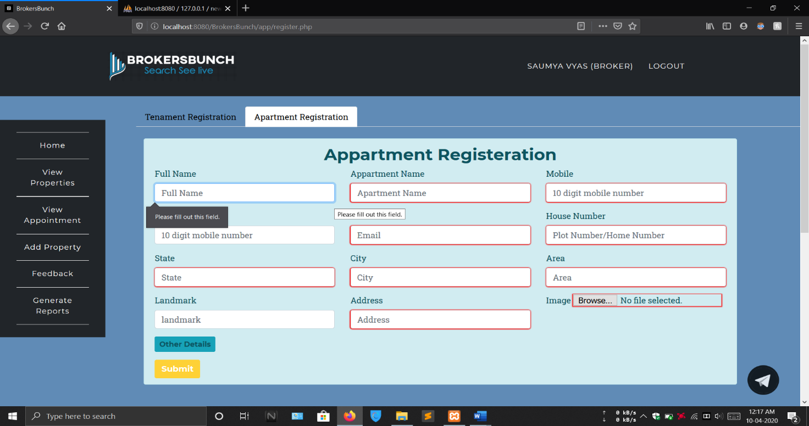Full Name: The full name text box includes your text validation in which user can only enter text values and will not be able to enter any numeric values or any special characters into that.

Apartment Name: The Apartment name text box includes your text validation in which user can only enter text values and will not be able to enter any numeric values or any special characters into that.

Mobile Number: mobile number text field includes number validation which accepts only numeric values of 10 digits not more than this user also cannot insert any alphabetical values alphanumeric values and any special character also space is not allowed.

Alternate Mobile Number: The alternate mobile number is an optional text field which can be left blank.

Email: email textbox inclusion email validation in which an email address must contain a @ sign and a . and should be having you proper domain no alphanumeric characters and numeric values are allowed before @ symbol.

House number: home number and a number of rooms textboxes can accept alphanumeric values not any special characters.

State, City, Area: state city area are having text validation in which no America values for alphanumeric values or any special characters can be inserted.

Image upload: image as having a image upload control using which a user can upload the image of the property

All the controls are having a required validation so that no control is left blank which are compulsorily to be filled. If left blank and click submit the form will displayed error in every control.

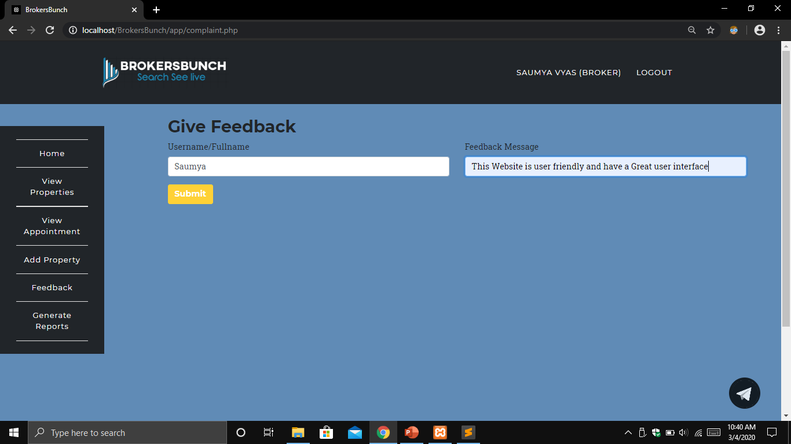 **GIVE FEEDBACK**

Full Name: The full name text box includes your text validation in which user can only enter text values and will not be able to enter any numeric values or any special characters into that.

Feedback Message: The Feedback message text box user can give the feedback by entering text values.

**CLIENT LAYOUTS**

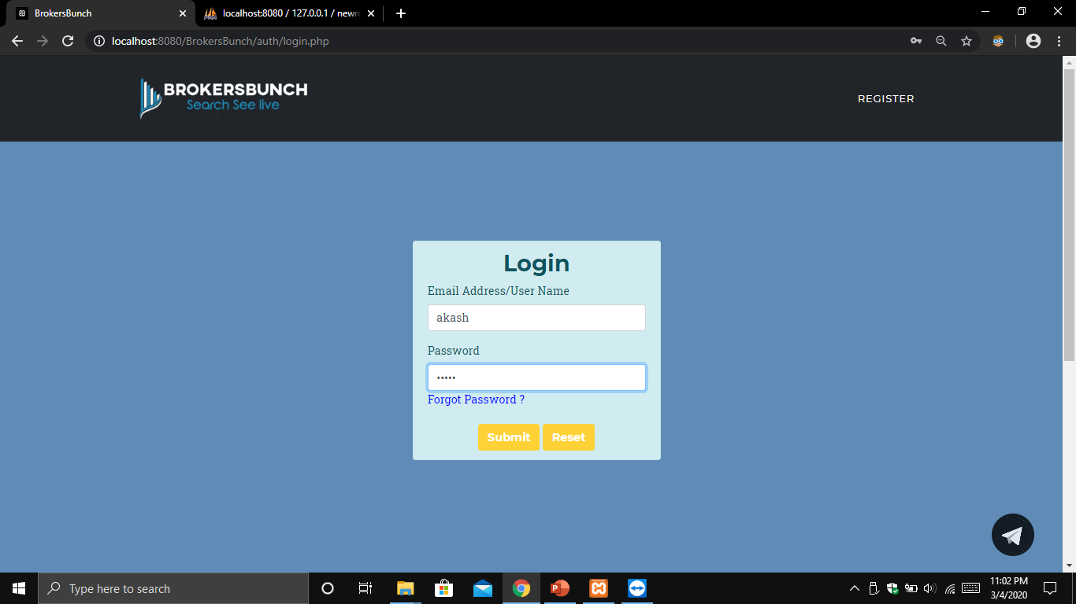**LOGIN**

User Name: The user name textbox includes a validation in which user can insert only text and cannot insert a numerical value or any special characters.

Email: email textbox includes email validation in which an email address must contain a @ sign and a . and should be having you proper domain no alphanumeric characters and numeric values are allowed before @ symbol.

Password: password textbox includes a validation in which user can enter both text and number or any special characters.

once clicked the submit button, user name and email will be saved to the database.

The reset button here is used to clear the values in all the fields.

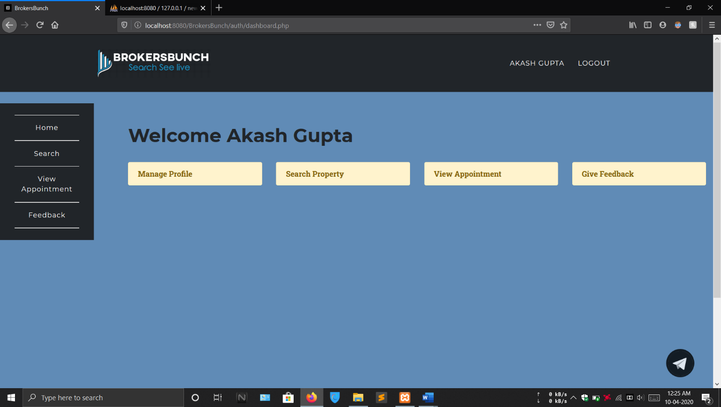 **CLIENT’S DASHBOARD**

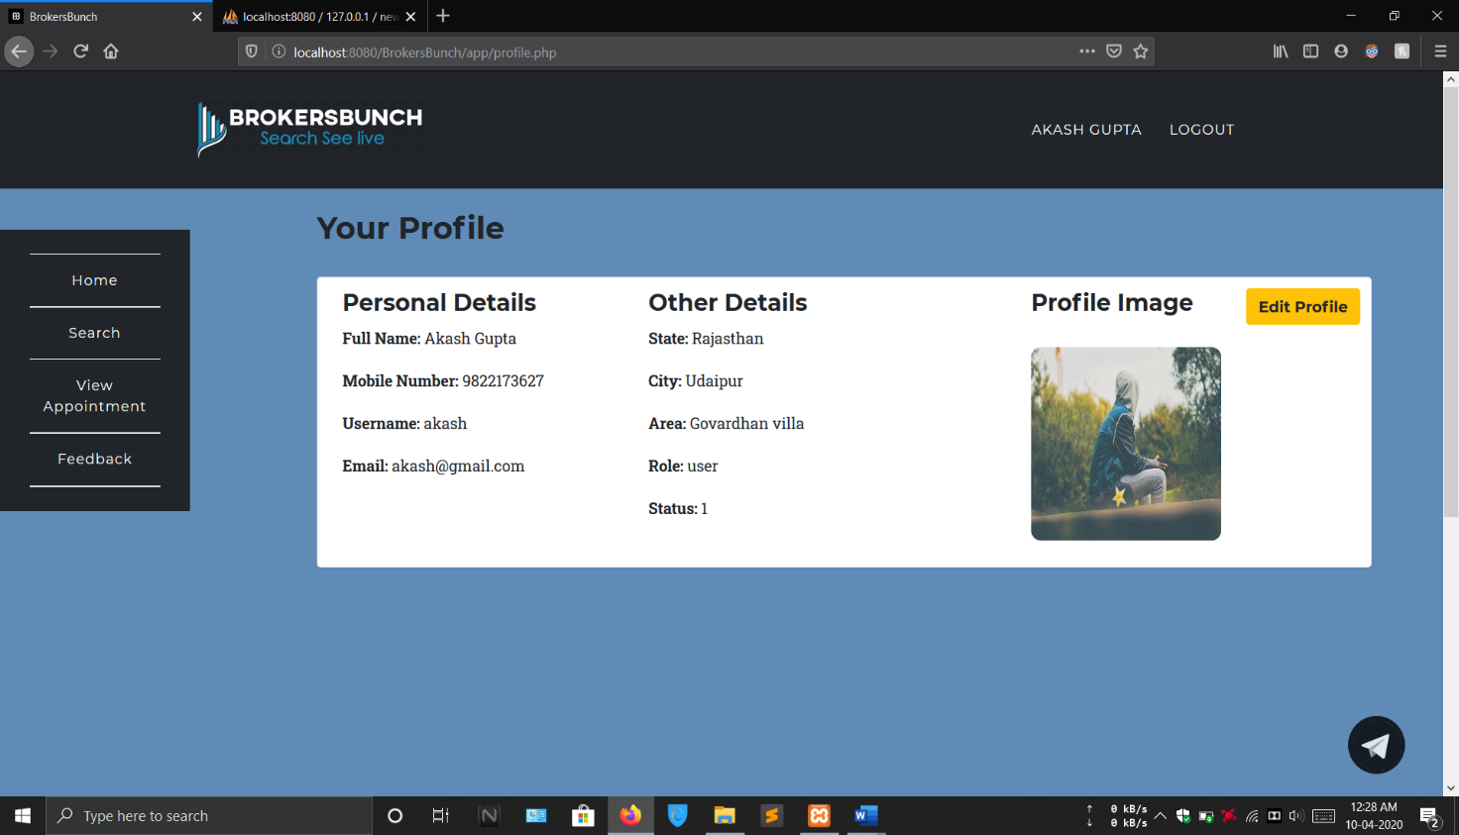 **MANAGE PROFILE**

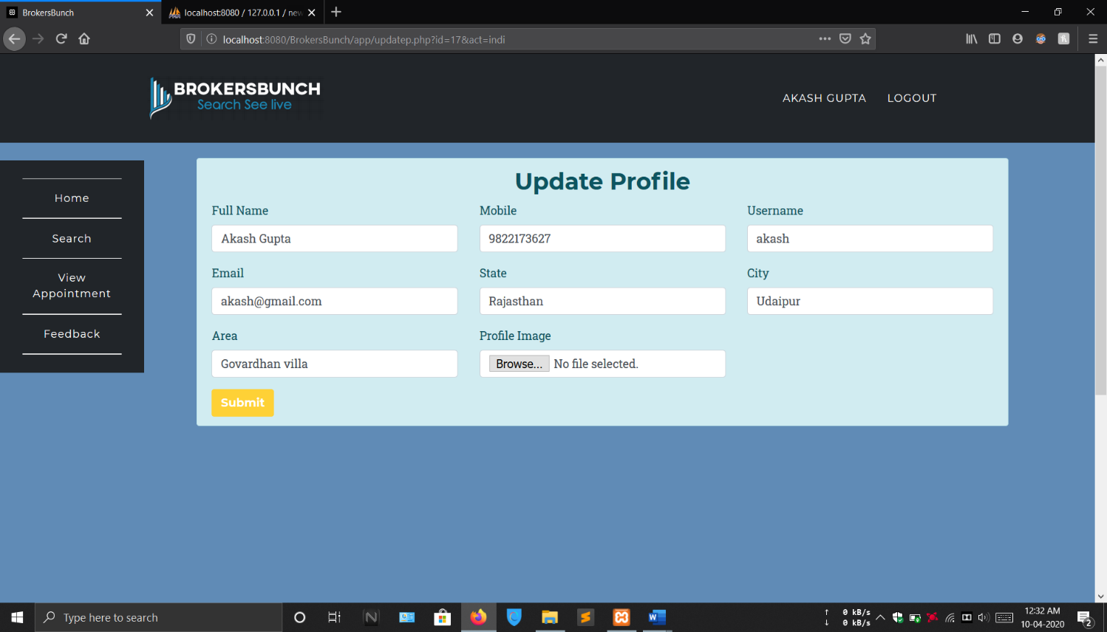

This form allows broker to change his personal details once the changes are made he or she can pressed submit button and get his changes saved. This form includes text boxes for inserting the text and mobile number

Full Name: The full name textbox includes a validation in which user can insert only text and cannot insert a numerical value or any special characters.

Mobile: the mobile number text field includes validation which allows user to enter only numeric values and that must be of 10 digits user cannot insert any alphabetical values special characters in mobile number text field.

User Name: The user name textbox includes a validation in which user can insert only text and cannot insert a numerical value or any special characters.

Email: the email text field includes a validation of accepting a proper email address including @ sign and a . and a proper domain user can insert numeric values in this but before the @ it does not accept any special characters.

State, City, Area: the state city and area textboxes also include validation of accepting only text values and not accepting numeric values or any special characters.

File Upload Control: the file upload control is here use to upload a profile picture if not selected profile picture and click submit it gives validation error.

all the controls are here validated as required as if none of the text box is filled with the correct data and hits submit the form will give a validation error in all those controls and the changes will not be saved.

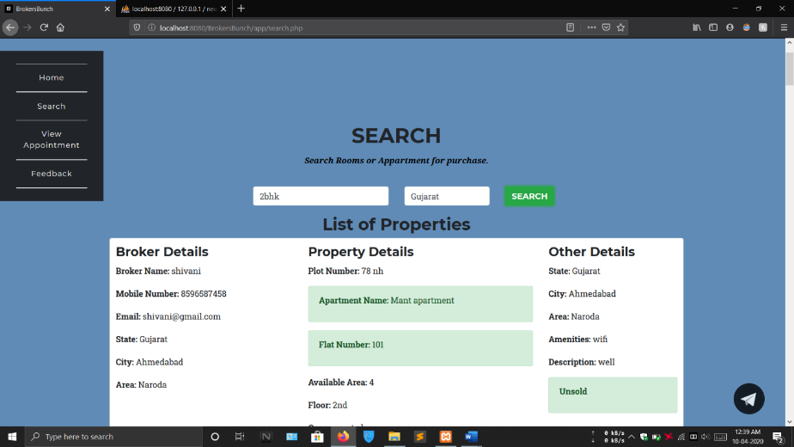 **SEARCH PROPERTY**

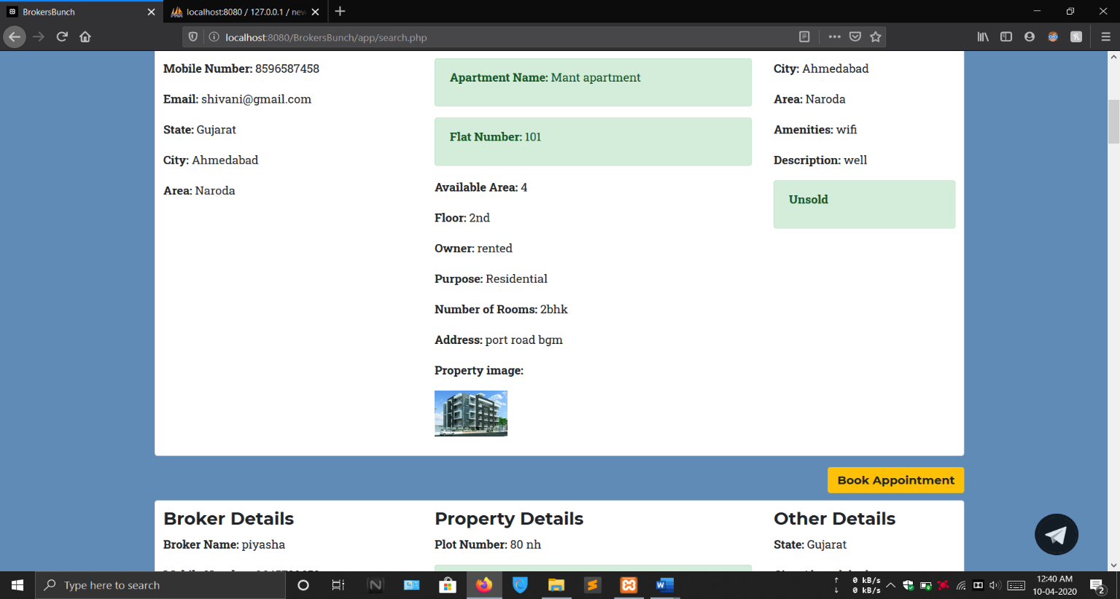

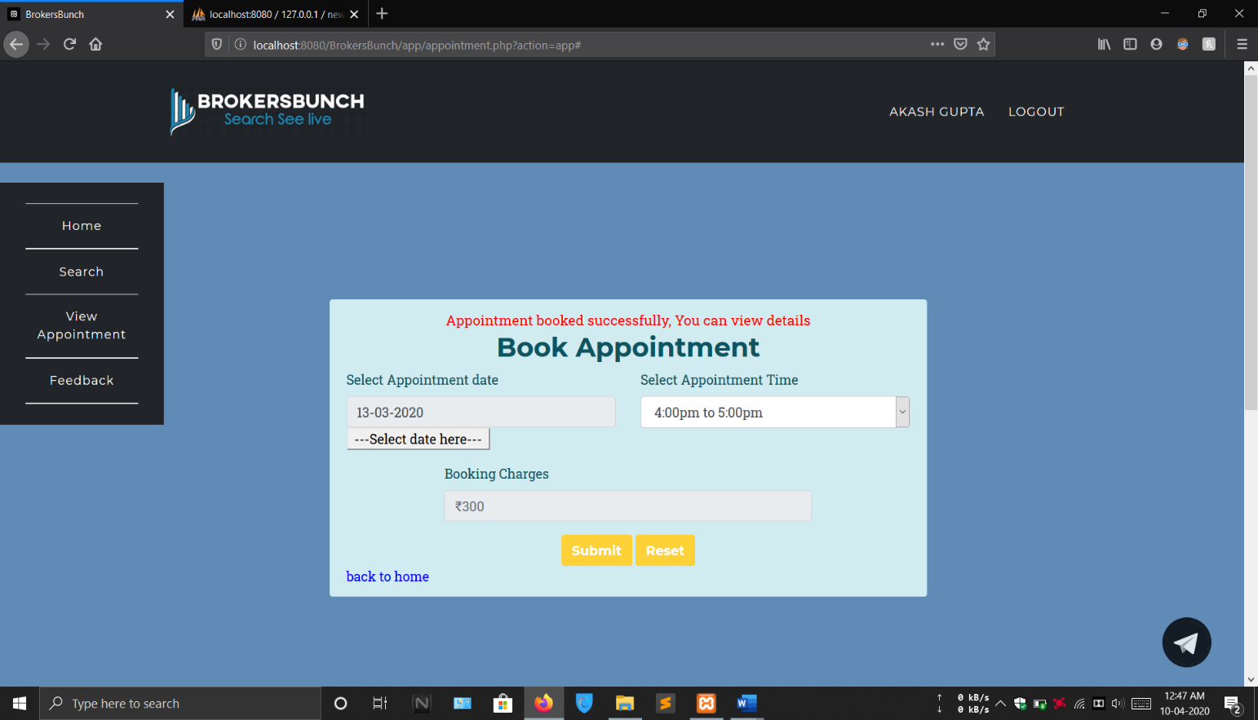**BOOK APPOINTMENT**

This form allows client to book appointment with the broker for the property.

Appointment Date: slide appointment date includes a textbox in which only did it can be inserted from the below given button as the textbox is disabled so user cannot enter a direct value.

Appointment Time: select appointment and includes a problem list which includes different time slots off 1 hour you can only select one time slot from the dropdown list.

Booking Charges: The broker will not be giving any booking charges marriage scheduled appointment only the client has to pay the booking charges to book an appointment.

once clicked the submit button, new date and times will be saved to the database and the same will be informed to the client and broker.

As in this form every control includes required validation so none of them can be left blank before clicking submit.

The reset button here is used to clear the values in all the fields.

**VIEW APPOINTMENT DETAILS**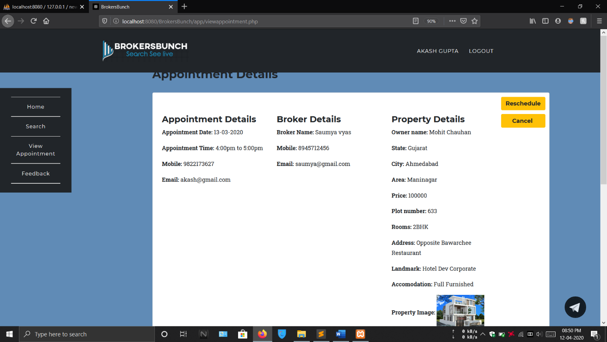

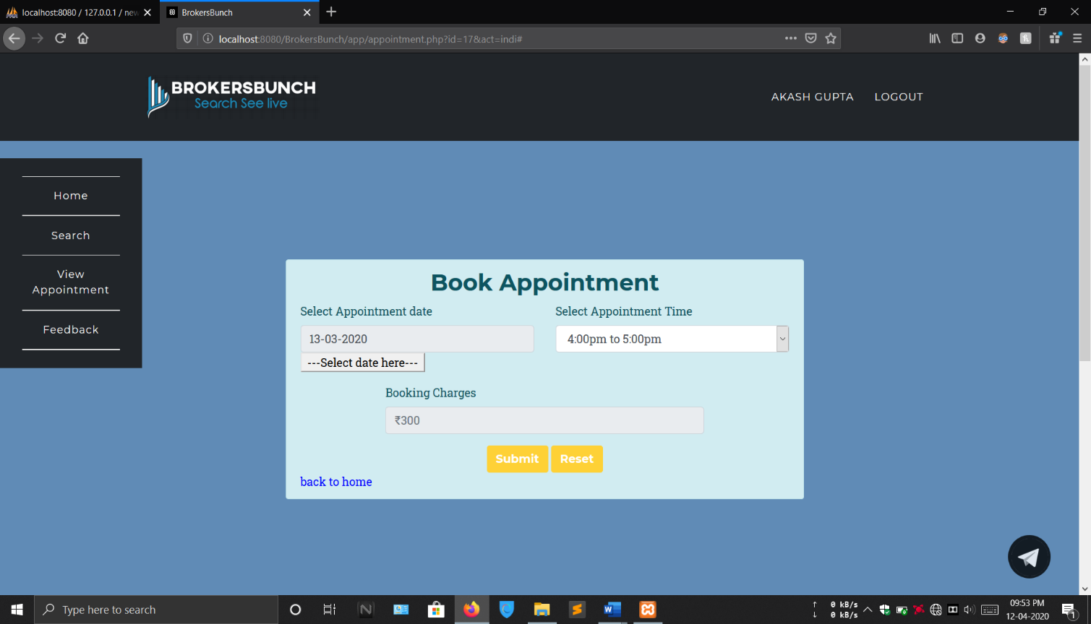

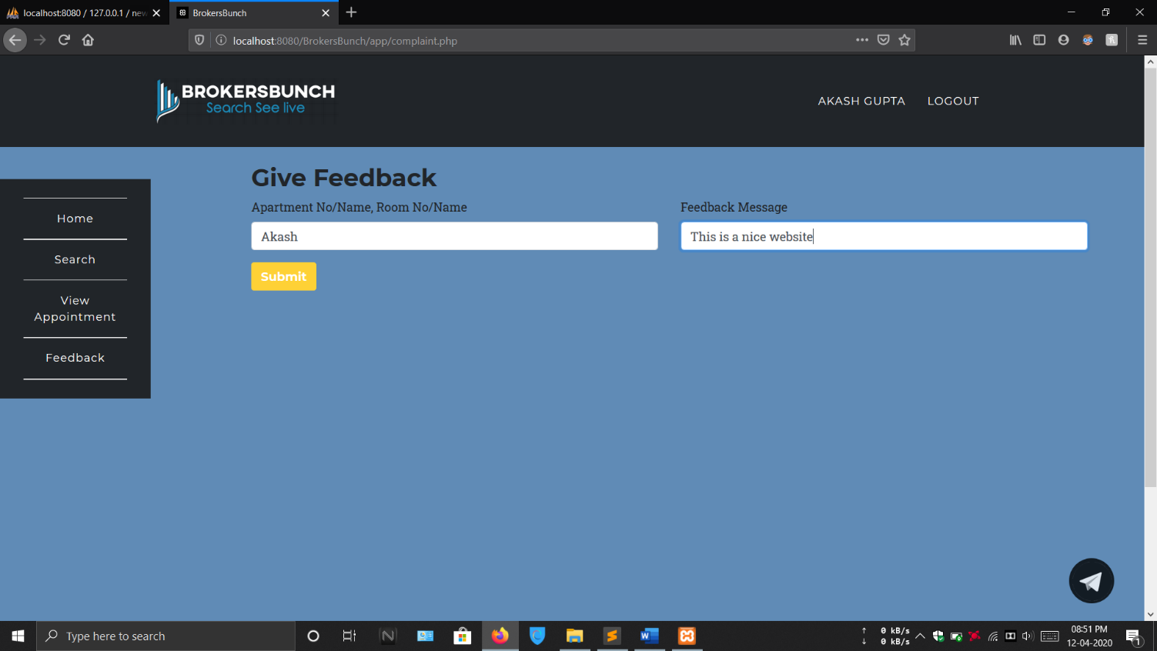**GIVE FEEDBACK**

Full Name: The full name text box includes your text validation in which user can only enter text values and will not be able to enter any numeric values or any special characters into that.

Feedback Message: The Feedback message text box user can give the feedback by entering text values.

**Reports Layouts**

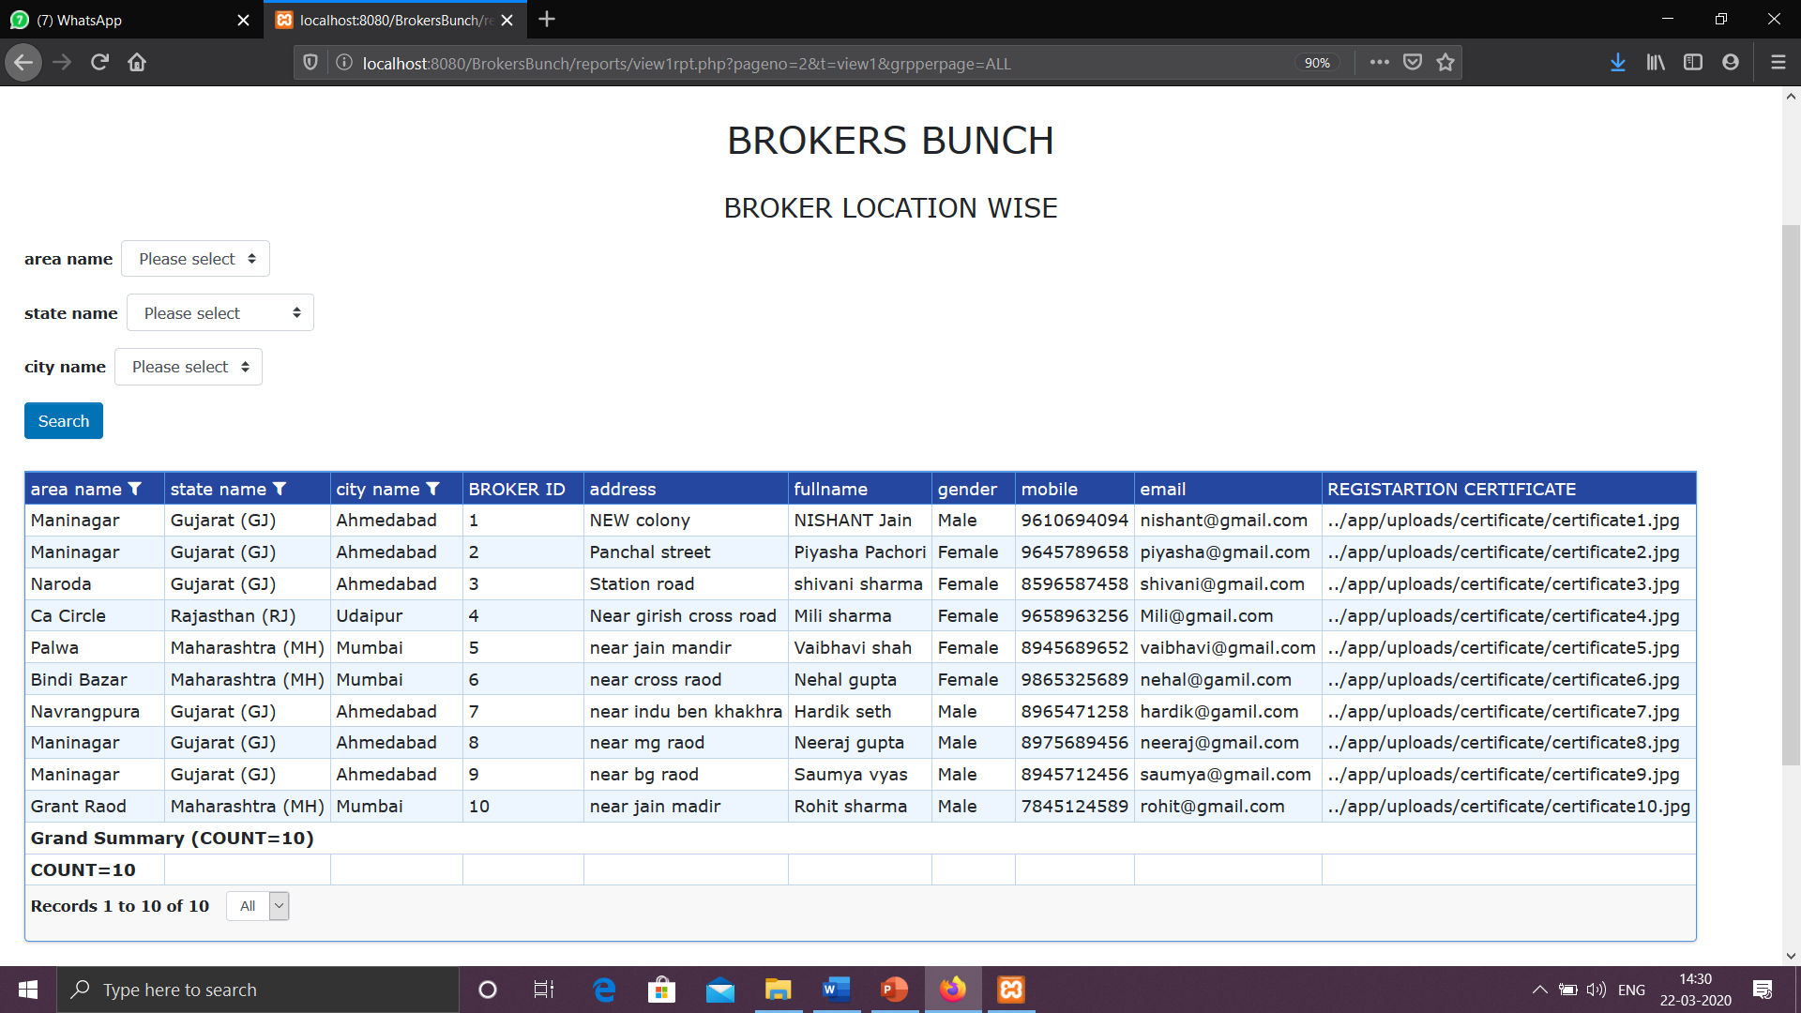**BROKER LOCATION WISE**

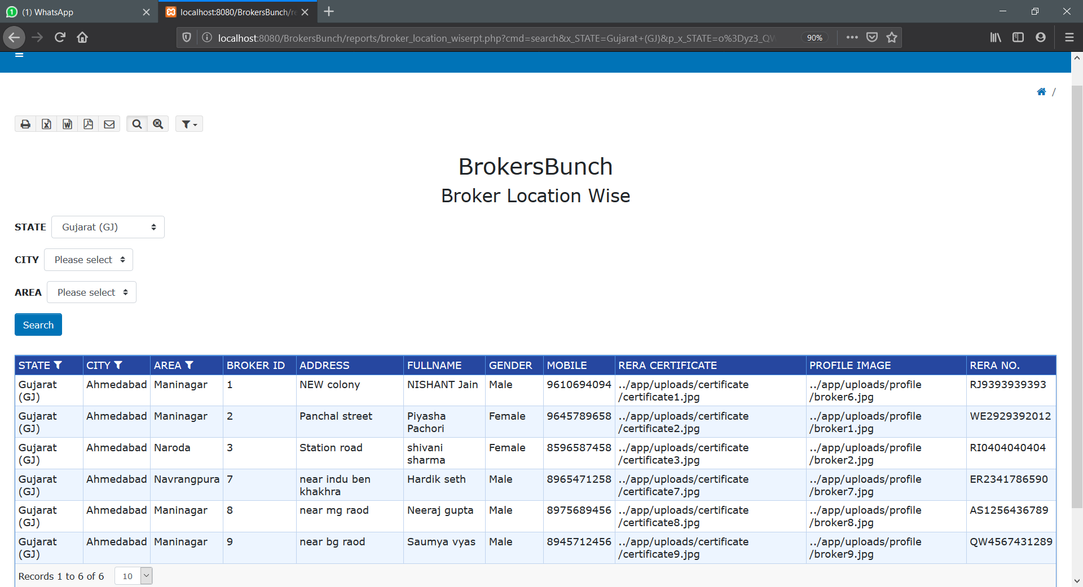**WITH FILTERS**

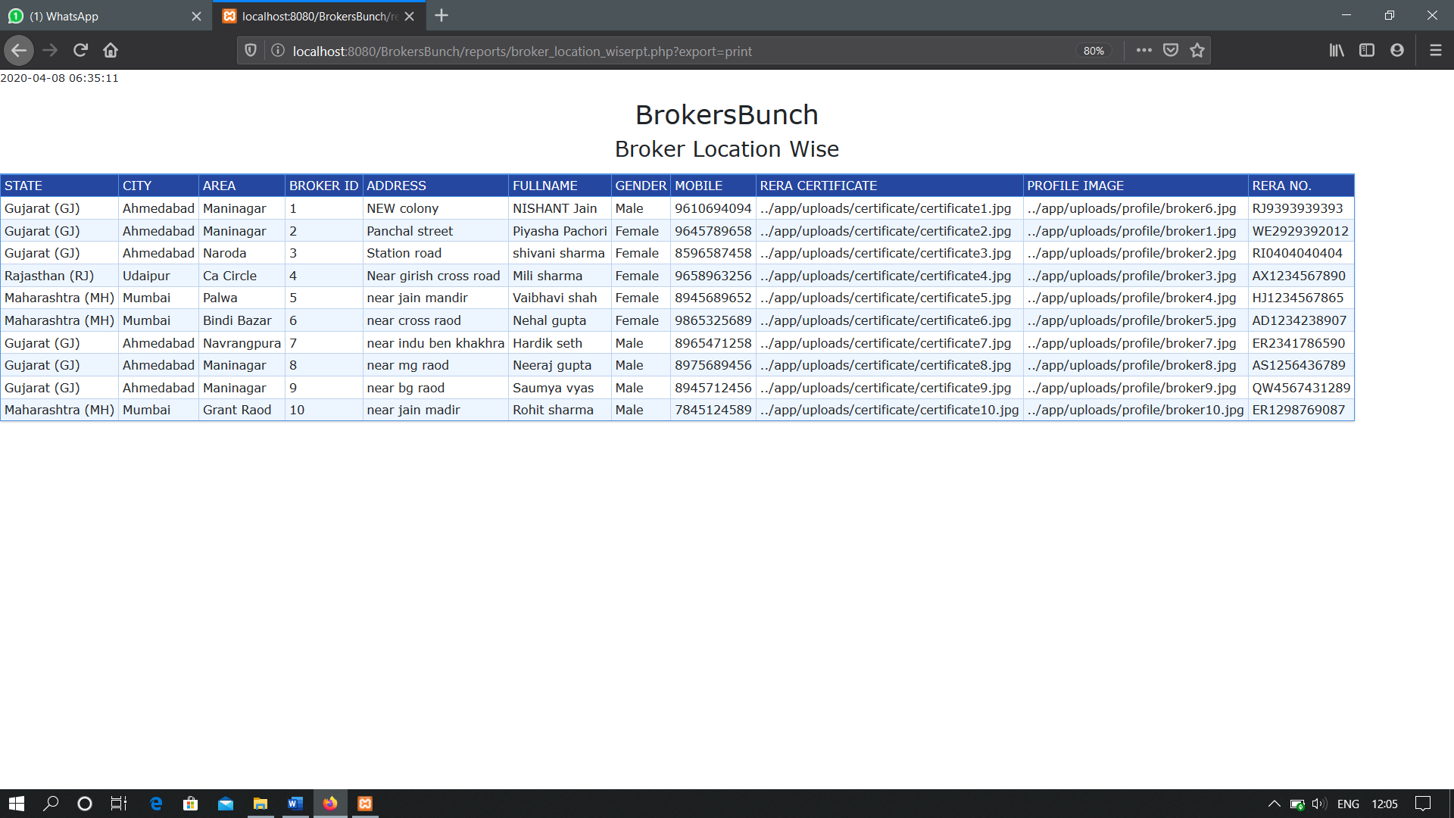**PRINT OPTION**

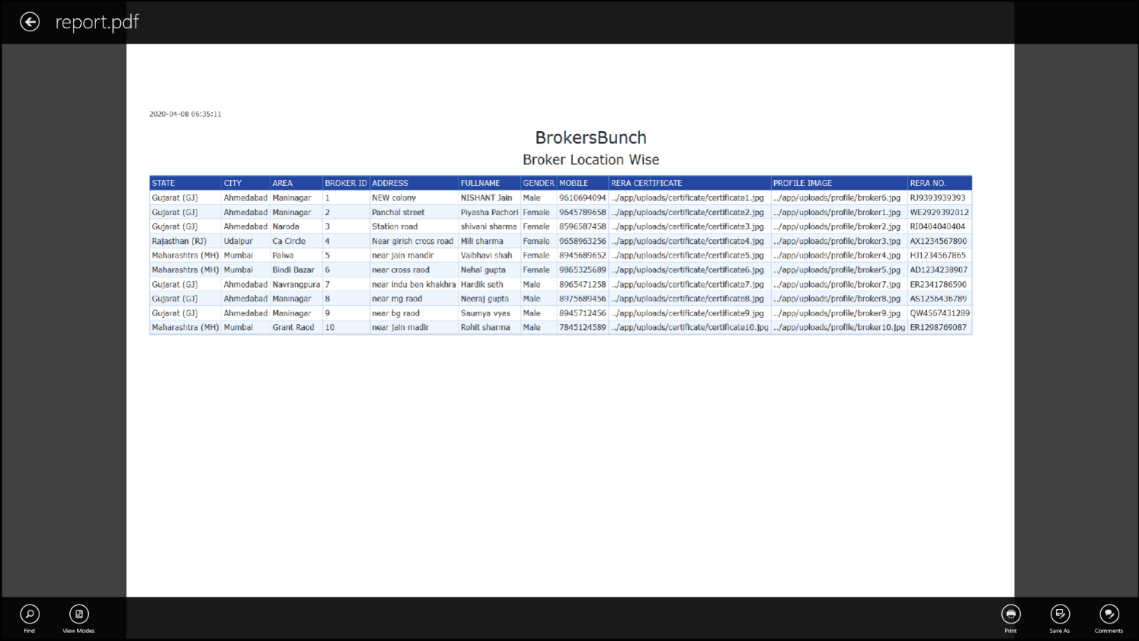**PDF**

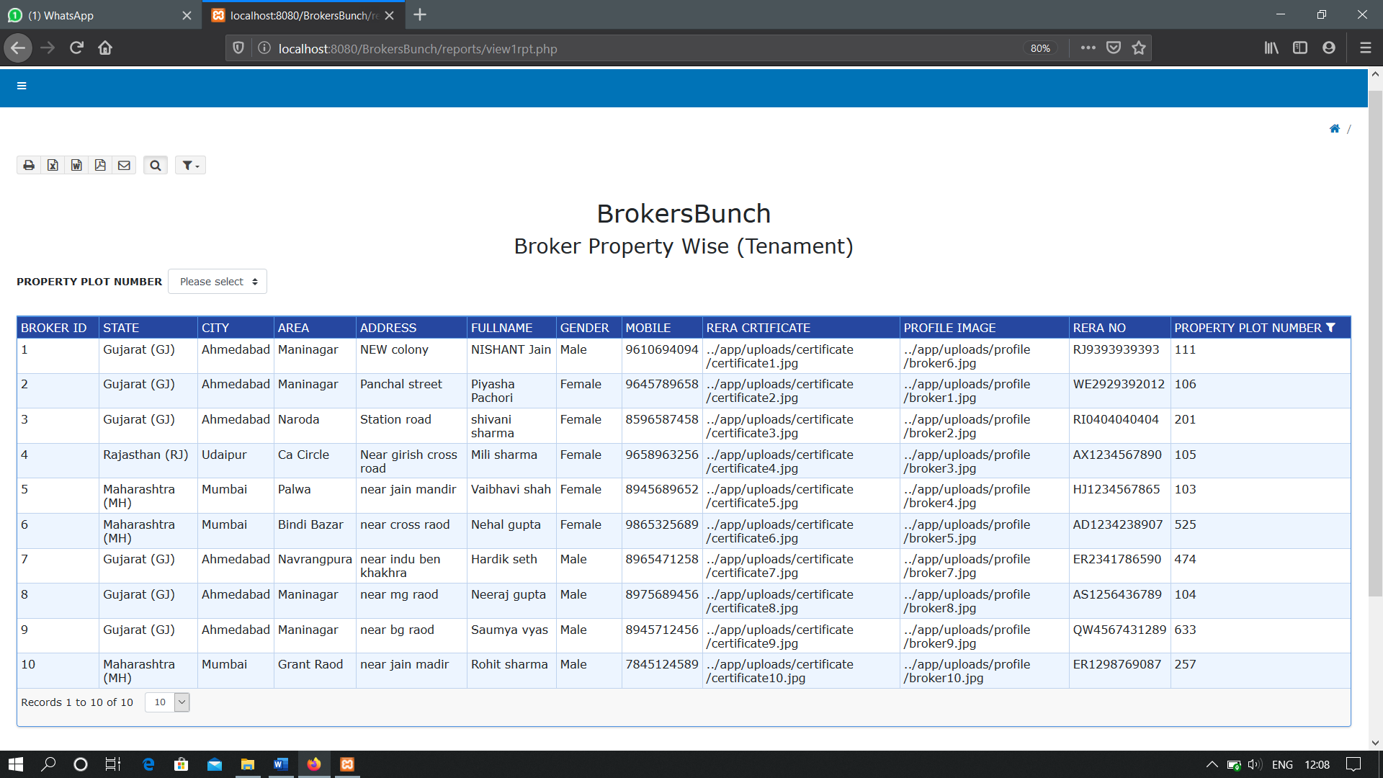**BROKER PROPERTY WISE (TENAMENT)**

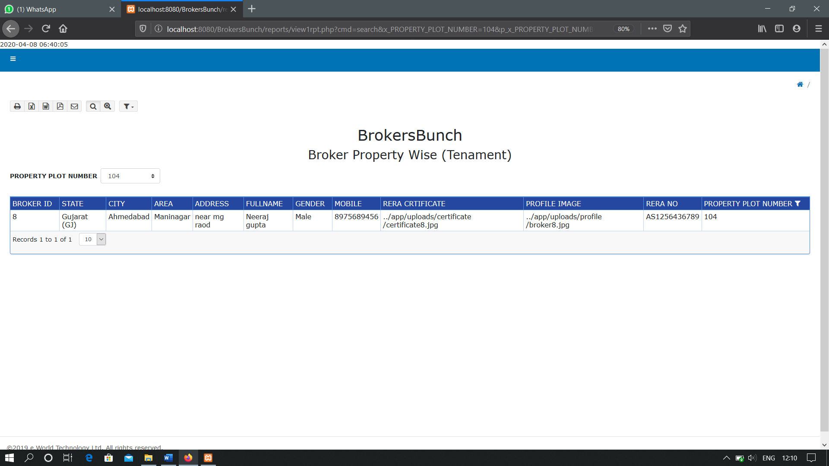**WITH FILTERS**

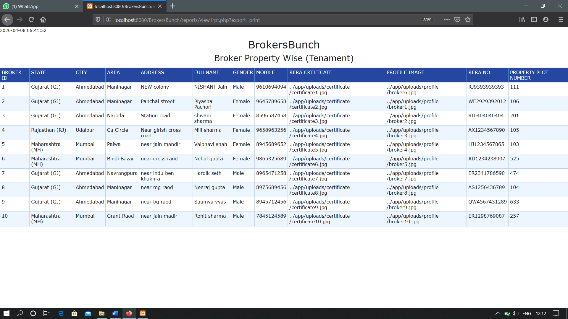**PRINT OPTION**

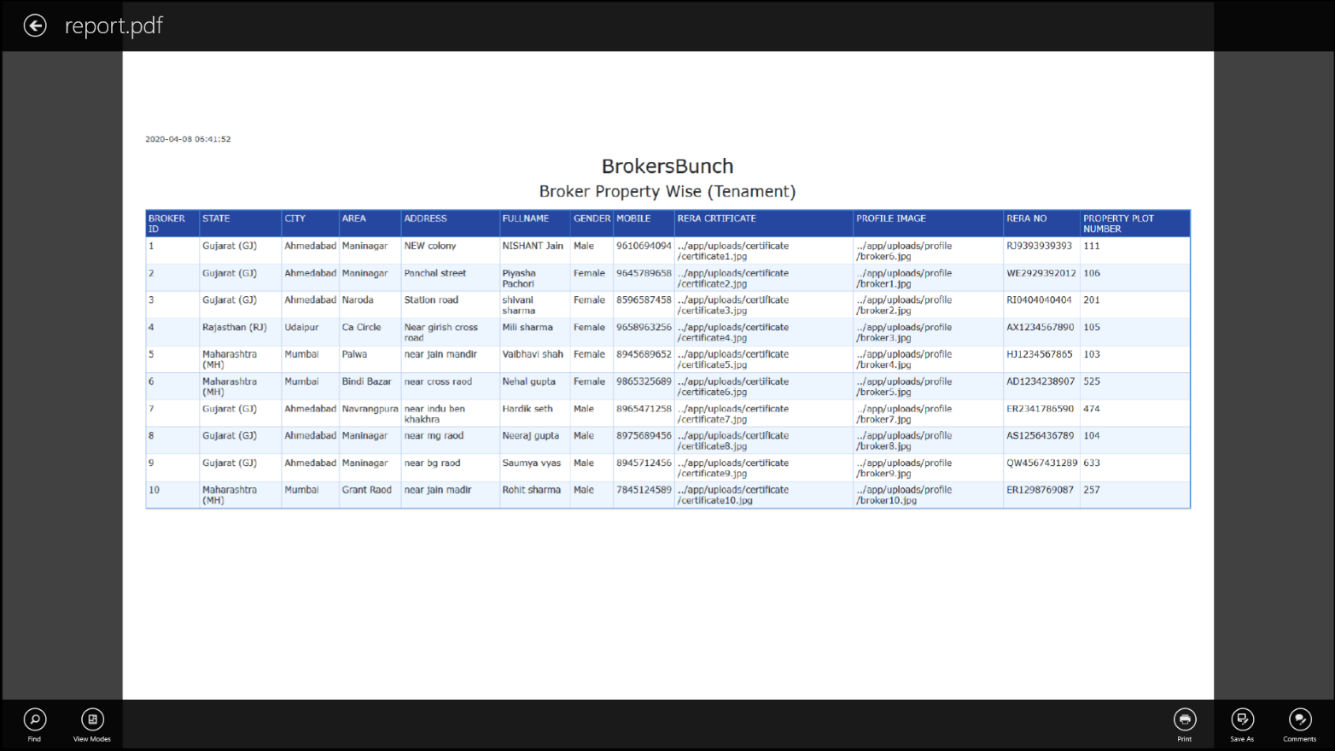**PDF**

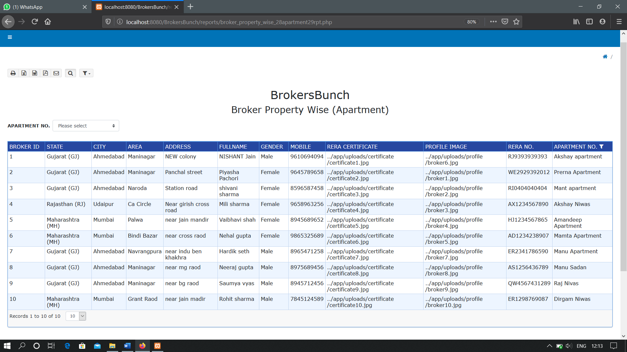**BROKER PROPERTY WISE (APARTMENT)**

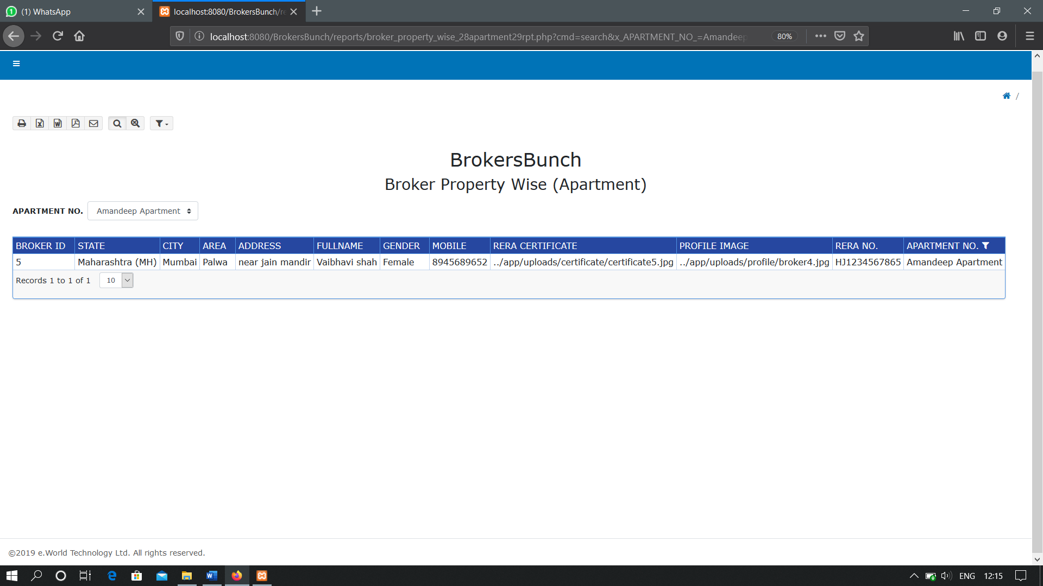 **WITH FILTER**

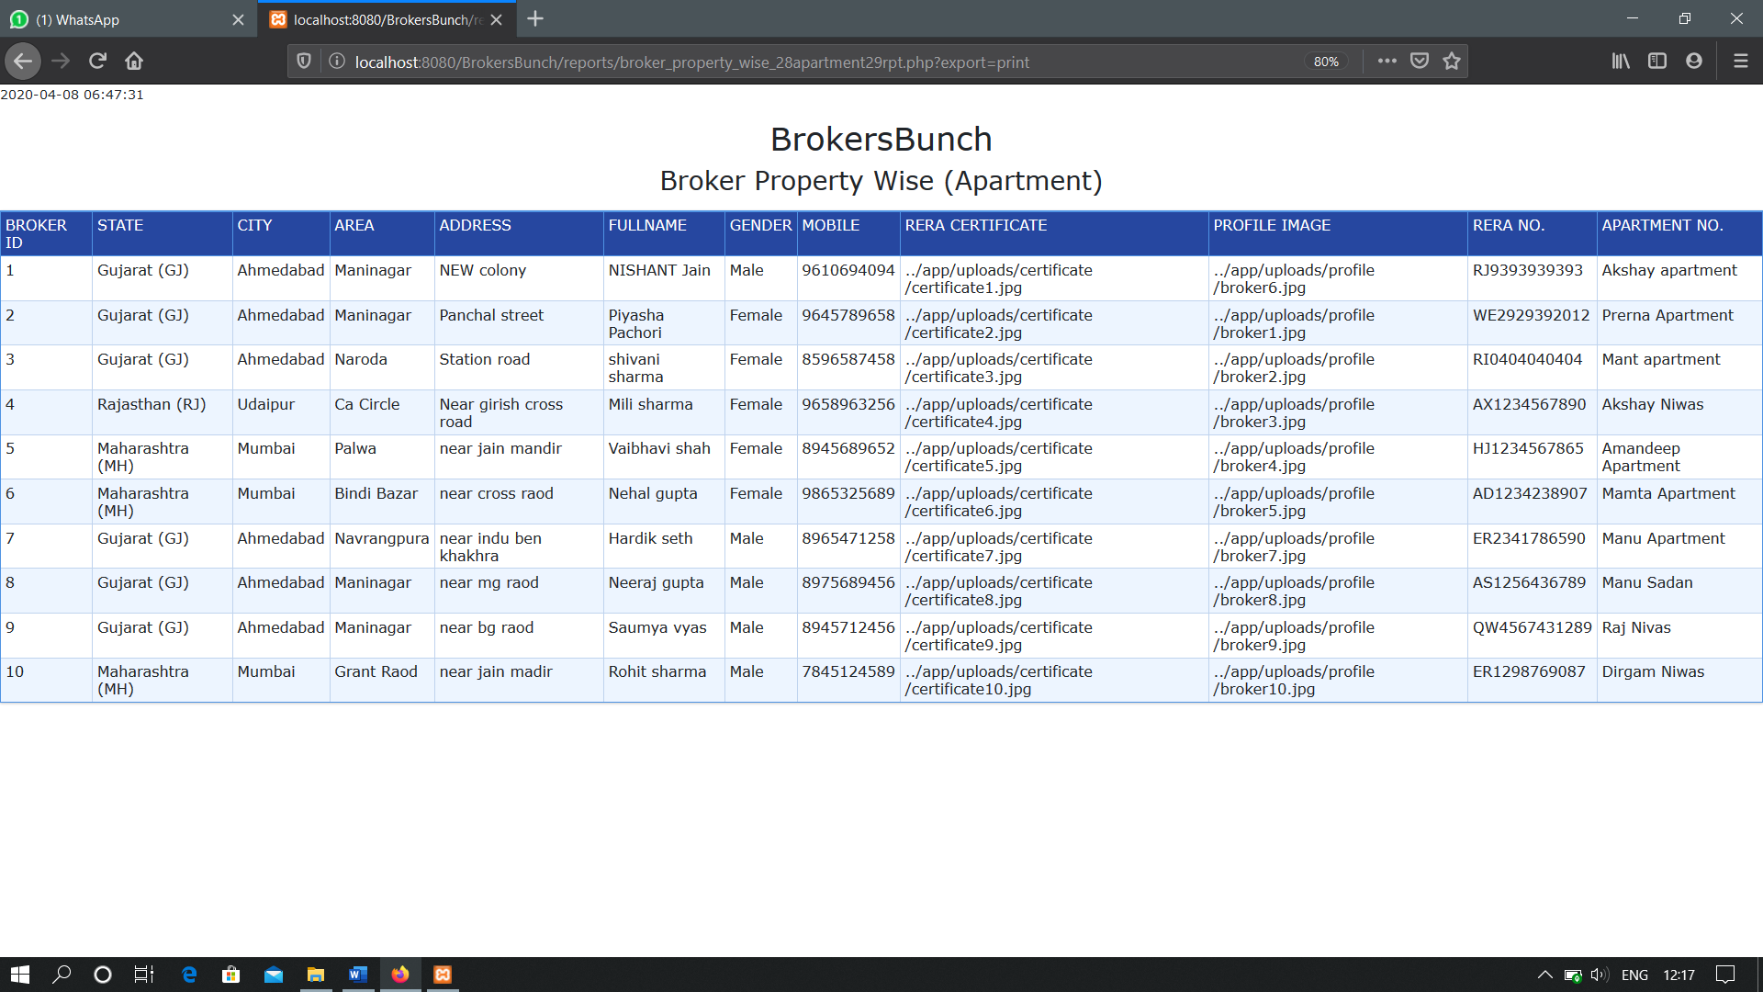 **PRINT OPTION**

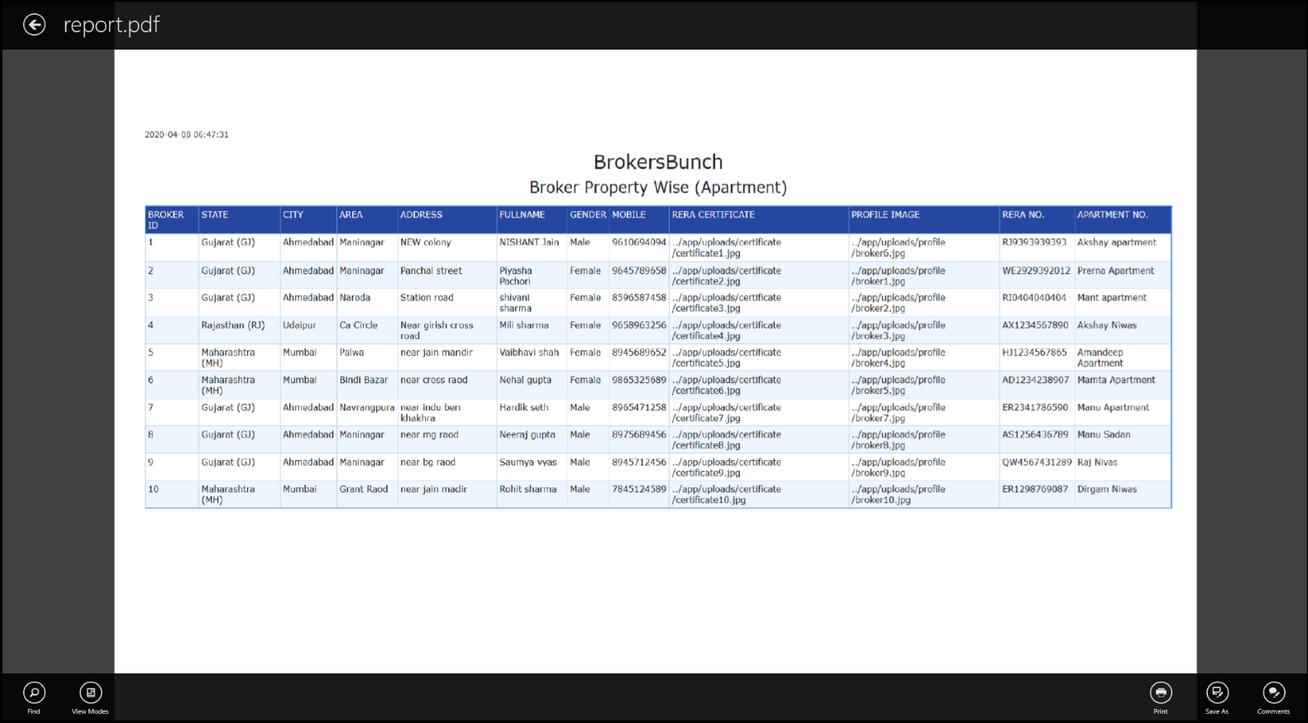**PDF**

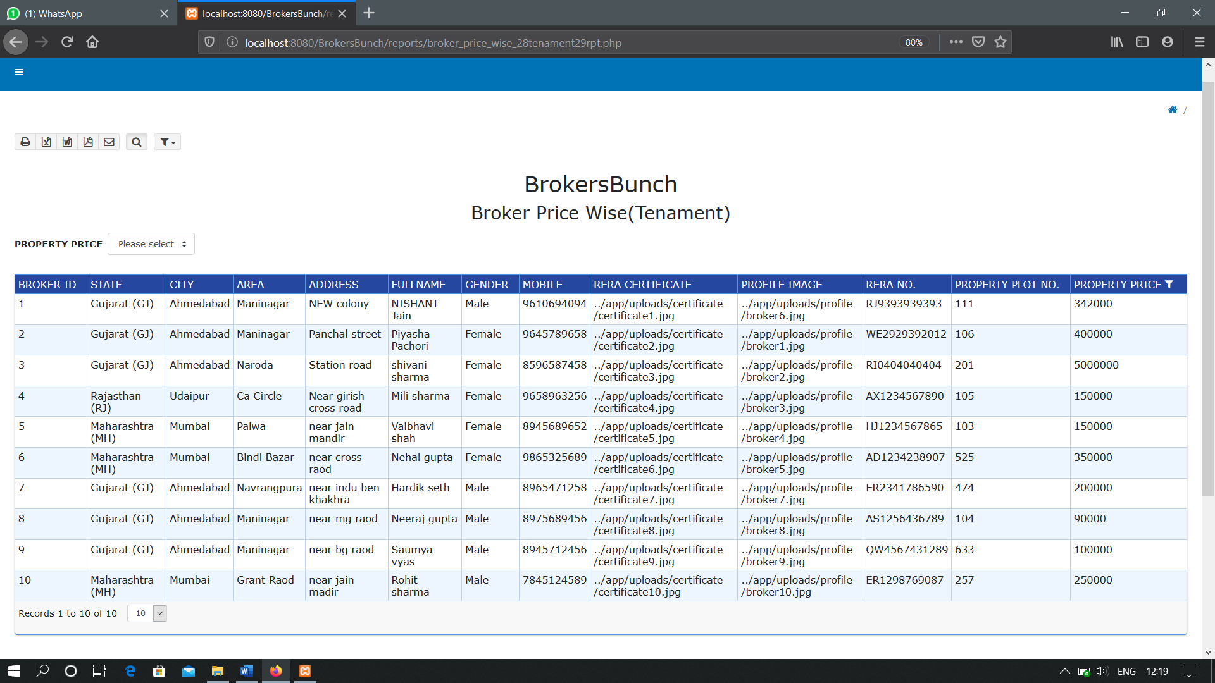**BROKER PRICE WISE(TENAMENT)**

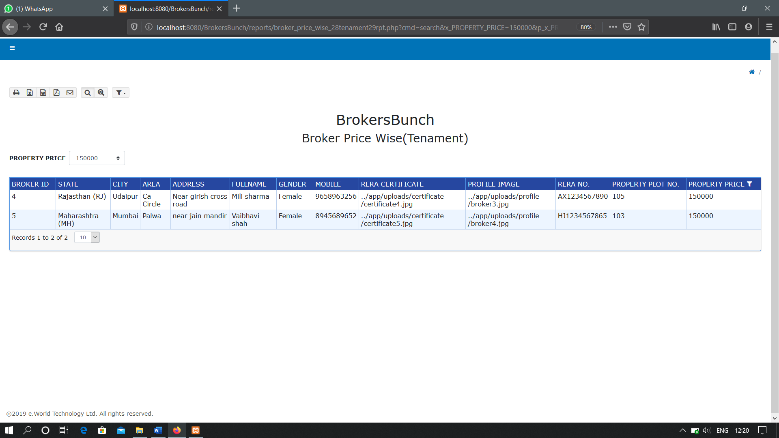**WITH FILTER**

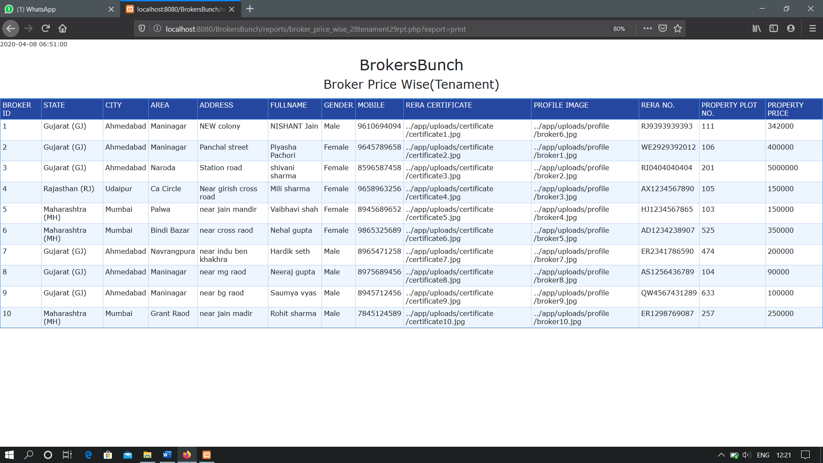 **PRINT OPTION**

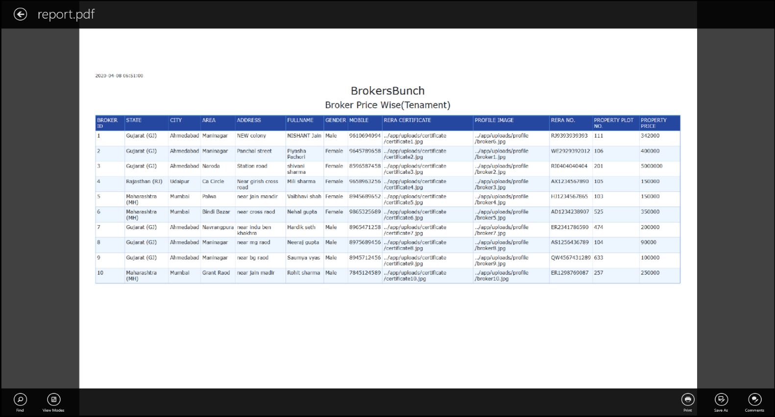**PDF**

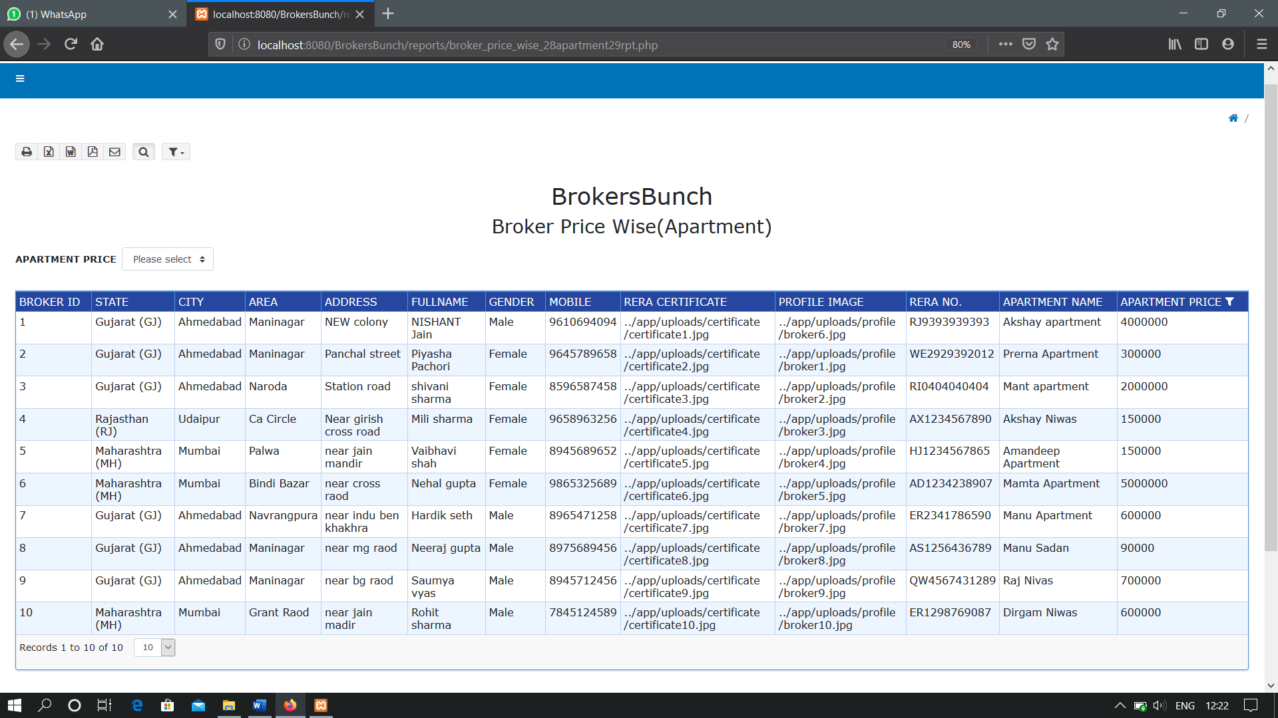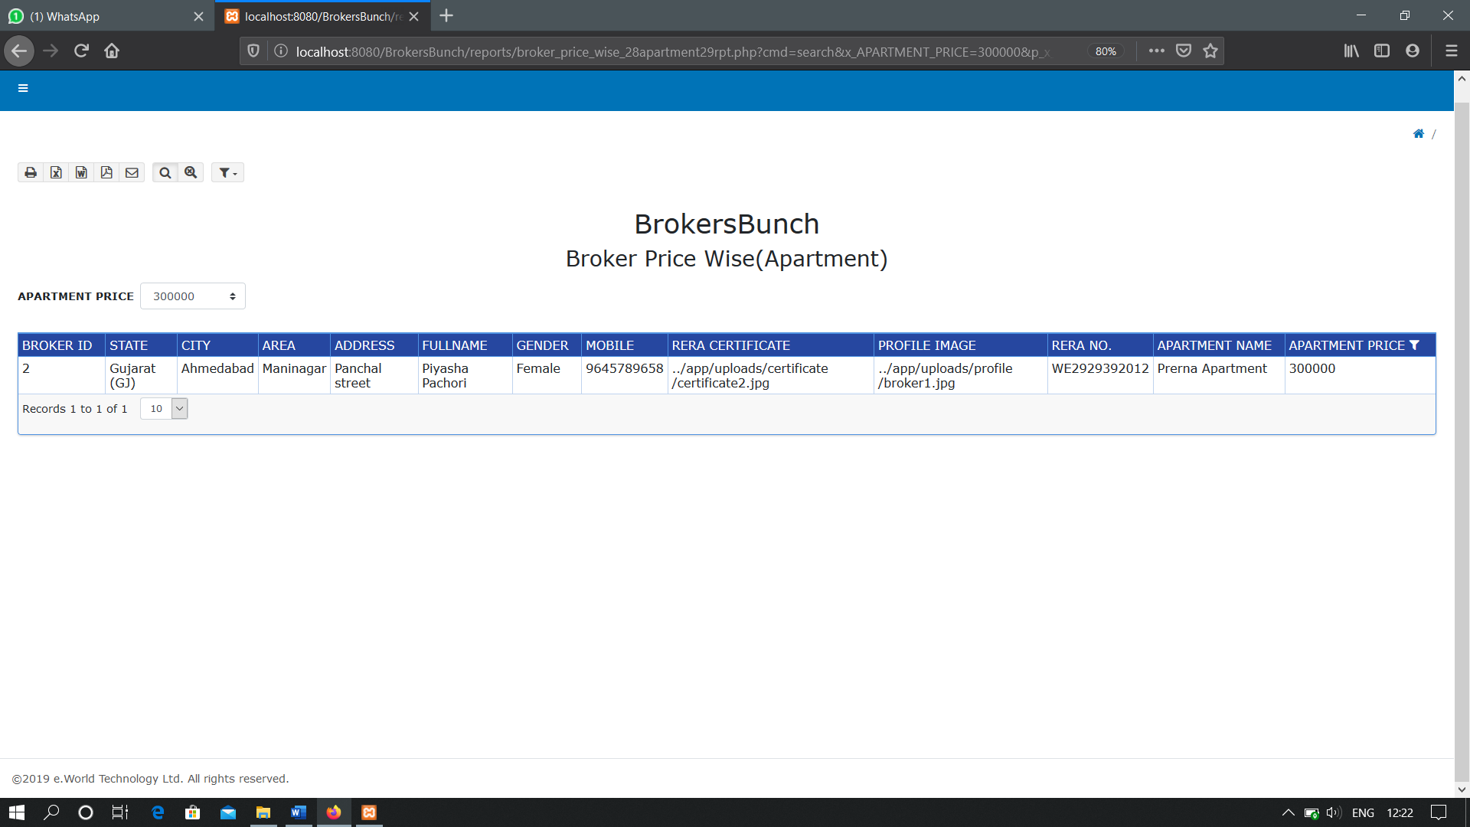**BROKER PRICE WISE(APARTMENT)**

**WITH FILTER**

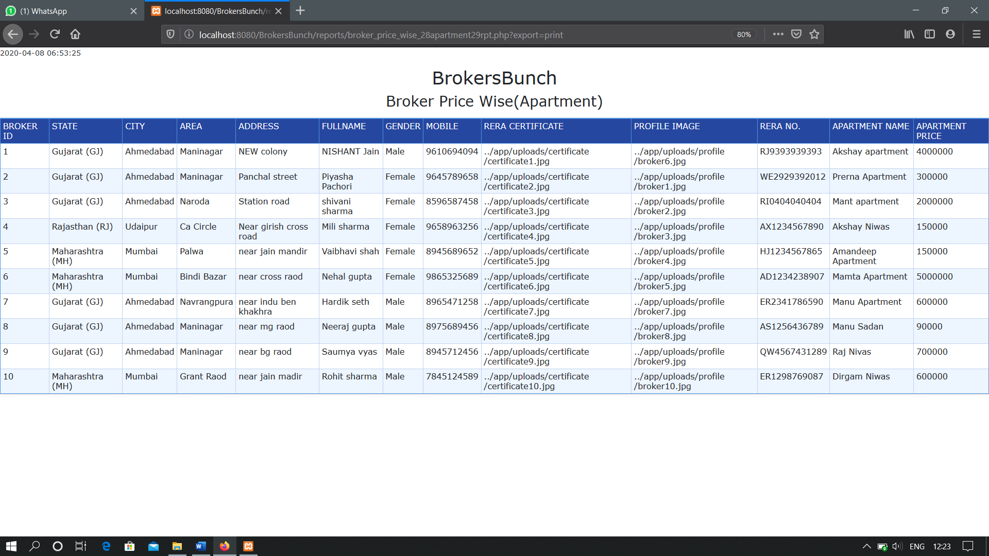**PRINT OPTION**

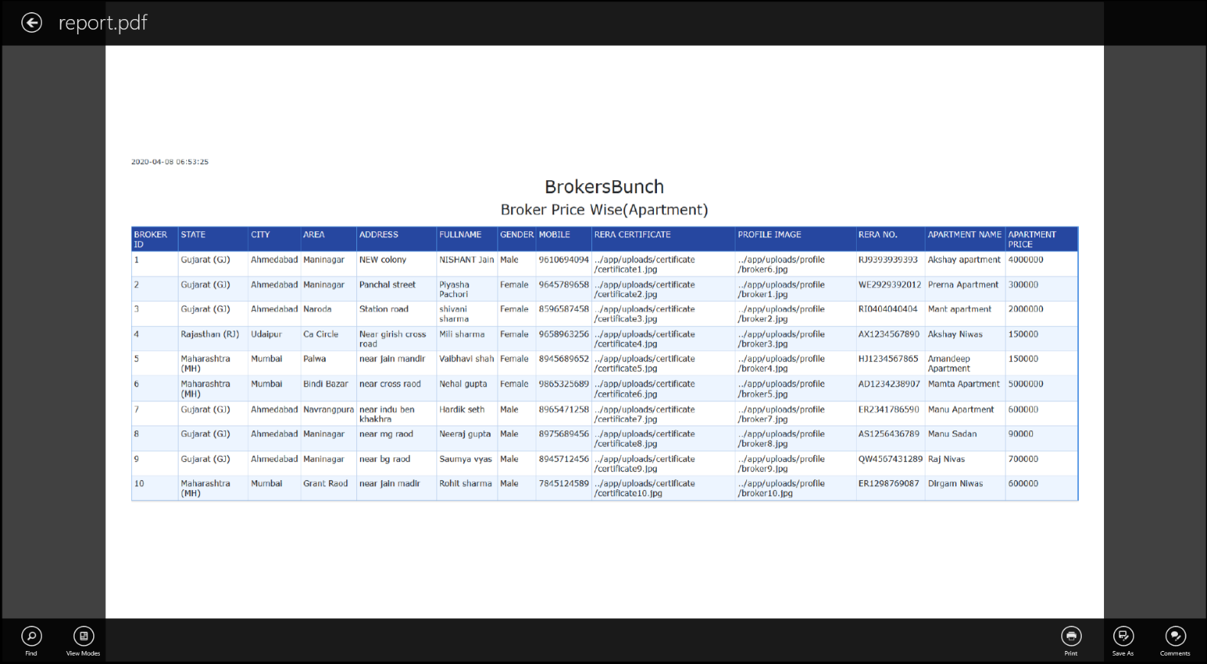**PDF**

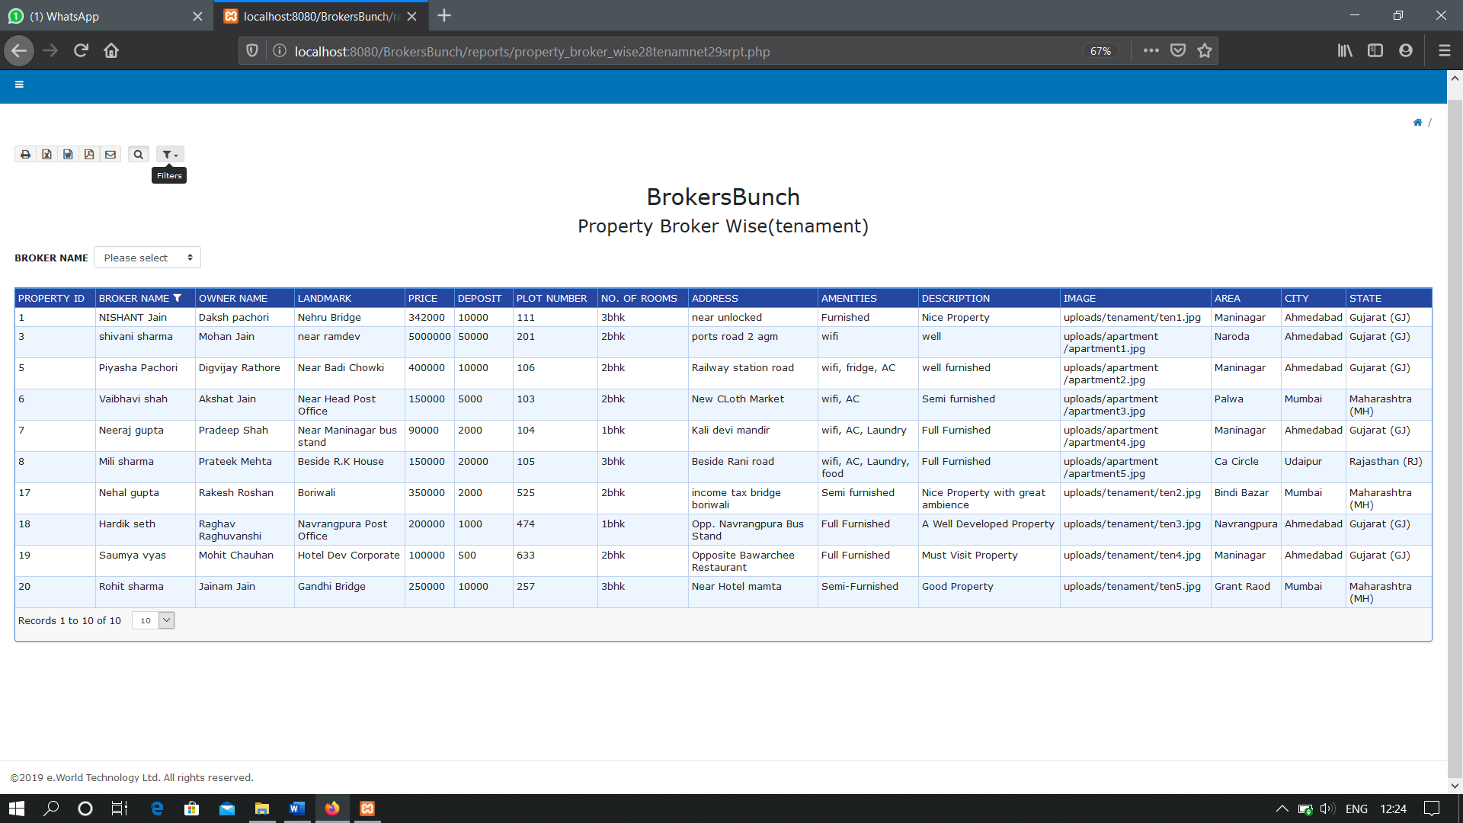**PROPERTY BROKER WISE(TENAMENT)**

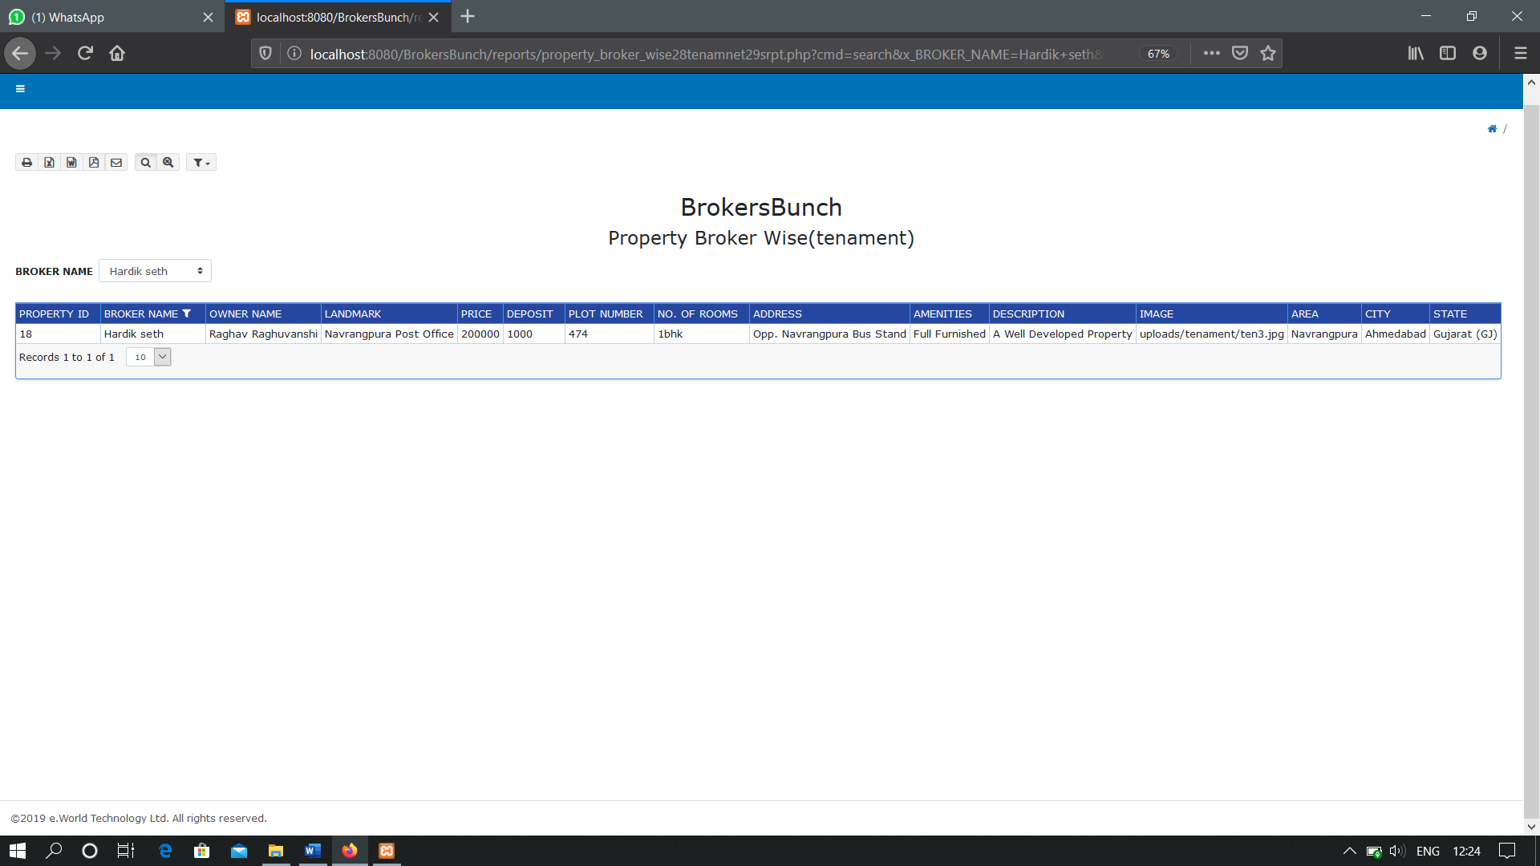**WITH FILTER**

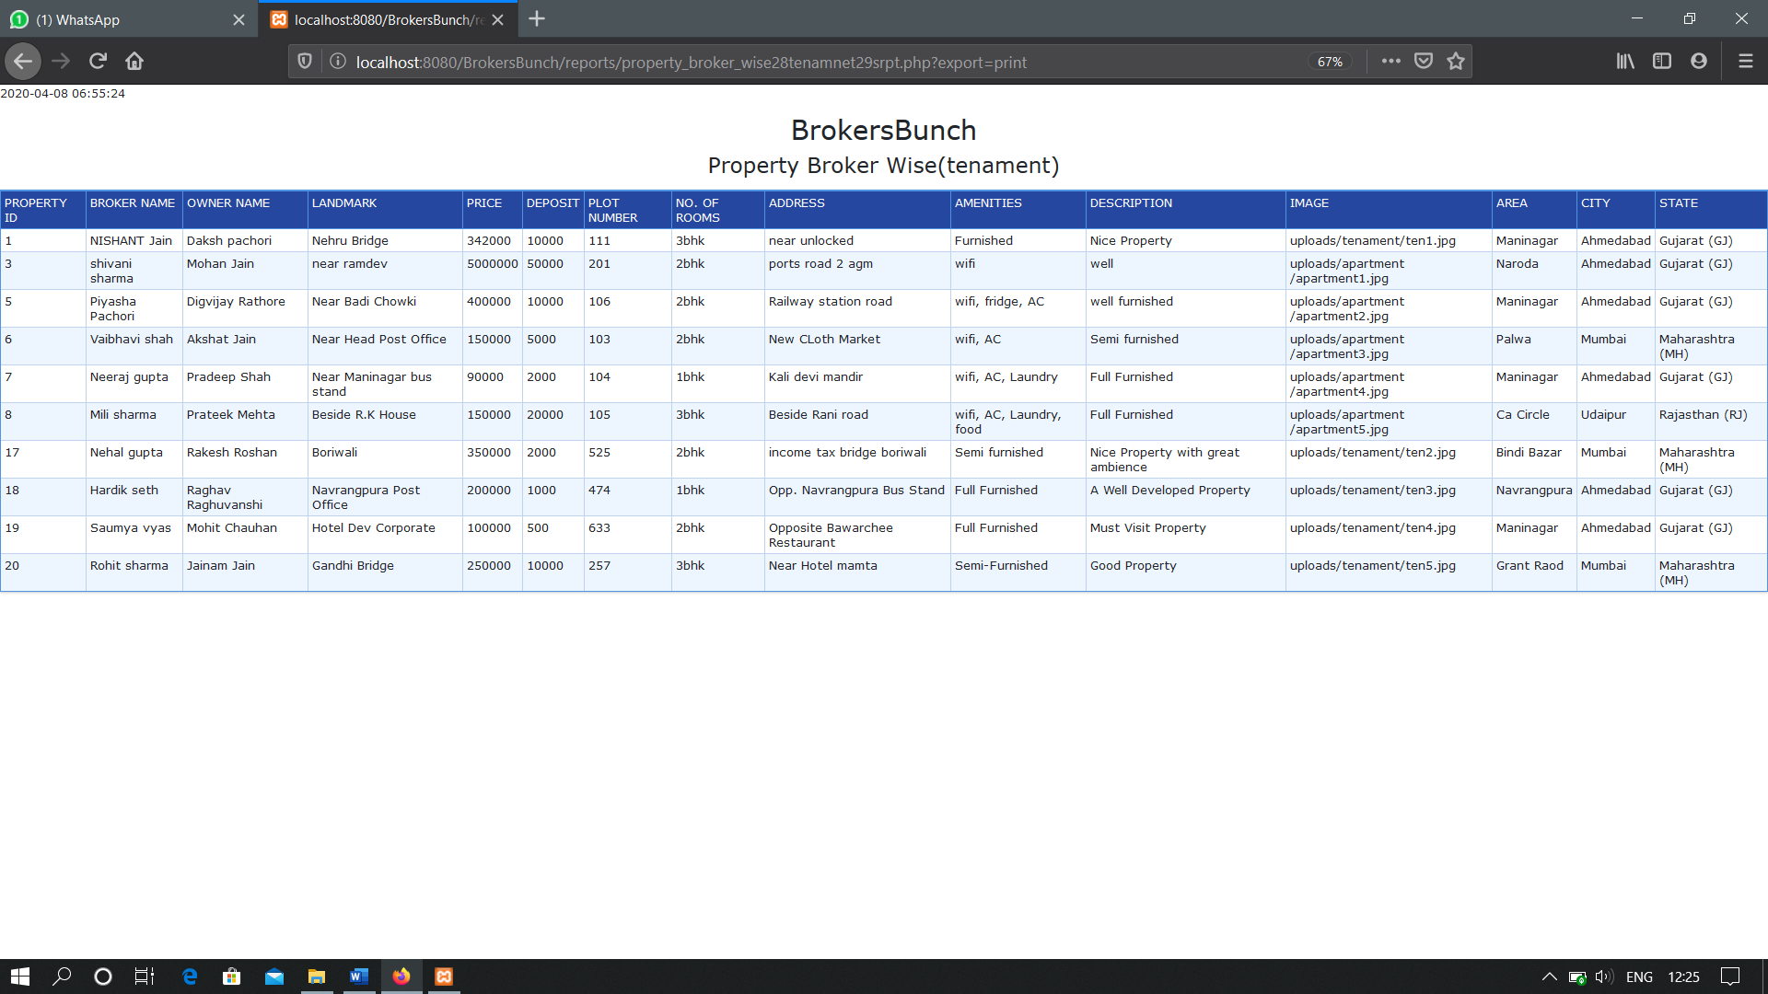**PRINT OPTION**

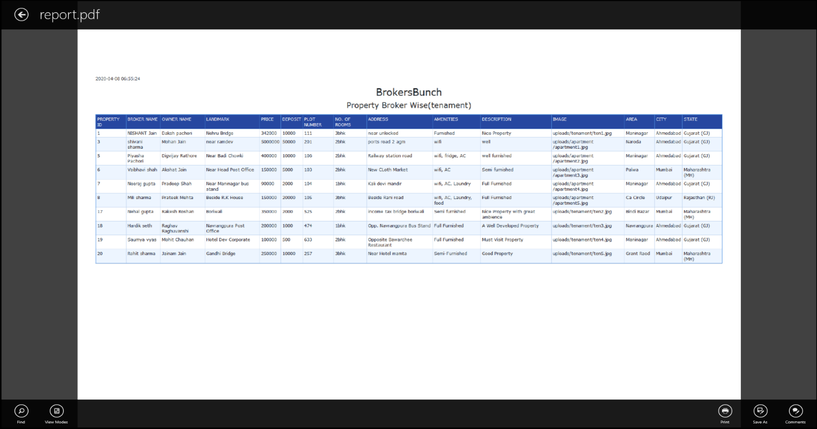**PDF**

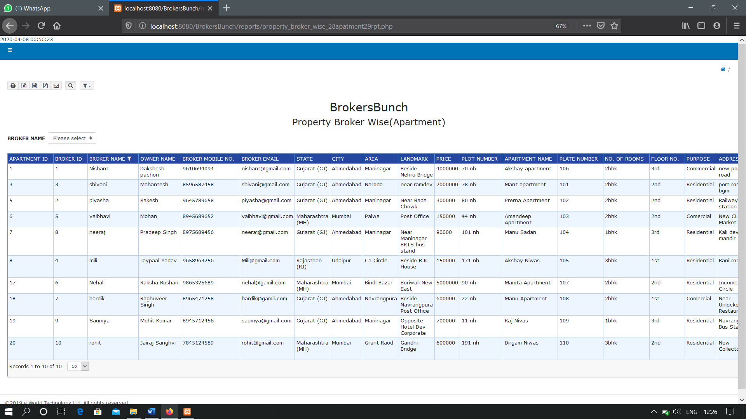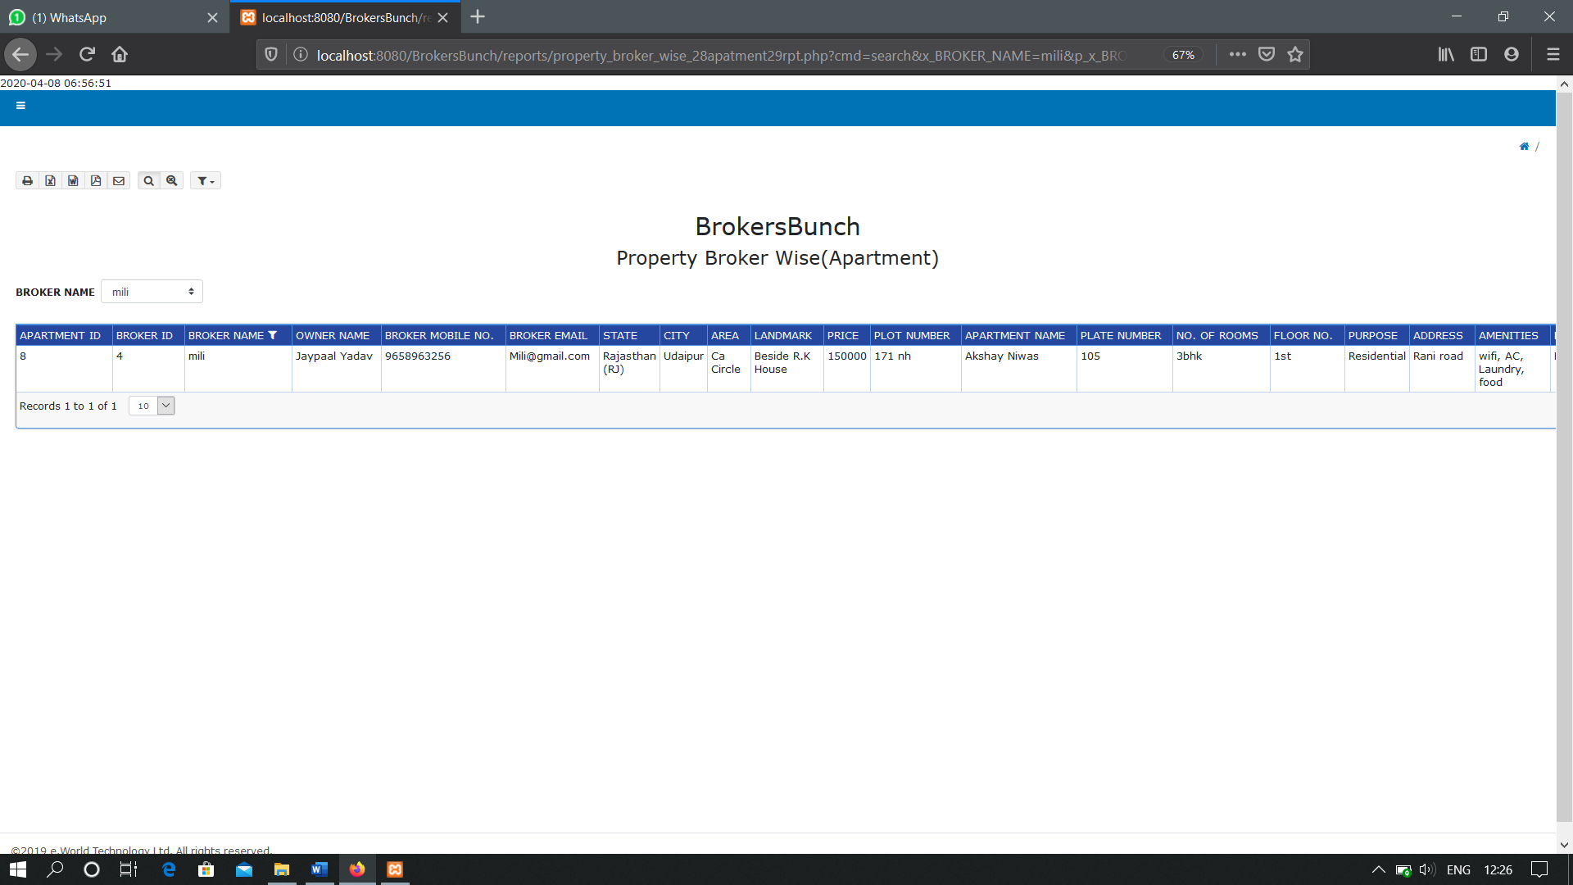**PROPERTY BROKER WISE(APARTMENT)**

**WITH FILTER**

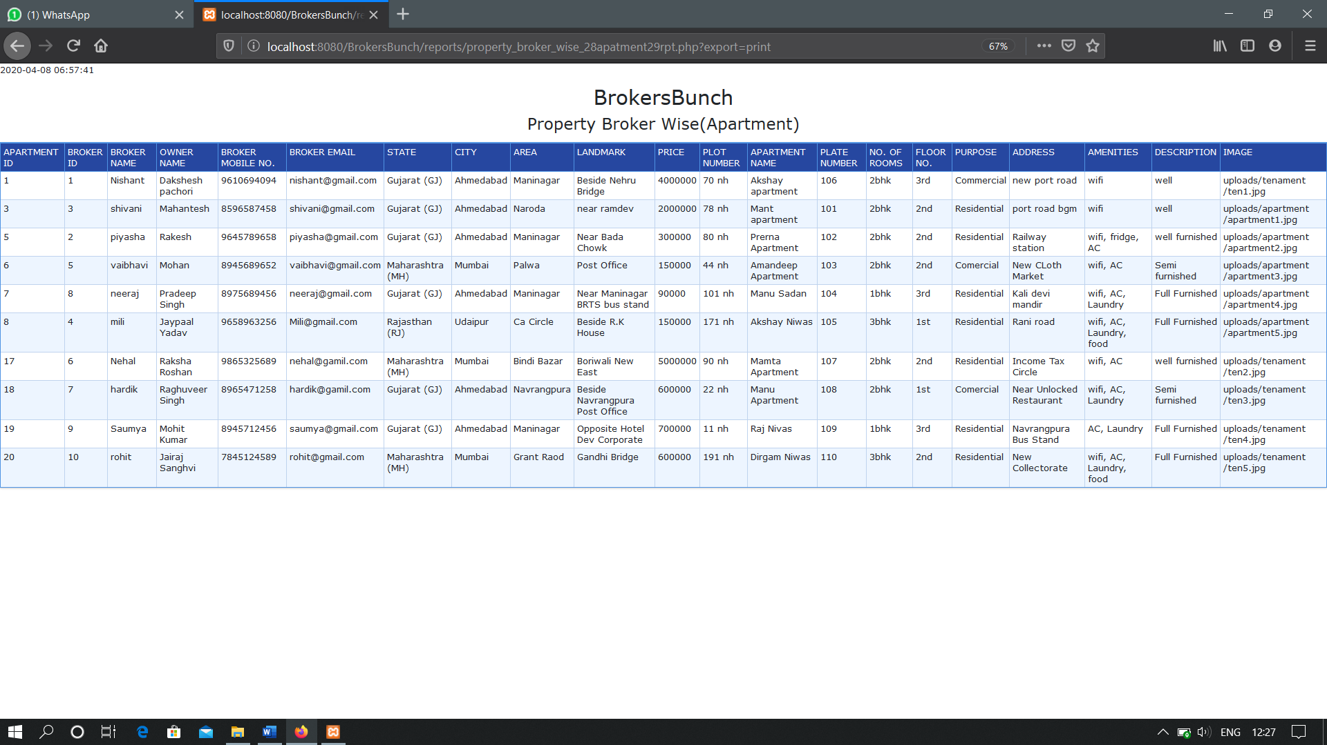**PRINT OPTION**

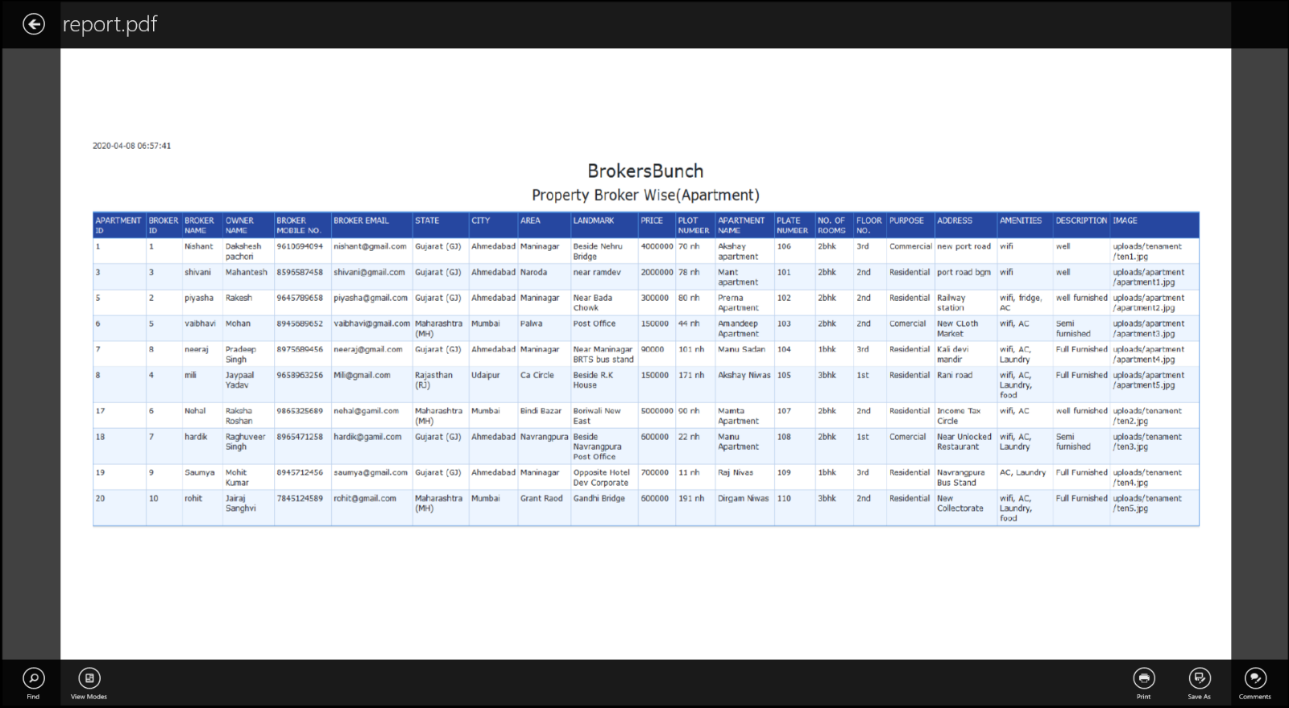**PDF**

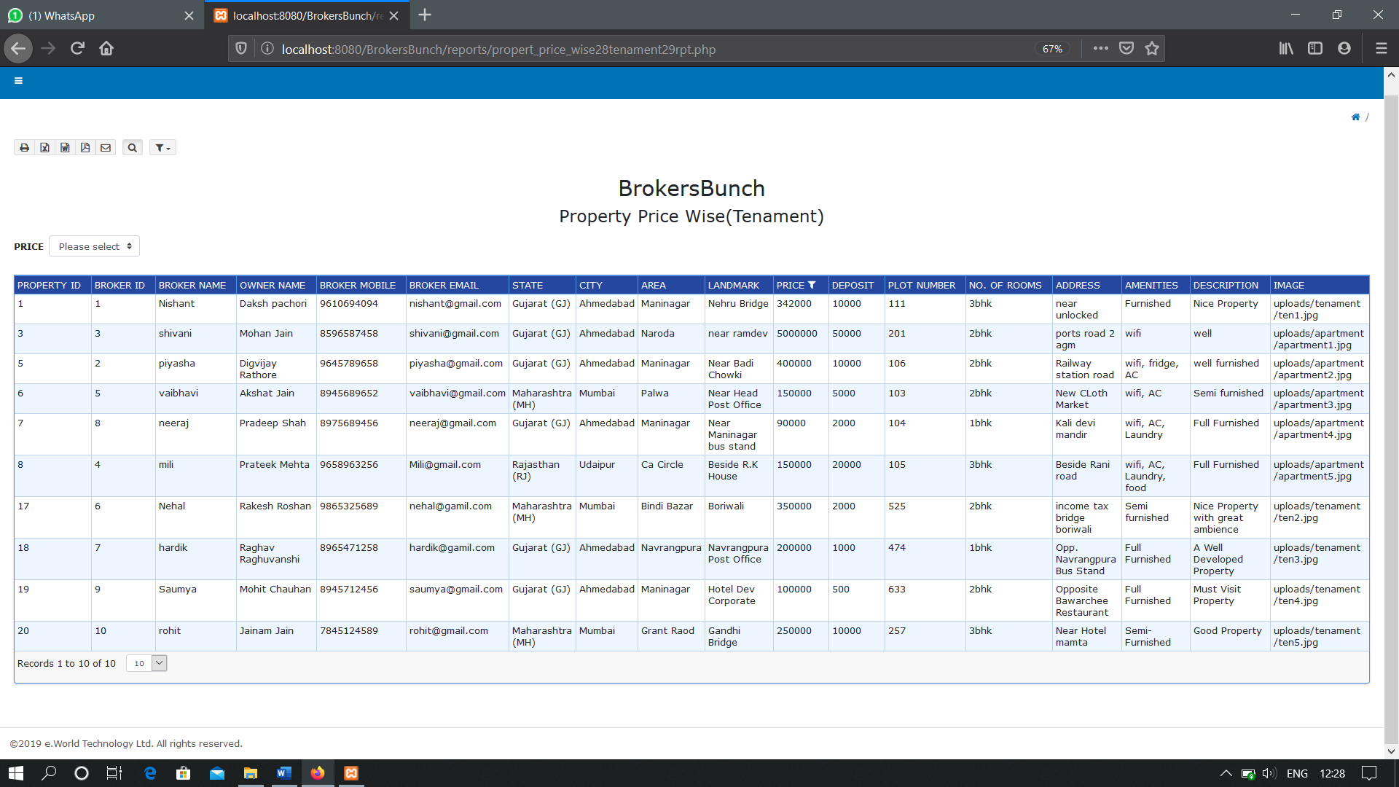**PROPERTY PRICE WISE(TENAMENT)**

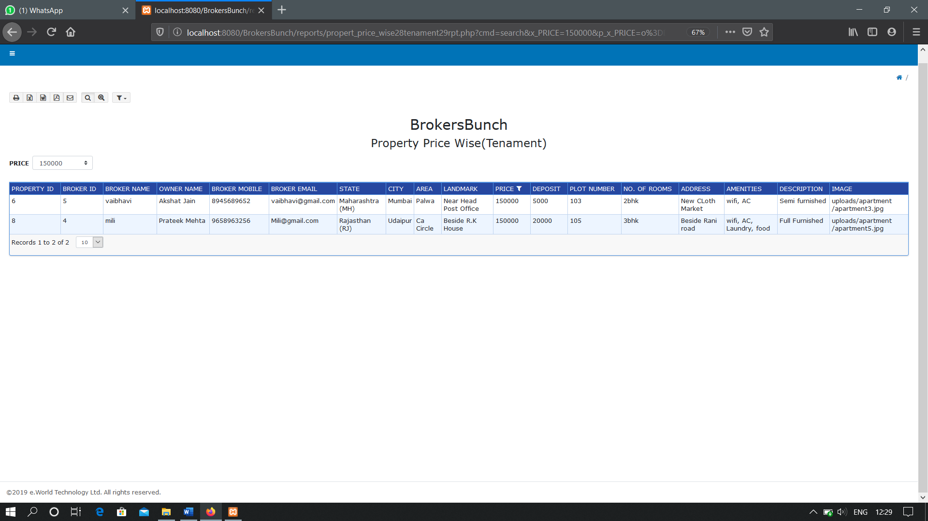**WITH FILTER**

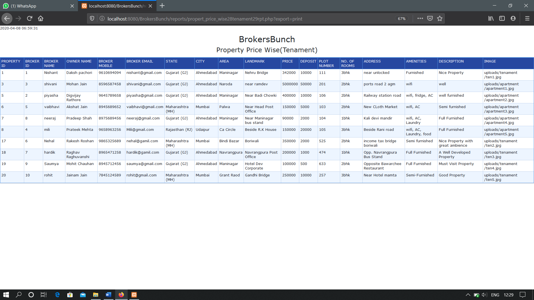**PRINT OPTION**

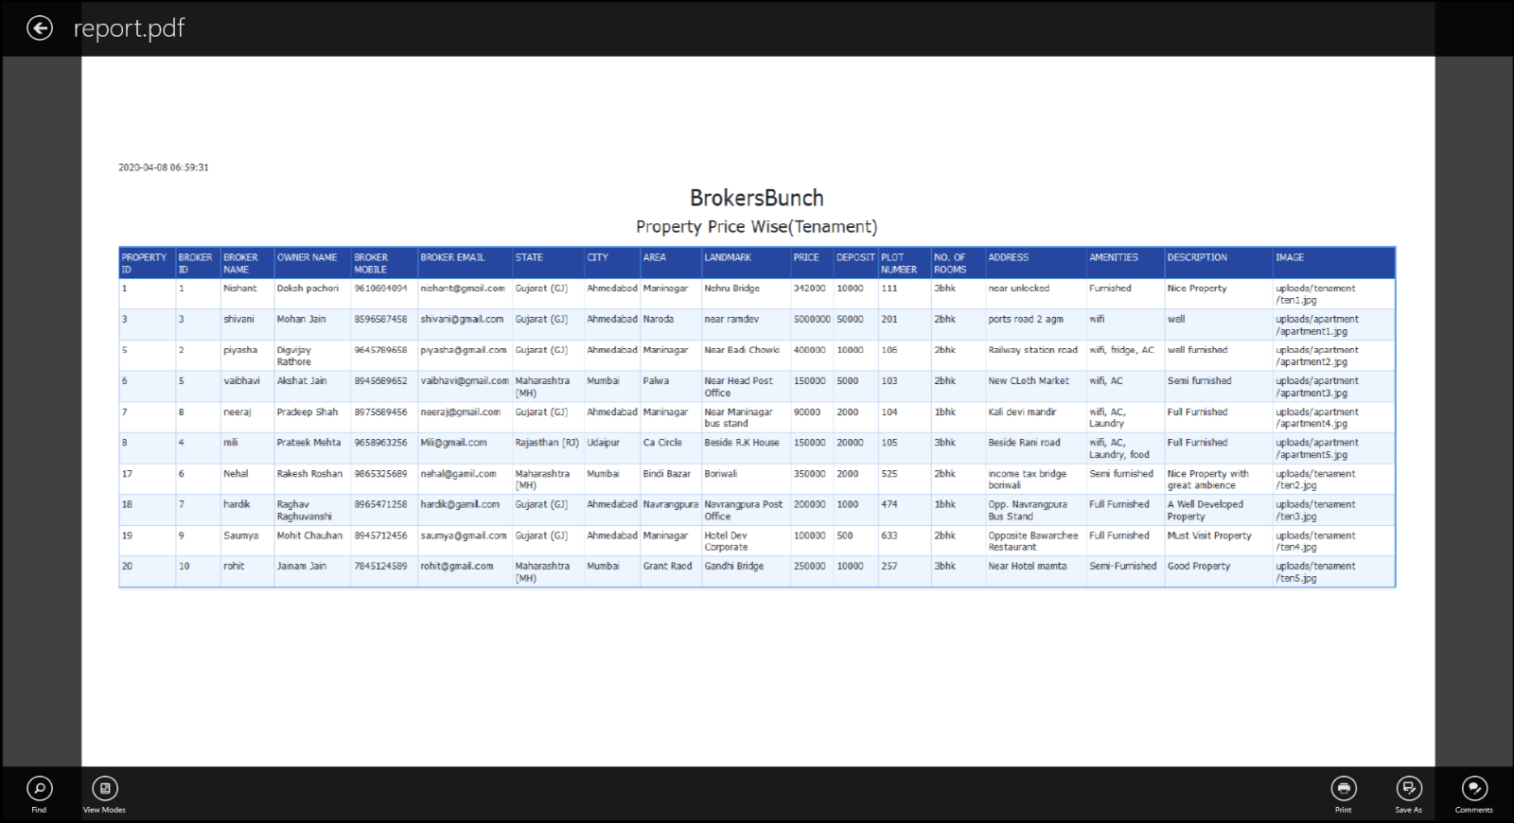**PDF**

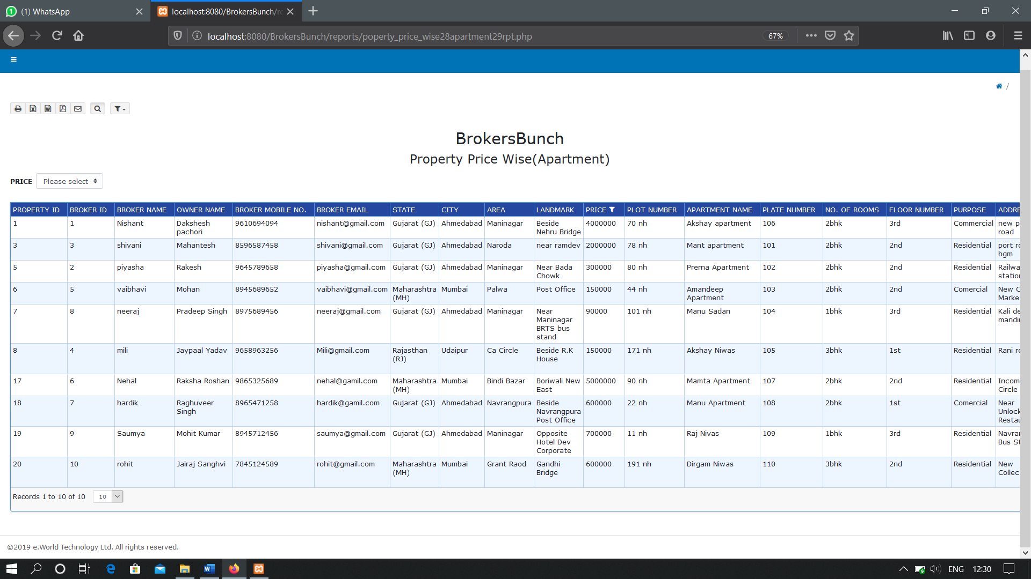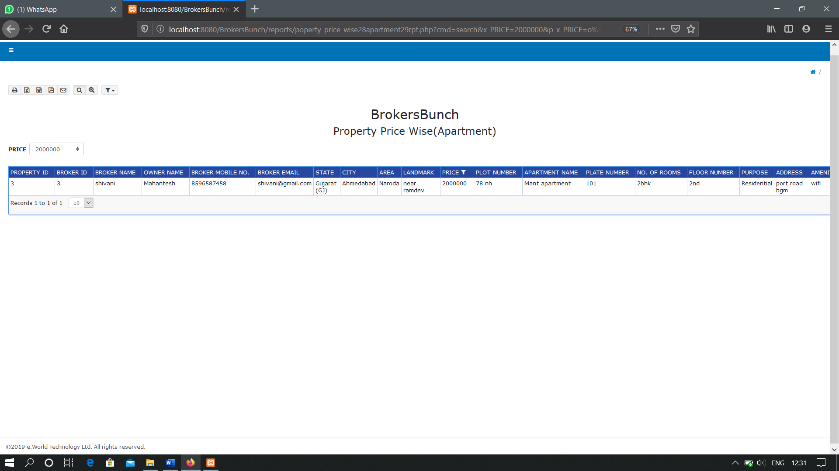**PROPERTY PRICE WISE(APARTMENT)**

**WITH FILTER**

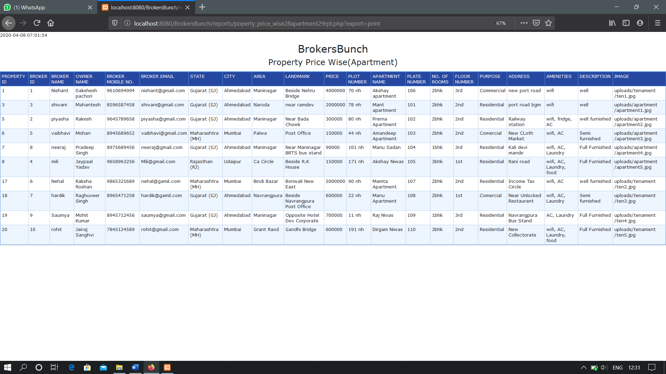**PRINT OPTION**

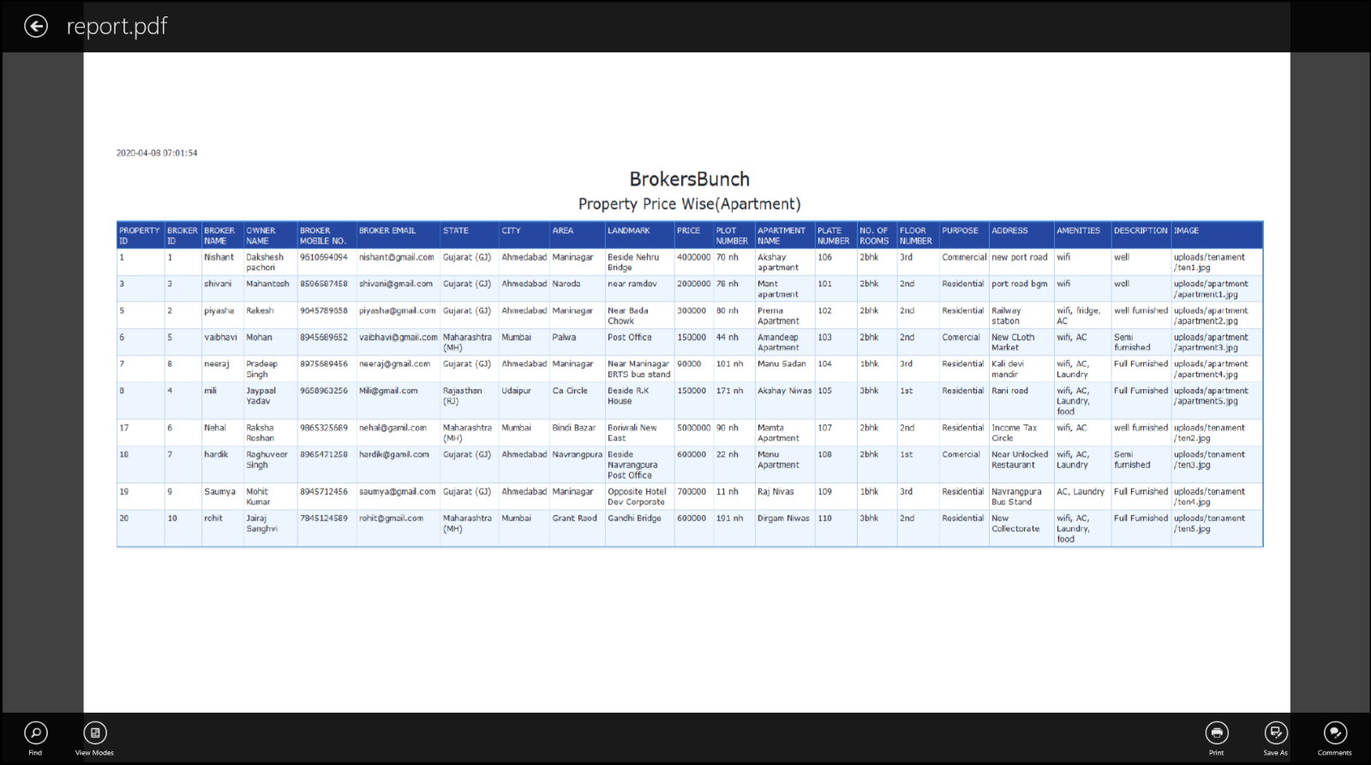**PDF**

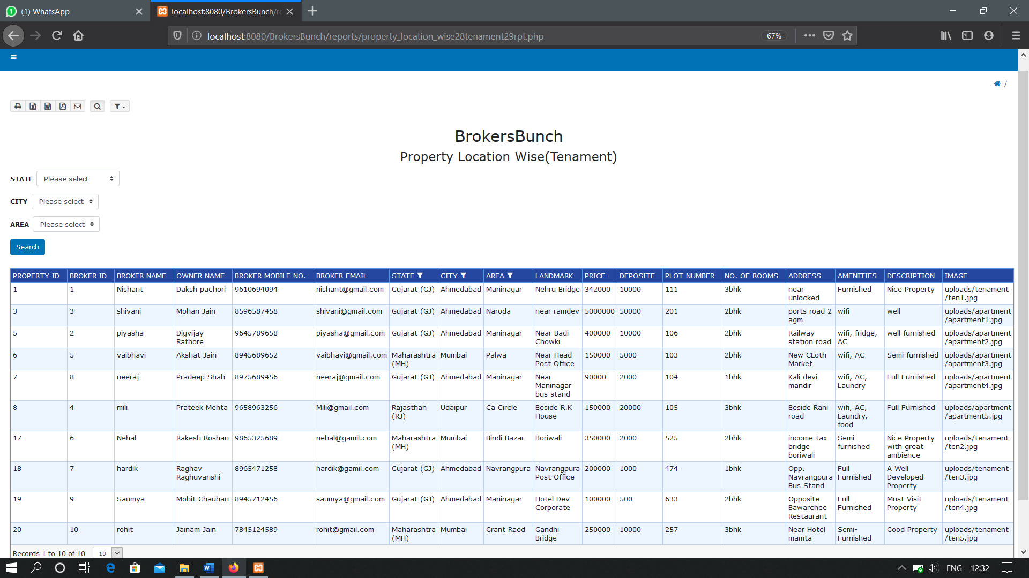**PROPERTY LOCATION WISE(TENAMENT)**

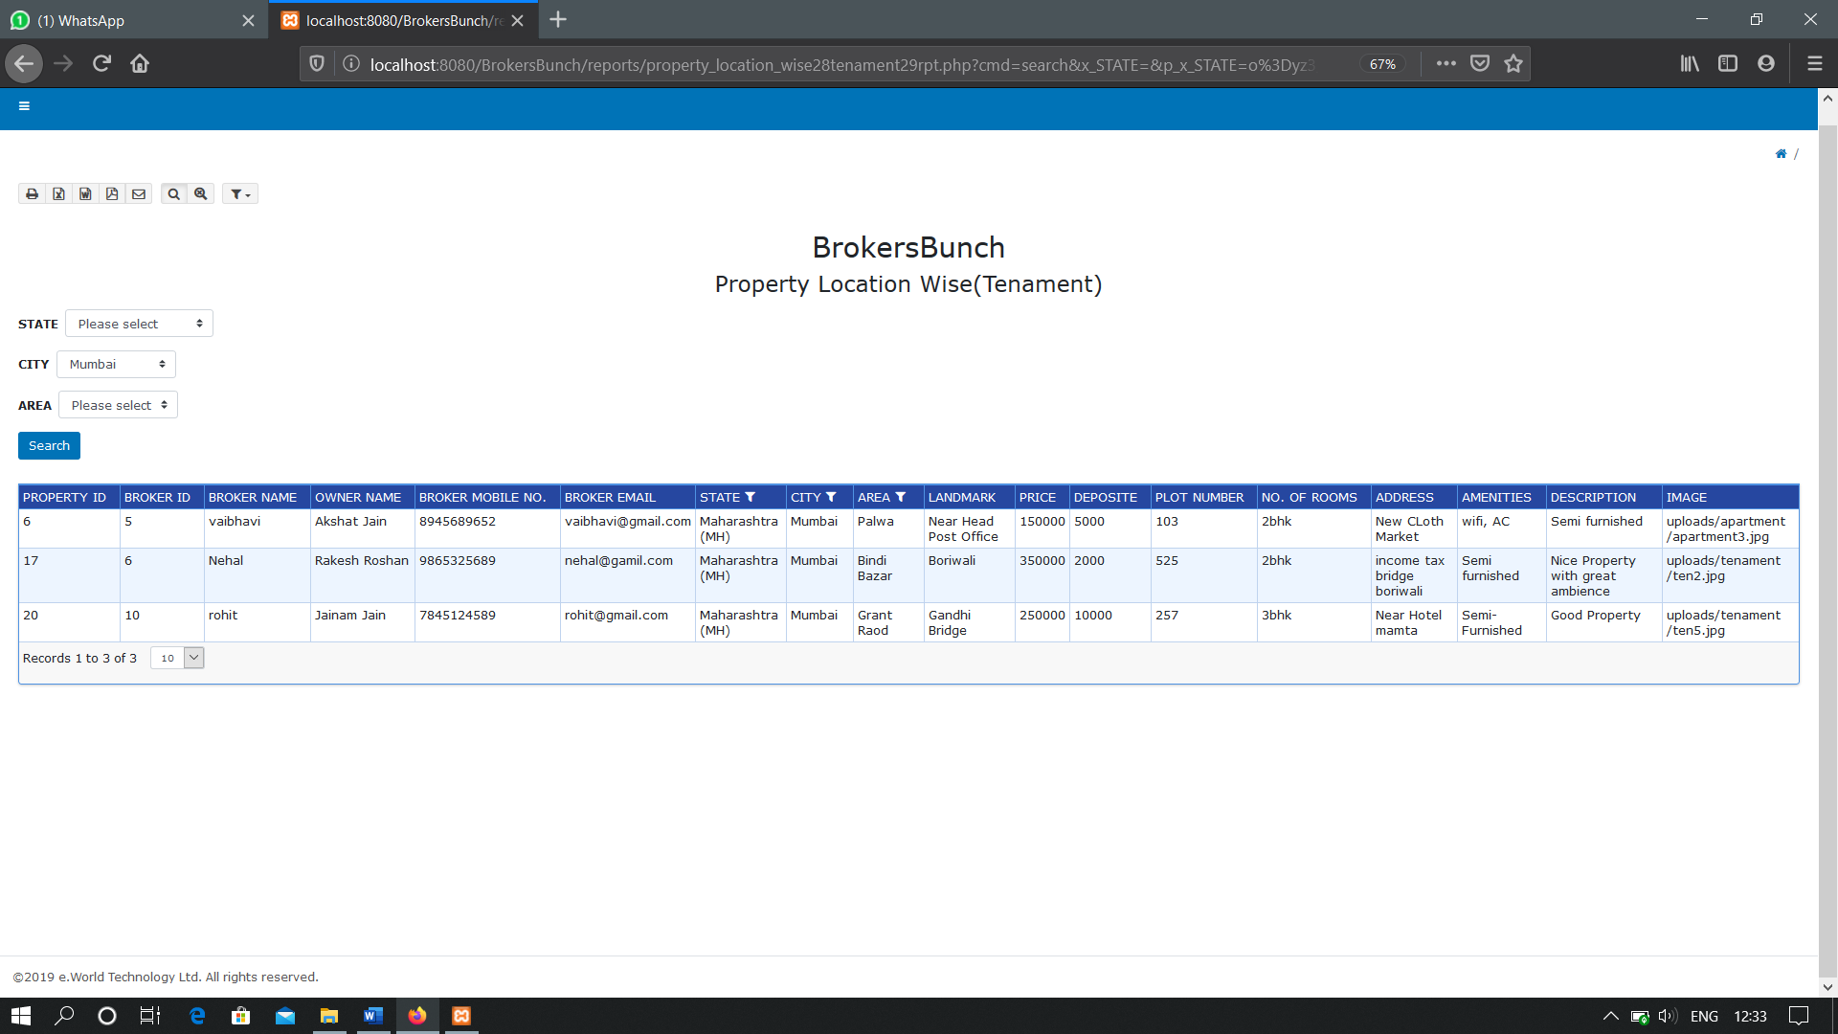**WITH FILTER**

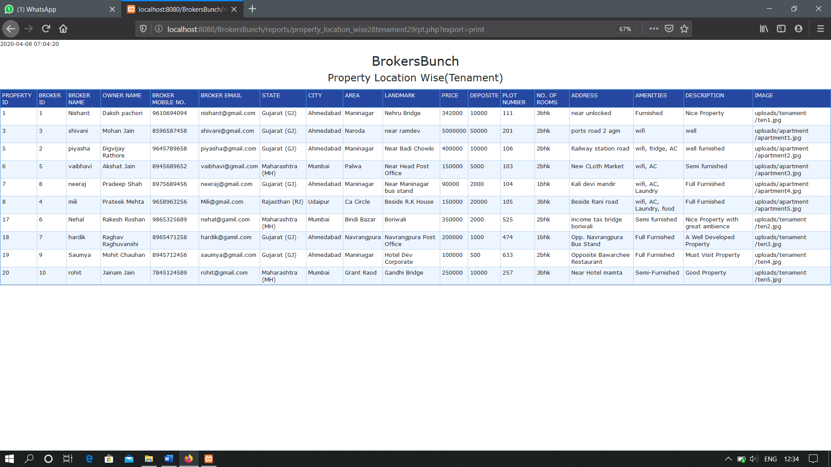 **PRINT OPTION**

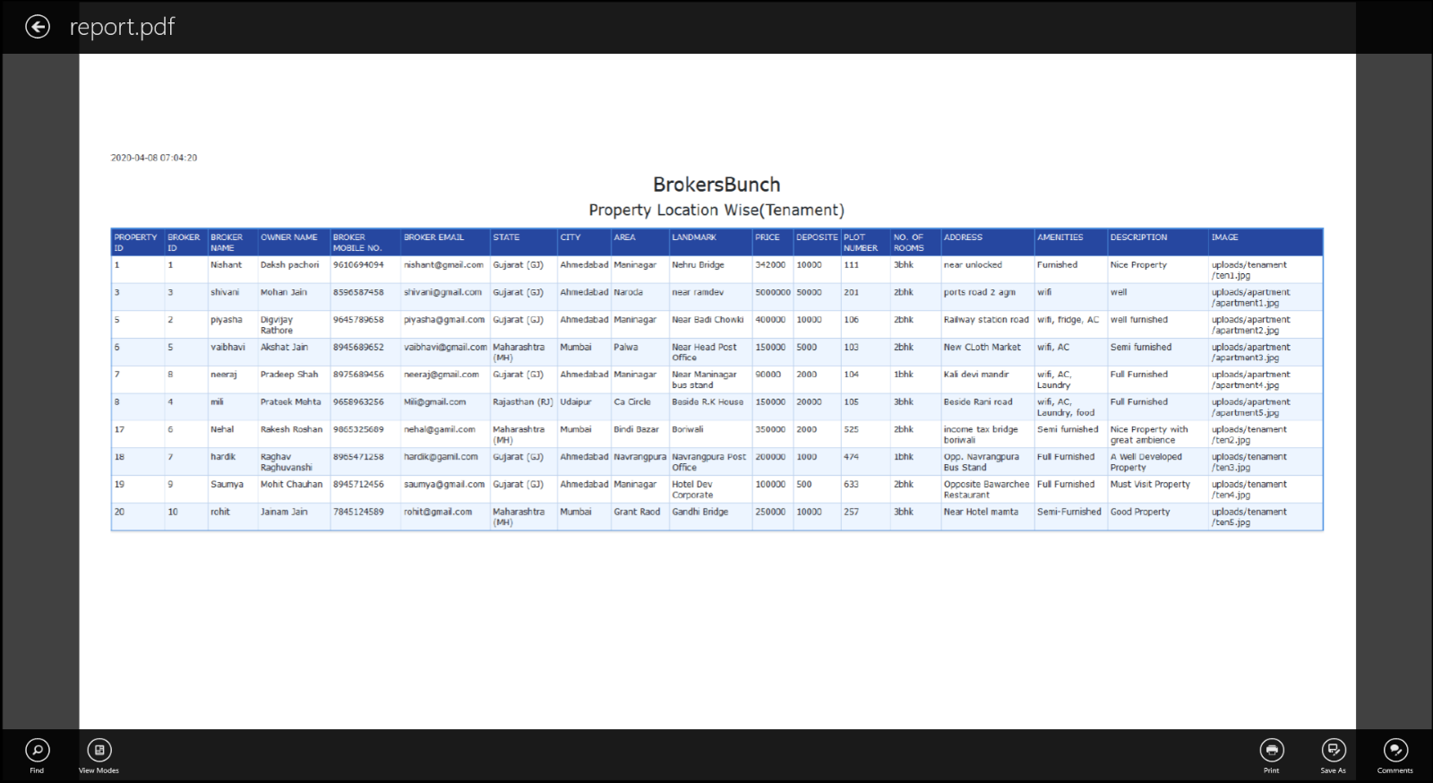**PDF**

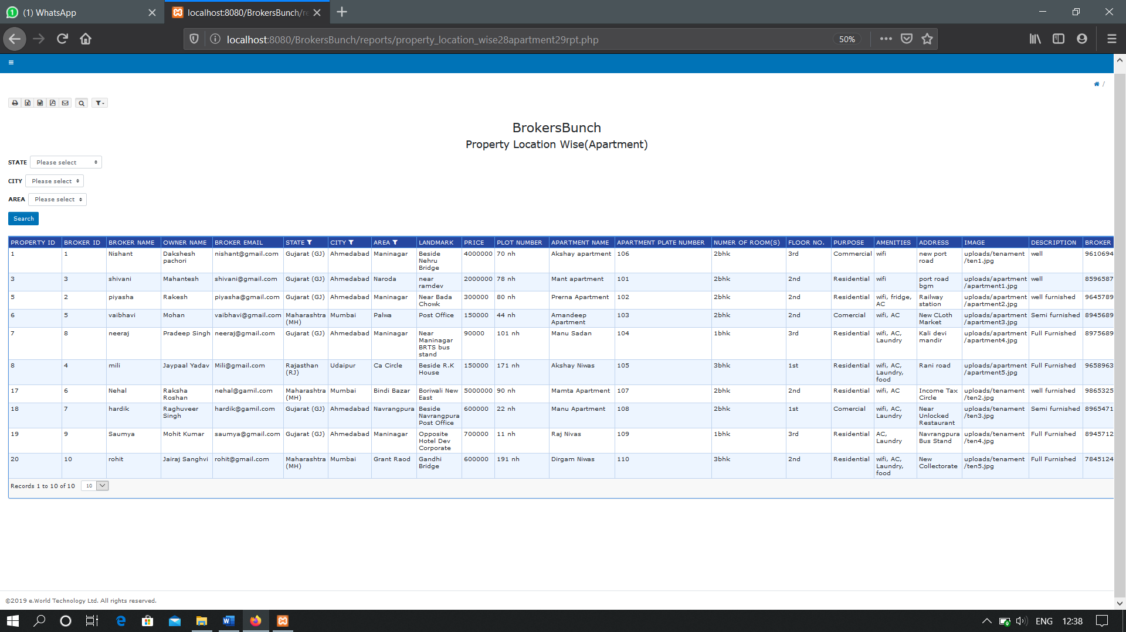**PROPERTY LOCATION WISE(APARTMENT)**

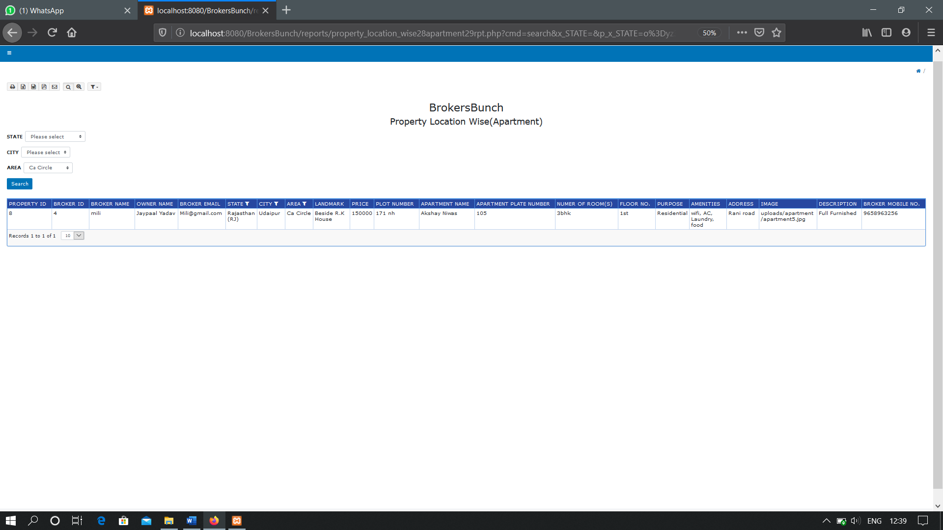**WITH FILTER**

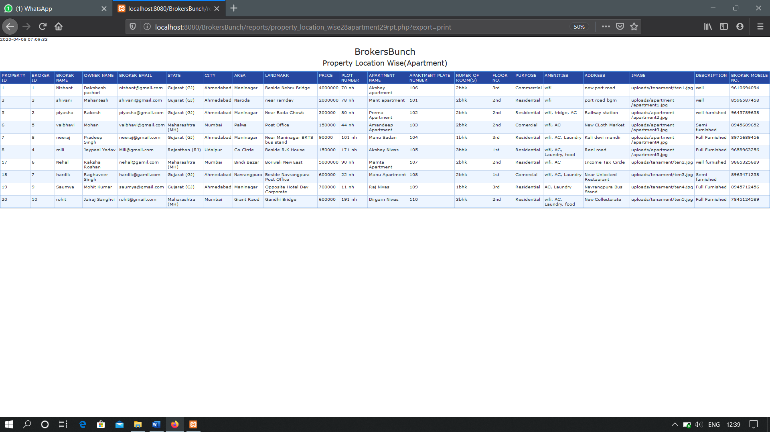**PRINT OPTION**

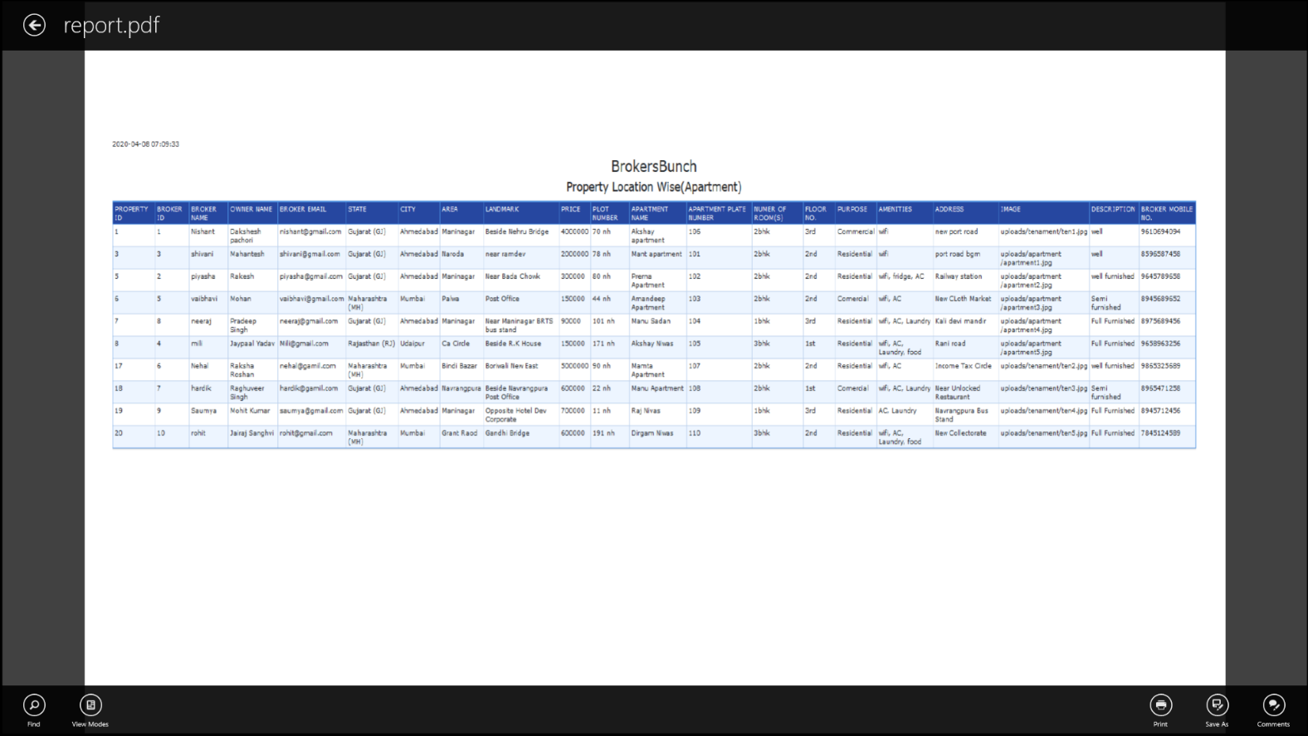**PDF**

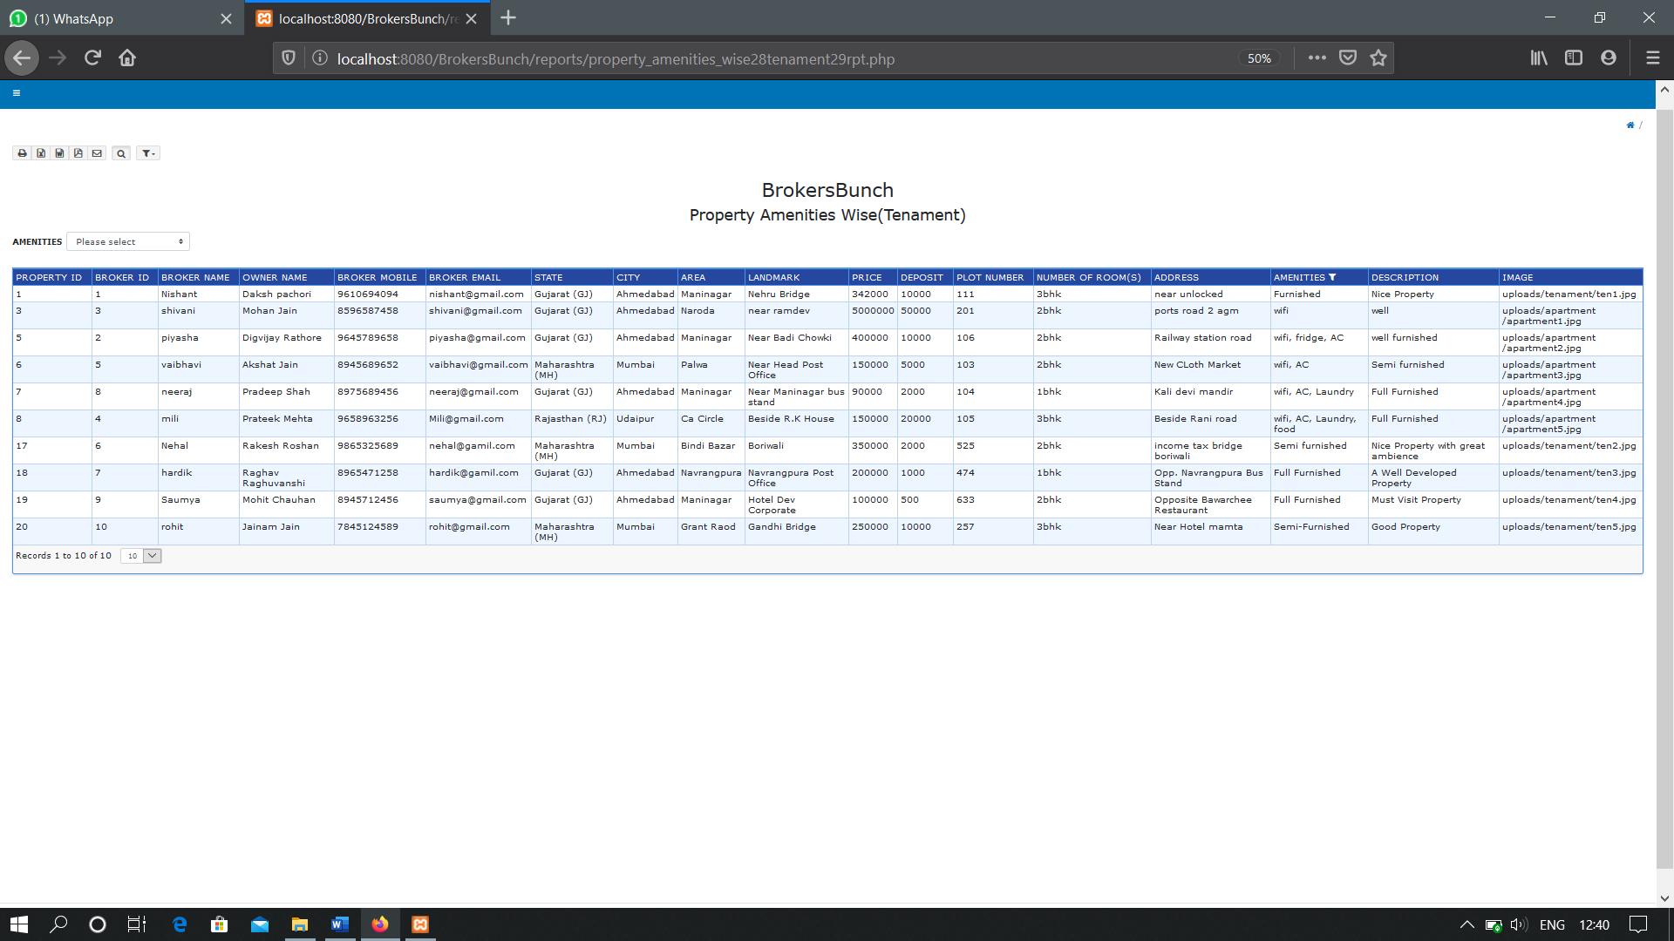**PROPERTY AMENITIES WISE(TENAMENT)**

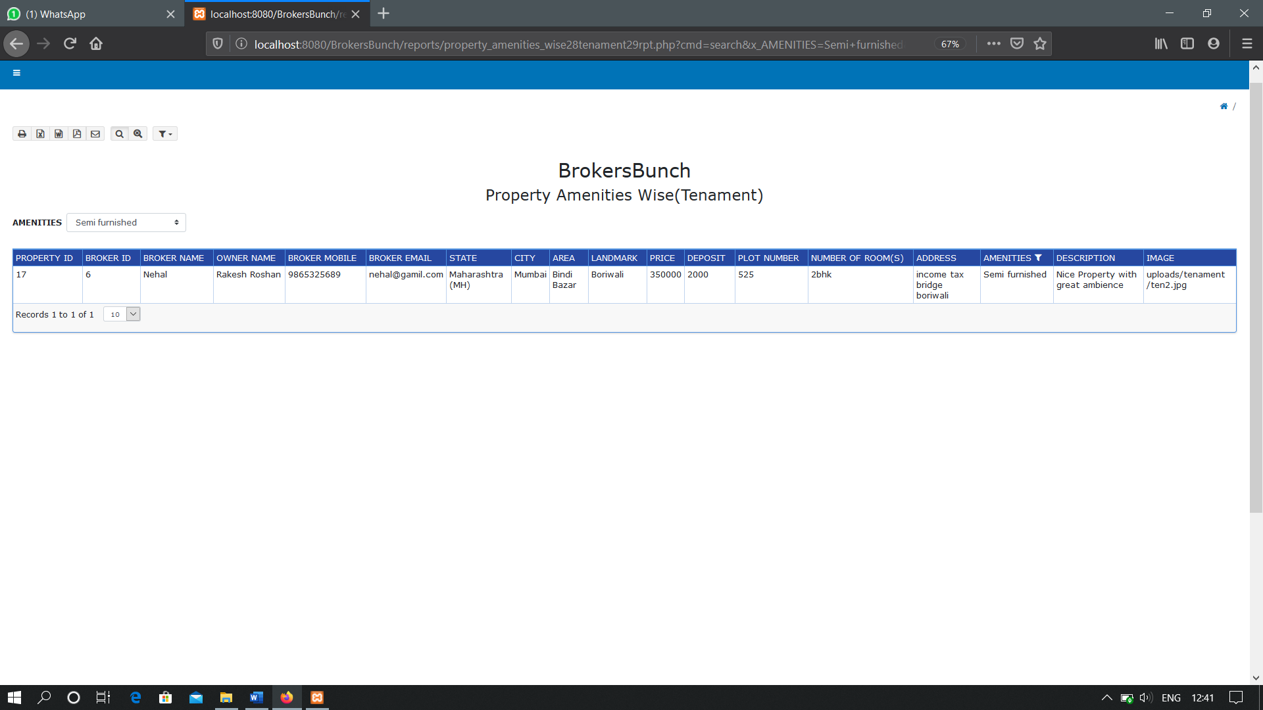**WITH FILTER**

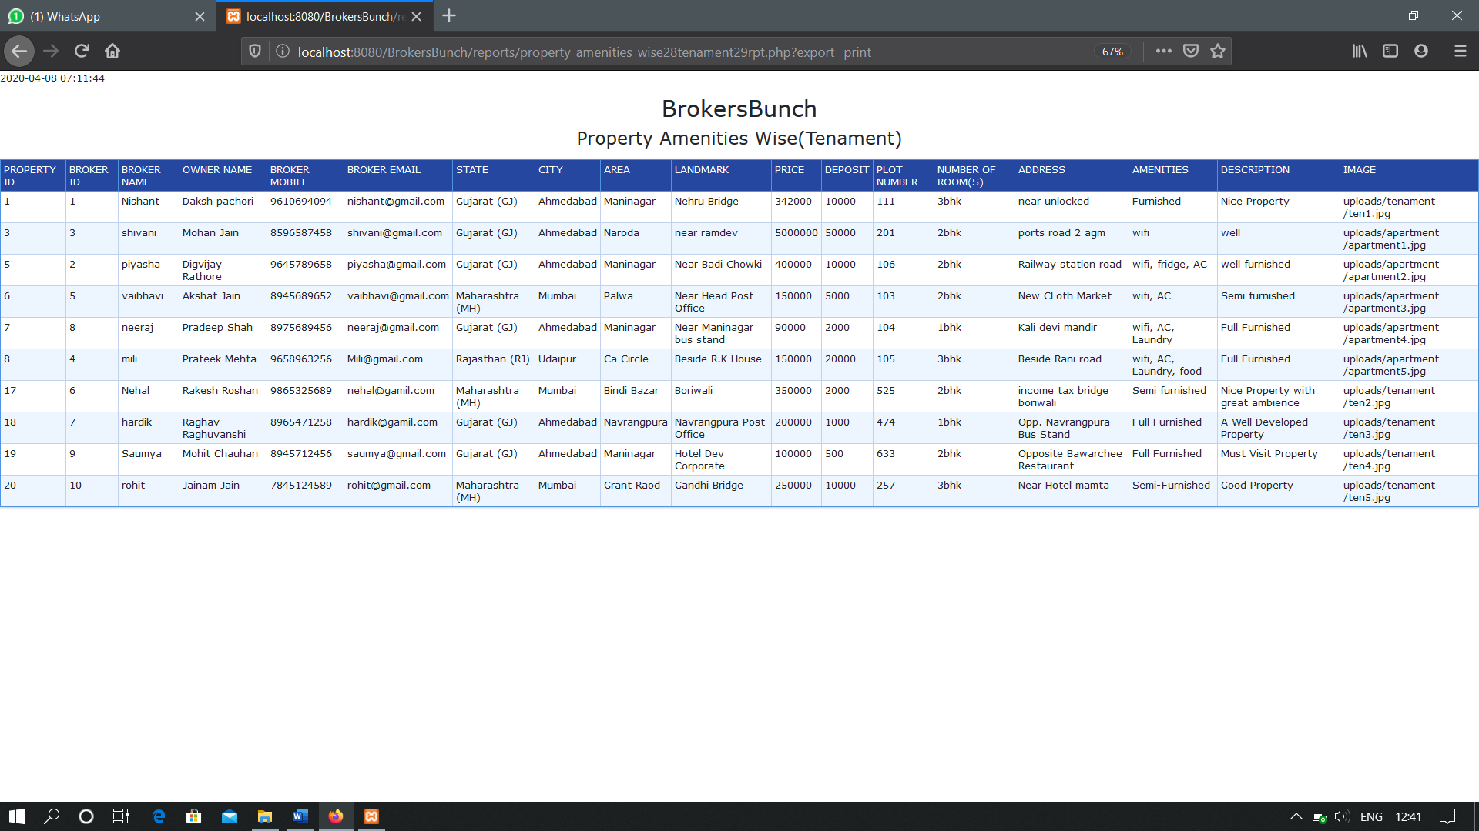**PRINT OPTION**

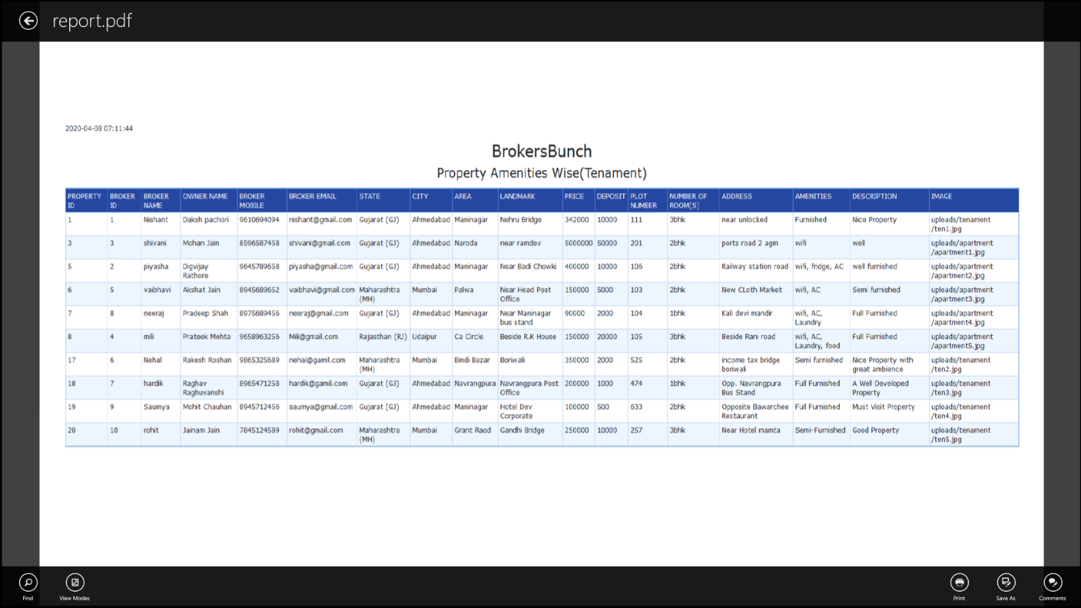**PDF**

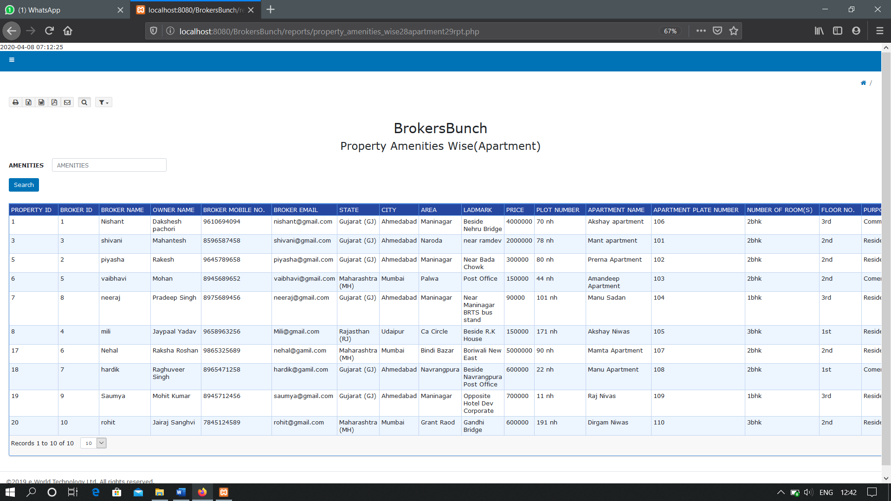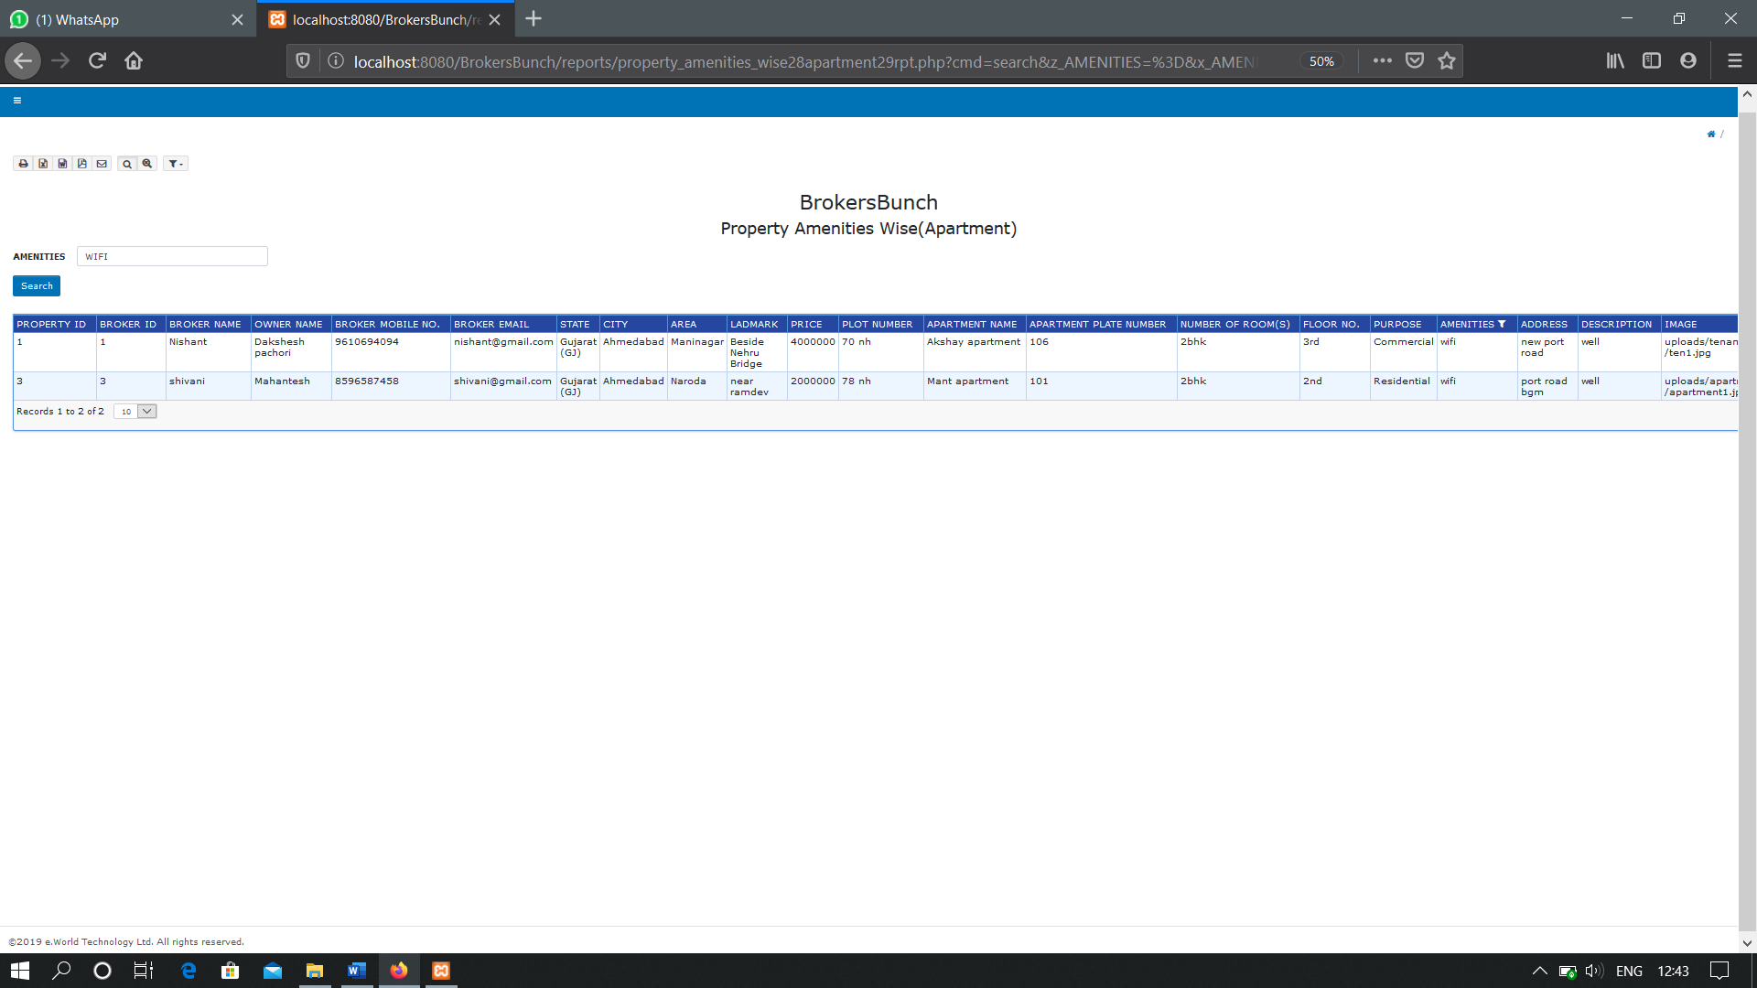**PROPERTY AMENITIES WISE(APARTMENT)**

**WITH FILTER**

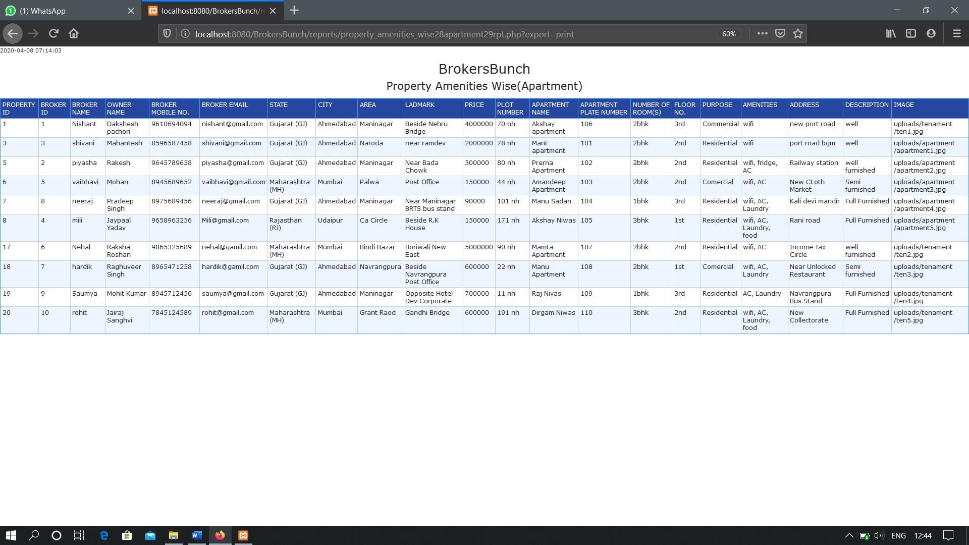**PRINT OPTION**

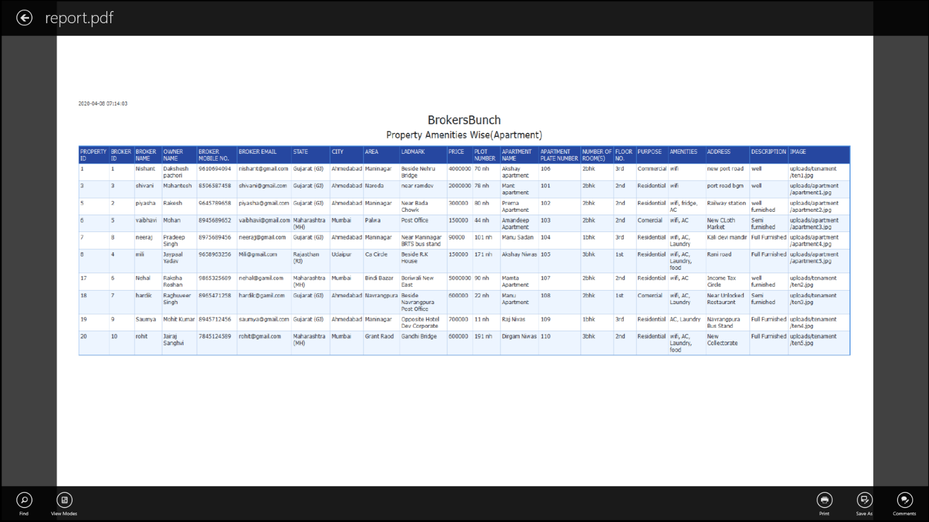**PDF**

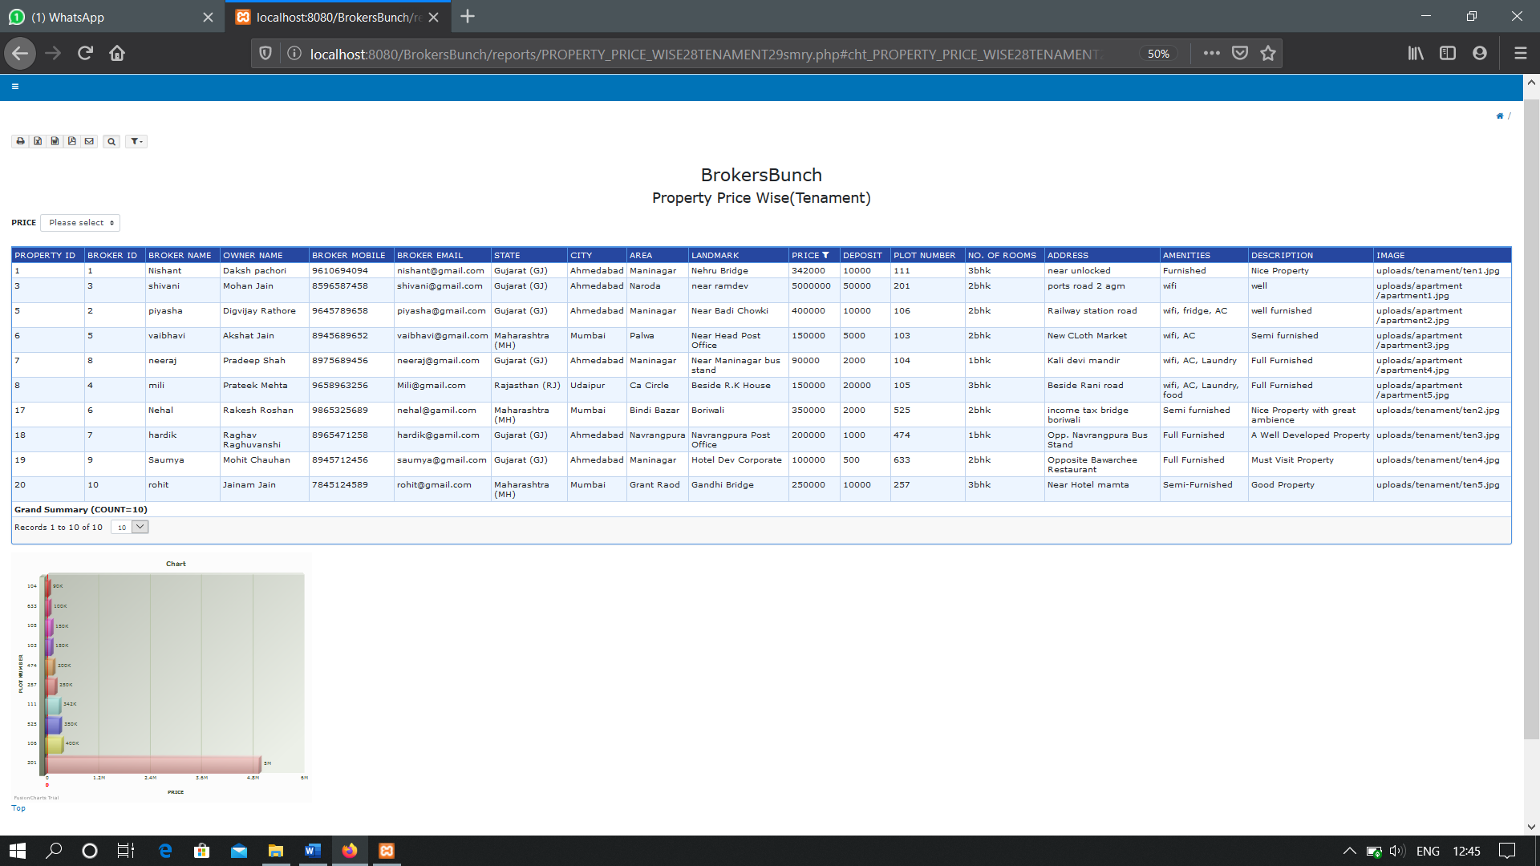**PROPERTY PRICE WISE(TENAMENT) (GRAPHICAL REPRESENTATION)**

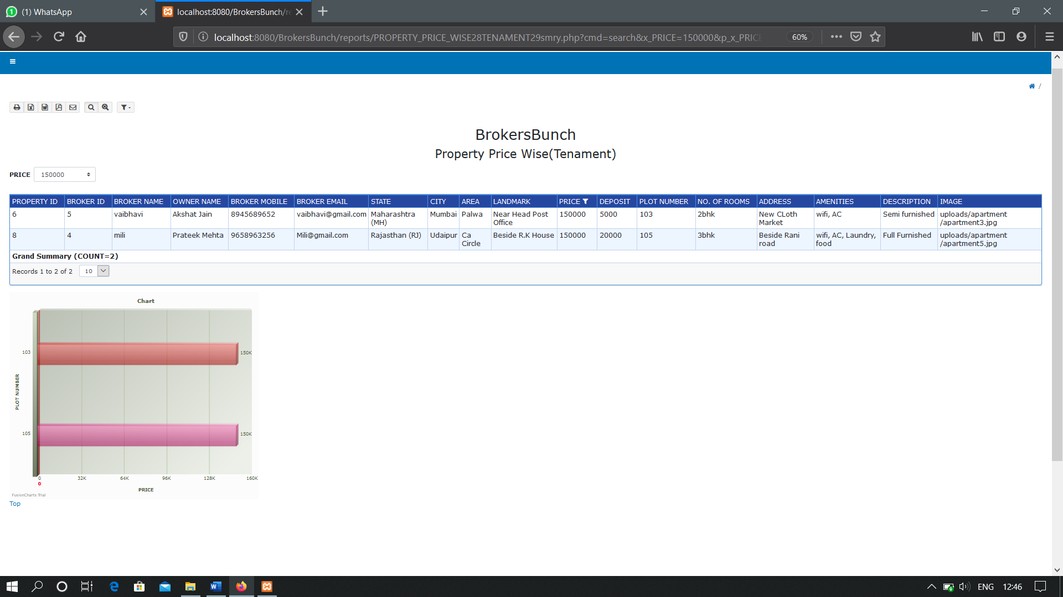**WITH FILTER**

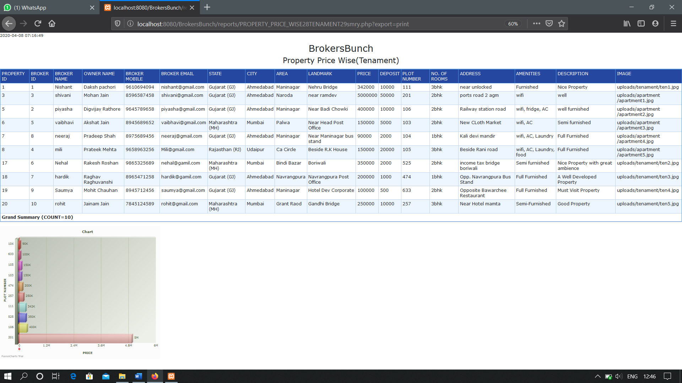**PRINT OPTION**

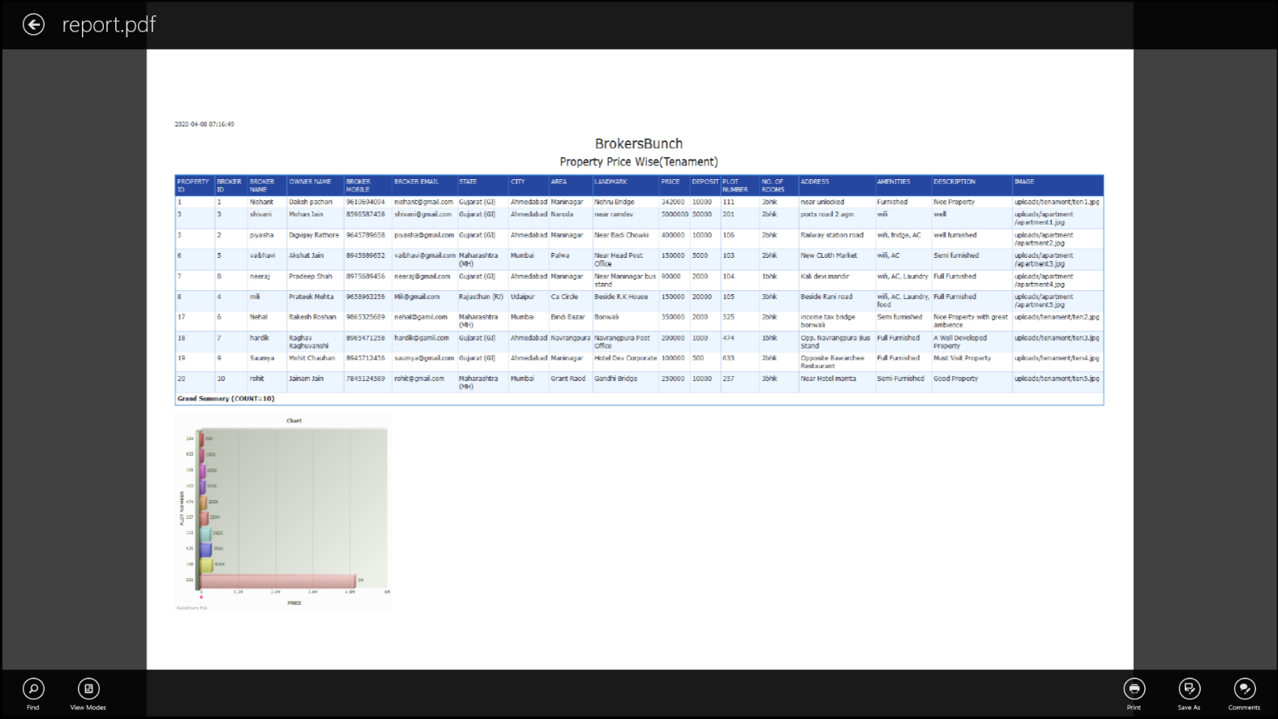**PDF**

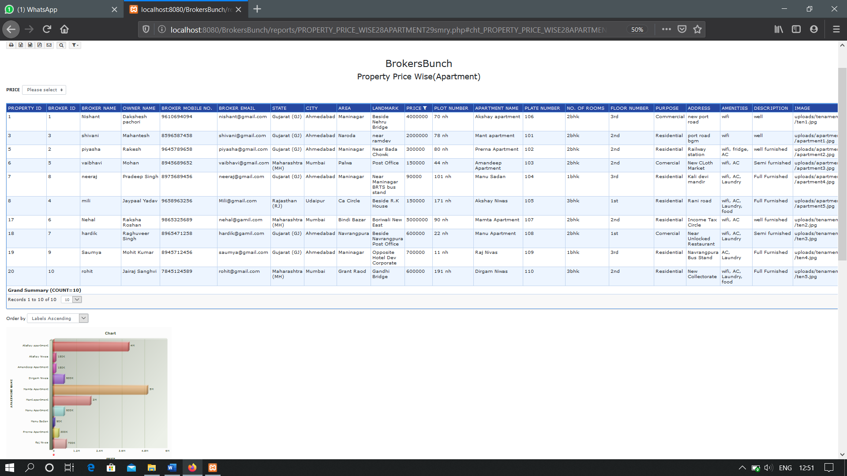**PROPERTY PRICE WISE(APARTMENT)(GRAPHICAL REPRESENTATION)**

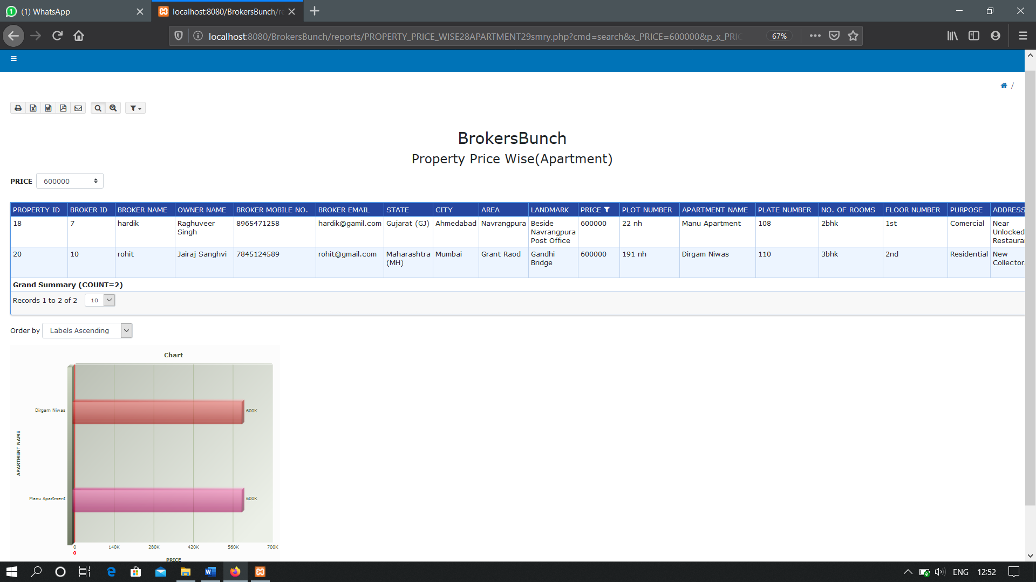**WITH FILTER**

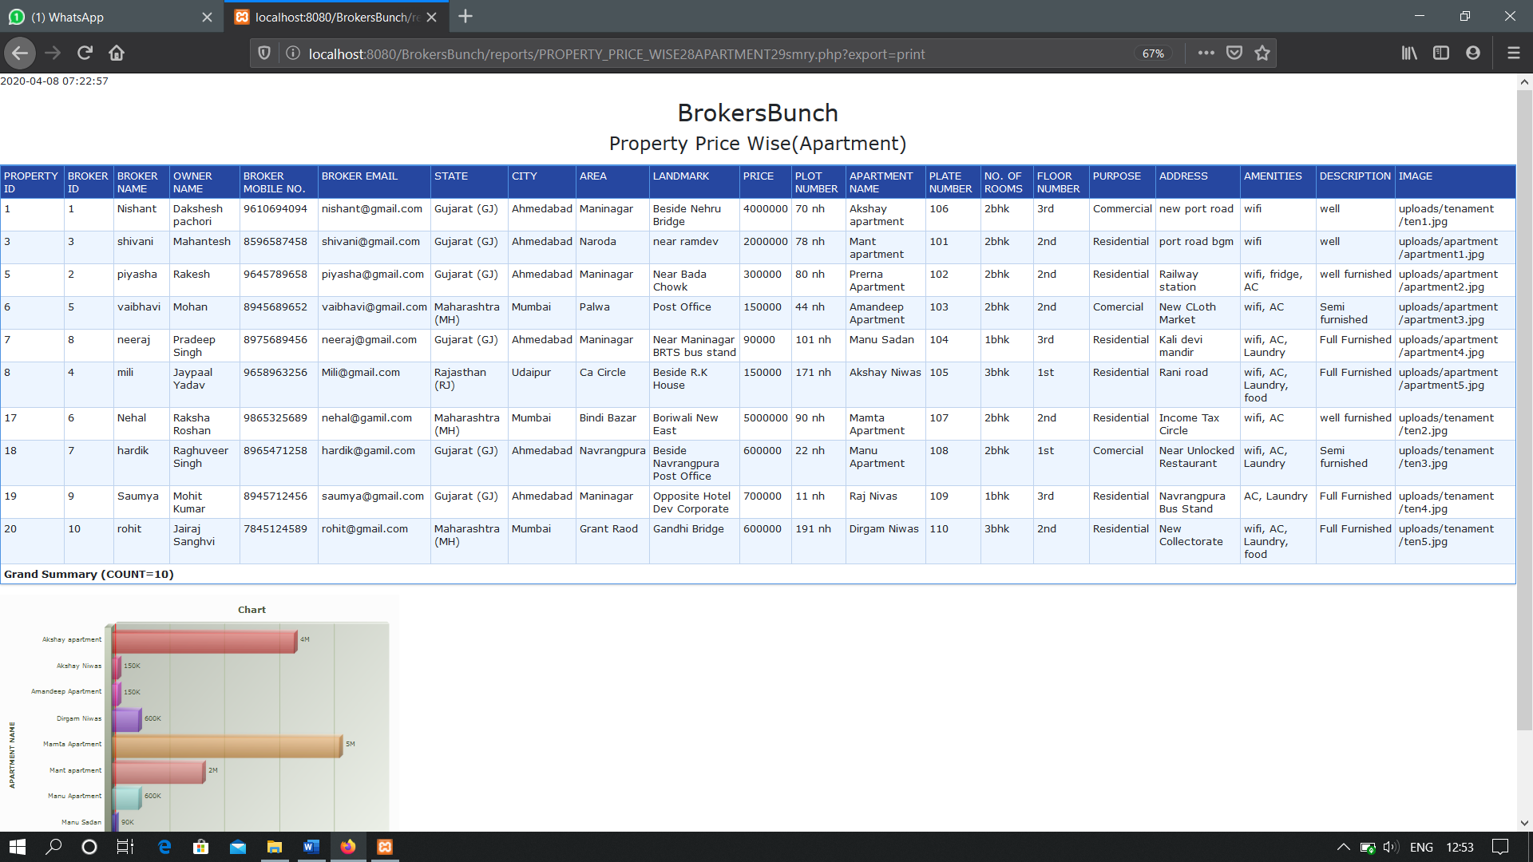**PRINT OPTION**

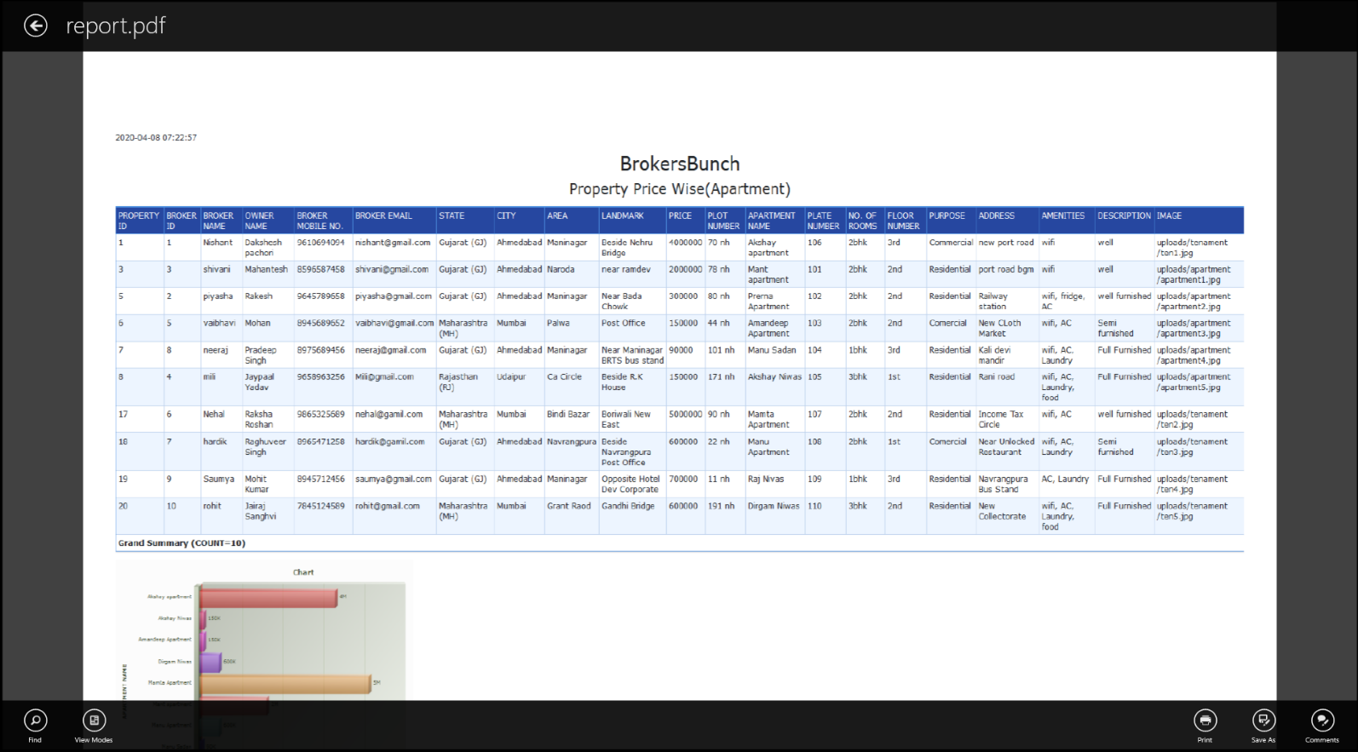**PDF**

**Conclusion**

The whole duration of this project has been a great learning experience from us. It has introduced us more to the working of the real wold projects and the problems that we face while developing them.

By development of this website, we here by conclude that at BrokersBunch we have achieved our aim at creating a platform where we have created and promoted a healthy environment for the interaction of the community of Brokers and Clients.

We also conclude that our project makes it easy for the Clients to purchase properties and Brokers to list the properties, register themselves on the website as well as clients can book appointment for brokers for different properties.

We also hope to expand the scale of the project and make it ubiquitous by developing it for all digital platforms.

**Bibliography**

**Website references :-**

Tutorials point: www.tutorialspoint.com

W3Schools: www.w3school.com

StackOverflow: www. stackoverflow.com

